Object oriented Programming

**Types of Constructors in C#**

There are five types of constructors available in C#, they are as follows

1. **Default or Parameter Less Constructor**
2. **Parameterized Constructor**
3. **Copy Constructor**
4. **Static Constructor**
5. **Private Constructor**

Let’s discuss each of these constructors in detail with examples.

**Default or Parameterless Constructors in C#**

If a constructor method does not take any parameters, then we call that a Default or Parameter Less Constructor. These constructors can be defined by a programmer explicitly or else will be defined implicitly provided there is no explicit constructor under the class. So, the Default or Parameterless Constructors are again classified into two types. They are as follows:

1. **System-Defined Default Constructor**
2. **User-Defined Default Constructor**

**What is System Defined Default or Parameterless Constructor in C#?**

As a programmer, if we are not defined any constructor explicitly in our program, then by default the compiler will provide one constructor at the time of compilation. That constructor is called a default constructor and the default constructor is parameterless. The default constructor will assign default values to the data members (non-static variables). As this constructor is created by the system this is also called a system-defined default constructor.

**Example to understand System-Defined Implicit or Default Constructor in C#:**

In the below example, within the Employee class, we have created a few variables. And then from the Main method, we created an instance of the Employee class and then printed the values of the variables.

**using** *System;*

**namespace** *ConstructorDemo*

**{**

**class** Employee

**{**

**public** **int** Id, Age;

**public** **string** Address, Name;

**public** **bool** IsPermanent;

**}**

**class** Test

**{**

**static** **void** Main**(string[]** args**)**

**{**

Employee e1 = new Employee**()**;

Console.WriteLine**(**"Employee Id is: " + e1.Id**)**;

Console.WriteLine**(**"Employee Name is: " + e1.Name**)**;

Console.WriteLine**(**"Employee Age is: " + e1.Age**)**;

Console.WriteLine**(**"Employee Address is: " + e1.Address**)**;

Console.WriteLine**(**"Is Employee Permanent: " + e1.IsPermanent**)**;

Console.ReadKey**()**;

**}**

**}**

**}**

when you run the above code, you will see that default values based on the variable type are being printed on the console as shown in the below image. For numeric (in our example Id and Age), the default is 0. For string (in our example Address and Name) or object, the default value will be null (in this case nothing will be printed on the console) and for Boolean (in our example IsPermanent), the default value is false.

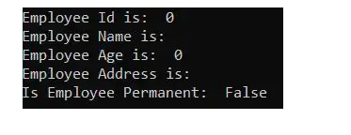

In our example, we have not specified these default values. Then who provided these default values and when? These default values are provided by the default constructor based on the variable data type and the compiler will provide the default constructor at the time of compilation. So, the Employee class will be converted as follows after compilation.

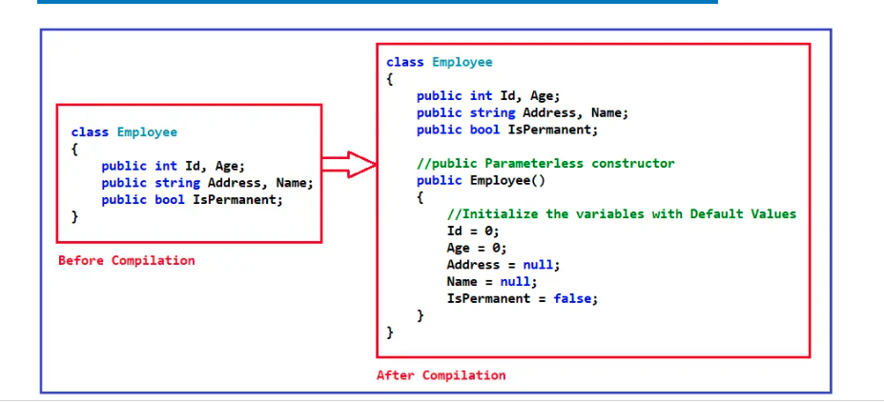

As you can see the Implicit Constructor which is always public and parameterless initialize the variables with default values and these default values you are seeing in the output. As this Implicit Constructor initializes the variables with default values, we also called this a System Defined Default Constructor.

**Note:** The point that you need to keep in mind is that the Compiler will only provide the default constructor if as a programmer we are not defined any constructor explicitly.

**When do we need to provide the Constructor Explicitly?**

If we want to execute some custom logic at the time of object creation, that logic may be object initialization logic or some other useful logic, then as a developer, we must provide the constructor explicitly in C#.

**What is a User-Defined Default Constructor in C#?**

The constructor which is defined by the user without any parameter is called the user-defined default constructor. This constructor does not accept any argument but as part of the constructor body, you can write your own logic.

**Example to understand User-defined Default Constructor in C#**

In the below example, within the Employee class, we have created a public parameterless constructor which is used to initialize the variables with some default hard-coded values. And then from the Main method, we created an instance of the Employee class and invoke the Display method.

using System;

namespace ConstructorDemo

{

class Employee

{

public int Id, Age;

public string Address, Name;

public bool IsPermanent;

//User Defined Default Constructor

public Employee()

{

Id = 100;

Age = 30;

Address = "Bhubaneswar";

Name = "Anurag";

IsPermanent = true;

}

public void Display()

{

Console.WriteLine("Employee Id is: " + Id);

Console.WriteLine("Employee Age is: " + Age);

Console.WriteLine("Employee Address is: " + Address);

Console.WriteLine("Employee Name is: " + Name);

Console.WriteLine("Is Employee Permanent: " + IsPermanent);

}

}

class Program

{

static void Main(string[] args)

{

Employee e1 = new Employee();

e1.Display();

Console.ReadKey();

}

}

}

**Output:**

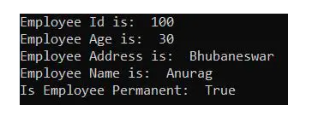

The Employee class constructor is also called a Default Constructor because it is public and parameter-less.

The Employee class constructor is also called a Default Constructor because it is public and parameter-less.

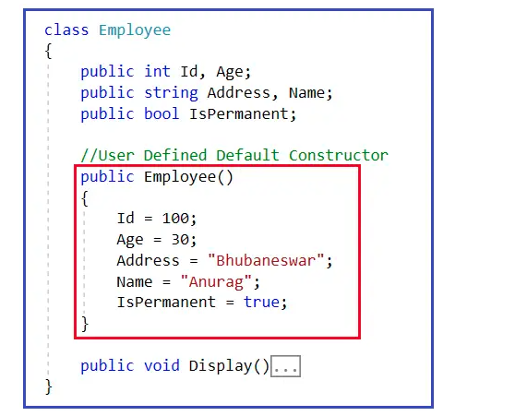

And more importantly, it does not matter how many objects are being created for the Employee class, each instance or object is initialized with the same set of values. This is the reason we call it a Default Constrictor. As this constructor is created by the user, so we call it a User-Defined Default Constructor.

The drawback of the above user-defined default constructor is that each and every instance (i.e. object) of the class will be initialized (assigned) with the same set of values. That means it is not possible to initialize each instance of the class with different values. For a better understanding, please modify the Main method as follows and see the output.

class Program

{

static void Main(string[] args)

{

Employee e1 = new Employee();

e1.Display();

Employee e2 = new Employee();

Console.WriteLine();

e2.Display();

Console.ReadKey();

}

}

**Output:**

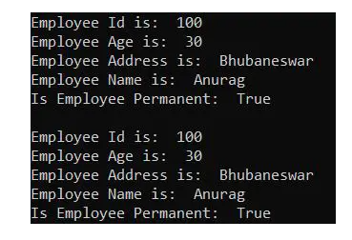

##### **When should we define a parameterized constructor in a class?**

If we want to initialize the object dynamically with the user-given values or if we want to initialize each instance of a class with a different set of values then we need to use the Parameterized Constructor in C#. The advantage is that we can initialize each instance with different values.

**What is Parameterized Constructor in C#?**

If a constructor method is defined with parameters, we call it a Parameterized Constructor in C#, and these constructors are defined by the programmers only but never can be defined implicitly. So, in simple words, we can say that the developer-given constructor with parameters is called Parameterized Constructor in C#.

Let us understand Parameterized Constructor in C# with Examples. Please have a look at the below code. Here, we have a class called ParameterizedConstructor, and this class has one constructor which is taking one integer parameter. As this constructor takes a parameter, we call it a Parameterized Constructor. And in this constructor, we are printing the i value.

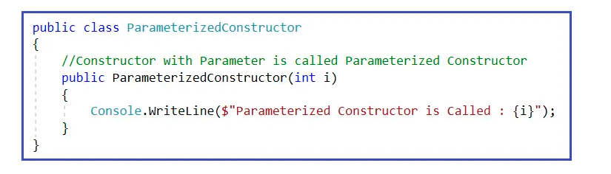

And now, when you are going to create an instance of the Parameterized Constructor class, it will ask you for the integer parameter value as shown in the below image.

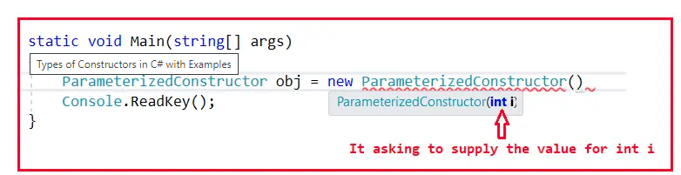

Now, you can pass an integer value. Suppose, we pass the value 10, then that value 10 will directly come to variable i which is then printed on the console. For a better understanding, please have a look at the below image.

The complete example code is given below.

using System;

namespace ConstructorDemo

{

class Program

{

static void Main(string[] args)

{

ParameterizedConstructor obj = new ParameterizedConstructor(10);

Console.ReadKey();

}

}

public class ParameterizedConstructor

{

public ParameterizedConstructor(int i)

{

Console.WriteLine($"Parameterized Constructor is Called: {i}");

}

}

}

**Output: Parameterized Constructor is Called: 10**

So, in this way, we can create any number of instances of the class, and while creating the instance we can pass different values and those values will go and sit in the variable i. In the below example, we are creating two different instances of ParameterizedConstructor class with two different values.

using System;

namespace ConstructorDemo

{

class Program

{

static void Main(string[] args)

{

ParameterizedConstructor obj1 = new ParameterizedConstructor(10);

ParameterizedConstructor obj2 = new ParameterizedConstructor(20);

Console.ReadKey();

}

}

public class ParameterizedConstructor

{

public ParameterizedConstructor(int i)

{

Console.WriteLine($"Parameterized Constructor is Called : {i}");

}

}

}

**Output:**

##### **When should we use Parameterized Constructor in C#?**

With the help of a Parameterized constructor, we can initialize each instance of the class with a different set of values. That means using parameterized constructor we can store a different set of values in different instances created in the class.

Let us understand this with an example. Please have a look at the below class. This is the same class that we worked on in our previous example with some changes. Now, in the class, I have declared a variable called x. Remember, this variable x is initialized with default value only i.e. 0. Why default value? Because we didn’t assign a value and when we don’t assign a value, the constructor will take the responsibility of assigning a value. And the value for x is going to be 0. Then we created a method called Display where we print the x value.

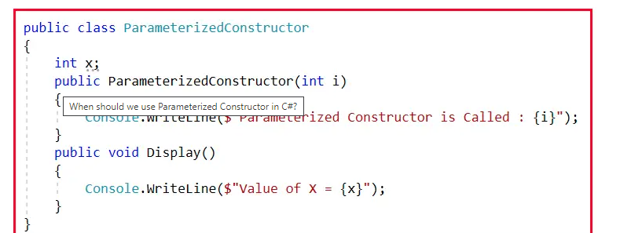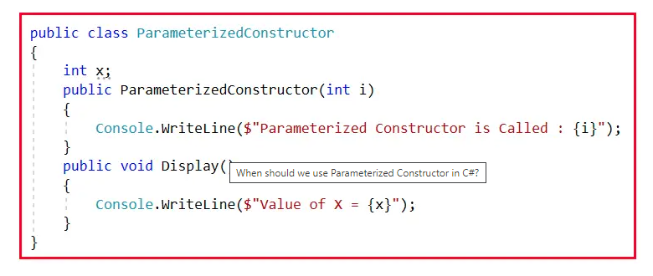

Now, let us call this Display method using two different instances. The complete example code is given below.

using System;

namespace ConstructorDemo

{

class Program

{

static void Main(string[] args)

{

ParameterizedConstructor obj1 = new ParameterizedConstructor(10);

obj1.Display();

ParameterizedConstructor obj2 = new ParameterizedConstructor(20);

obj2.Display();

Console.ReadKey();

}

}

public class ParameterizedConstructor

{

int x;

public ParameterizedConstructor(int i)

{

Console.WriteLine($"Parameterized Constructor is Called : {i}");

}

public void Display()

{

Console.WriteLine($"Value of X = {x}");

}

}

}

**Output:**

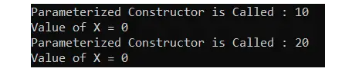

As you can see in the above image, for both the instances it is printing the x value as 0. In instance one we pass 10 to the constructor and in instance two we pass 20 to the constructor. So, can we use the values 10 and 20 in place of x? Yes, it is possible. How it is possible? By using Parameterized constructor only. Let us see how we can do this. Inside the constructor, we can assign the x variable with the value of I as shown in the below image.

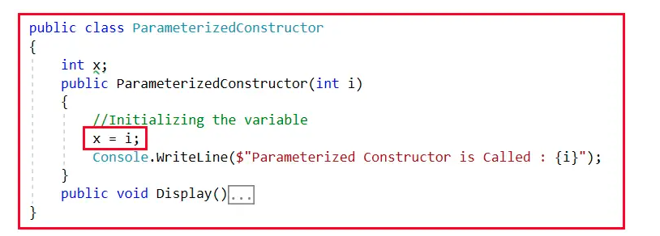

With the above changes in place, now if you run the application, then it will print 10 and 20 for the x variable. The complete example code is given below.

using System;

namespace ConstructorDemo

{

class Program

{

static void Main(string[] args)

{

ParameterizedConstructor obj1 = new ParameterizedConstructor(10);

obj1.Display();

ParameterizedConstructor obj2 = new ParameterizedConstructor(20);

obj2.Display();

Console.ReadKey();

}

}

public class ParameterizedConstructor

{

int x;

public ParameterizedConstructor(int i)

{

//Initializing the variable

x = i;

Console.WriteLine($"Parameterized Constructor is Called : {i}");

}

public void Display()

{

Console.WriteLine($"Value of X = {x}");

}

}

}

###### ****Output:****

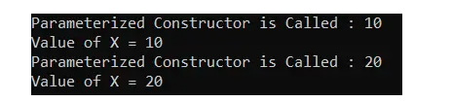

As we have created two instances separately i.e. obj1 and obj2. So, internally two copies of the x variable are available in the memory for us. For a better understanding, please have a look at the below diagram. As you can see in the below image, we have two separate objects i.e. obj1 and obj2. For obj1 we have one copy of the x variable with the value 10 is there and the obj2 another copy of the x variable with the value 20 is there in the memory.

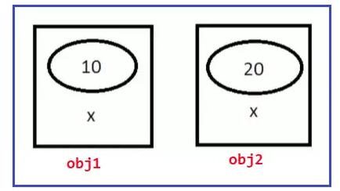

##### **Copy Constructor in C#:**

If we want to create multiple instances with the same values then we need to use the copy constructor in C#, in a copy constructor the constructor takes the same class as a parameter to it.

Let us understand Copy Constructor in C# with Examples. Please have a look at the below code. This is the same code that we have written in our previous example.

using System;

namespace ConstructorDemo

{

class Program

{

static void Main(string[] args)

{

CopyConstructor obj1 = new CopyConstructor(10);

obj1.Display();

Console.ReadKey();

}

}

public class CopyConstructor

{

int x;

public CopyConstructor(int i)

{

x = i;

}

public void Display()

{

Console.WriteLine($"Value of X = {x}");

}

}

}

**output: Value of X = 10**

Now, I want to create another instance with the same value. Then I can create another instance as follows.

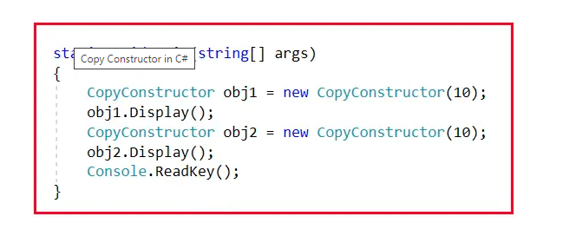

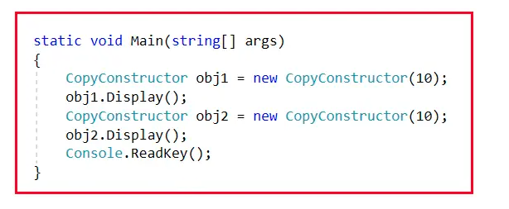

See, passing one parameter is not a difficult task. Suppose, the constructor takes 10 or 20 parameters, then it is a time-consuming and error-prone process to pass the same 10 or 20 parameters. We can overcome this problem by using Copy Constructor in C#. The copy constructor takes a parameter of the same class type. How we can pass a class name as a parameter. This is because a class is a user-defined data type. For a better understanding, please have a look at the below image.

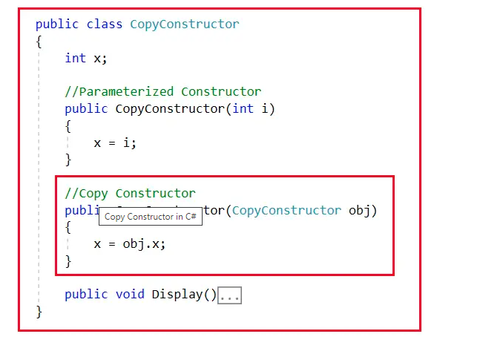

With the above changes, now you can see we have two constructors as shown in the below image. One constructor takes an int as a parameter and the other constructor takes the CopyConstructor type as a parameter.

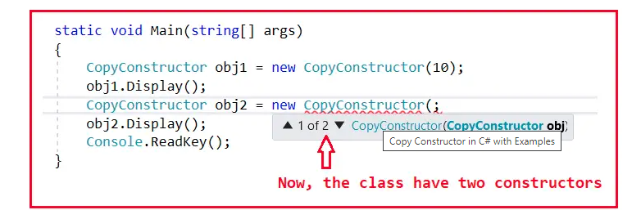

So, can we define multiple constructors in a class? Yes, we can. Constructors can be overloaded in C#. The complete example code is given below. Now, we are passing obj1 as a parameter to the copy constructor.

using System;

namespace ConstructorDemo

{

class Program

{

static void Main(string[] args)

{

CopyConstructor obj1 = new CopyConstructor(10);

obj1.Display();

CopyConstructor obj2 = new CopyConstructor(obj1);

obj2.Display();

Console.ReadKey();

}

}

public class CopyConstructor

{

int x;

//Parameterized Constructor

public CopyConstructor(int i)

{

x = i;

}

//Copy Constructor

public CopyConstructor(CopyConstructor obj)

{

x = obj.x;

}

public void Display()

{

Console.WriteLine($"Value of X = {x}");

}

}

}

Now, if you run the application then you see that both the instances will have the same x value as shown in the below image,

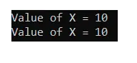

Now, the memory is separate for each instance but the value is going to be the same for both instances. For a better understanding, please have a look at the below diagram.

##### **How many Constructors can be Defined in a Class in C#?**

In C#, within a class, we can define any number of constructors. But the most important point that you need to remember is that each and every constructor must have a different signature. A different signature means the number, type, and parameter order should be different. So, in a class, we can define one no-argument constructor plus ‘n’ number of parameterized constructors in C#.

##### **Static Constructor in C#**

In C#, it is also possible to create a constructor as static and when we do so, it is called a Static Constructor. If a constructor is declared explicitly by using the static modifier, then it is called a static constructor in C#. All the constructors we defined till now are non-static or instance constructors.

For a better understanding, please have a look at the below example. In a static constructor, you cannot use any access specifiers like public, private, and protected.

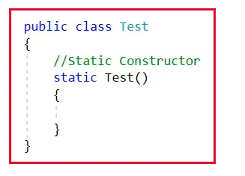

But, when you will compile the above, the compiler will provide the default parameter less constructor. For a better understanding, please have a look at the below code.

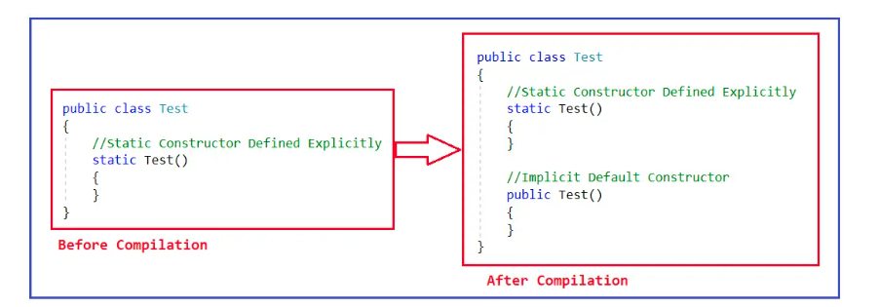

##### **Points to Remember while working with Static Constructors in C#:**

###### ****Point1:****

If a class contains any static variables, then only implicit static constructors come into the picture otherwise we must be defined them explicitly. On the other hand, non-static constructors will be implicitly defined in every class (except the static class) provided we didn’t define any constructor explicitly.

###### ****Point2:****

Static Constructors are responsible for initializing static variables and these constructors are never called explicitly. They are called Implicitly and moreover, these constructors are the first to execute in any class. For a better understanding, please have a look at the below example. Here, we have defined one static constructor, and please observe from the Main method we are not calling the Static constructor.

using System;

namespace ConstructorDemo

{

public class StaticConstructor

{

static StaticConstructor()

{

Console.WriteLine("Static Constructor Executed!");

}

static void Main(string[] args)

{

Console.WriteLine("Main Method Exceution Started...");

Console.ReadKey();

}

}

}

Now, when you execute the above code, the Static constructor will execute first and then the main method. And this proves the following output.

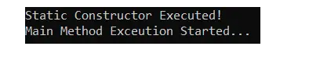

The non-static constructors are never called implicitly, they are always called explicitly whereas the static constructor never called explicitly, they are always going to be called implicitly. How does the execution happen? See, the Main method is the starting point of execution, and in this case no difference. The program execution will start from the Main method but before executing any statement inside the Main method, it will first execute the Static constructor and once the Static Constructor execution is completed, then it will continue the execution of the Main method. So, the static constructor is the first block of code in a class to be executed.

###### ****Point3:****

Static Constructors cannot be parameterized, so overloading of the static constructors is not possible in C#. Now, the question is why we cannot parameterize the static constructor? The answer is simple. The static constructors are executed implicitly and hence we never get a chance to pass a value. And as the static constrictor is the first block to be executed in a class, and hence there is no chance to pass a value.

##### **Points To Remember About Static Constructor in C#:**

1. There can be only one static constructor in a class.
2. It can’t be called explicitly, it is always called implicitly.
3. The static constructor should be without any parameters.
4. It can only access the static members of the class.
5. There should not be any access specifiers in the static constructor definition.
6. If a class is static then we cannot create the object for the static class.
7. It is called automatically to initialize the static members.
8. Static constructor will be invoked only once i.e. at the time of class loading.

##### **Can we initialize non-static data members within a static constructor in C#?**

It is not possible to initialize non-static data members within a static constructor, it raises a compilation error. For a better understanding, please have a look at the following example.

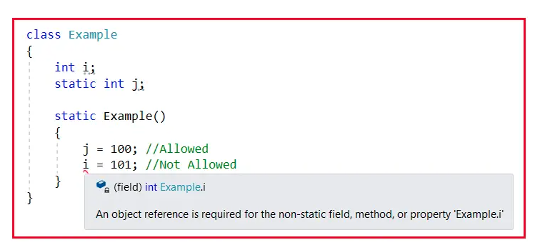

##### **Can we initialize static data fields within a non-static constructor in C#?**

Yes, we can initialize static data members within a non-static constructor. Consider the following example for better understanding:

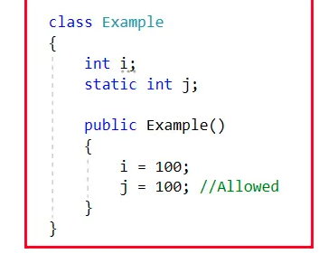

##### **What is a Private Constructor in C#?**

In C#, it is also possible to create a constructor as private. The constructor whose accessibility is private is known as a private constructor. When a class contains a private constructor then we cannot create an object for the class outside of the class. So, private constructors are used to create an object for the class within the same class. Generally, private constructors are used in the Remoting concept.

##### **Example to understand Private Constructor in C#**

using System;

namespace ConstructorDemo

{

class Program

{

private Program()

{

Console.WriteLine("This is private constructor");

}

static void Main(string[] args)

{

Program p = new Program();

Console.WriteLine("Main method");

Console.ReadKey();

}

}

}

##### **Points To Remember about C# Private Constructor:**

1. Using Private Constructor in C# we can implement the singleton design pattern.
2. We need to use the private constructor in C# when the class contains only static members.
3. Using a private constructor is not possible to create an instance from outside the class.

In the next article, I am going to discuss [**Why Do We Need Constructors in C#**](https://dotnettutorials.net/lesson/why-do-we-need-constructors-in-csharp/) with Examples. Here, in this article, I try to explain the **Types of Constructors in C#**with Examples. I hope you enjoy this Types of Constructors in C# article. Please give your feedback, suggestions, and questions about this article in the comment section.

## **Garbage Collection in C#.NET Framework**

In this article, I am going to discuss **Garbage Collection in C#.NET** with Examples. Please read our previous article where we discussed [**Destructor in C#**](https://dotnettutorials.net/lesson/destructor-csharp/) with Examples. At the end of this article, you will understand what is Garbage Collector in .NET Framework and how does it work? As part of this article, we are going to discuss the following pointers in detail.

So, Garbage Collector is nothing but, it is a feature provided by CLR which helps us to clean or destroy unused managed objects. Cleaning or destroying those unused managed objects basically reclaim the memory.

**Note:** The Garbage Collector will destroy only the unused managed objects. It does not clean unmanaged objects.

##### **Managed and Unmanaged objects in .NET Framework:**

Let us understand Managed and Unmanaged objects. Whenever we create any EXE (i.e. console application, windows application, etc.) or web application (i.e. ASP.NET MVC, Web API, ASP.NET, Class Library, etc.) in .NET Framework using visual studio and using any .NET supported programming language such as C#, VB, F#, etc., then these applications are run completely under the control of CLR (Common Language Runtime). That means, if your applications have unused objects, then CLR will clean those objects using Garbage Collector.

Now, let’s say, you have also used other third-party EXE in your .NET application like Skype, PowerPoint, Microsoft Excel, etc. These “EXEs” are not made in dot net, they are made using some other programming languages such as C, C++, Java, etc.

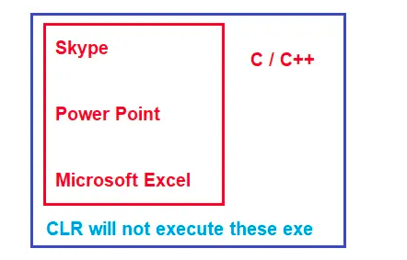

When you use these “EXEs” in your application, then these are not run by CLR. Even though you are running these “EXE” in dot net applications, they are going to run under their own environment. For example, if one EXE is developed using C or C++, then that EXE will run under the C or C++ runtime environment. In the same line, if the EXE is created using VB6, then it is going to run under the VB6 runtime environment.

##### **What Exactly is the Managed and Unmanaged Code in .NET?**

The codes which run under the complete control of CLR are called Managed Code in .NET Framework. These kinds of code (Managed code in C#) are run by a dot net runtime environment. If the dot net framework is not installed or if dot net runtime is not available, then these kinds of codes are not going to be executed. CLR will provide all the facilities and features of .NET to the managed code execution like Language Interoperability, Automatic Memory Management, Exception Handling Mechanism, Code Access Security, etc.

On the other hand, Skype, PowerPoint, and Microsoft Excel do not require dot net runtime, they run under their own environment. So, in short, the code (EXE, Web App) which not run under the control of CLR is called unmanaged code in .NET. CLR will not provide any facilities and features of .NET to the unmanaged code in C# execution like Language Interoperability, Automatic memory management, Exception handling mechanism, code access security, etc.

##### **Garbage Collection Generations in C#.NET:**

Let us understand what Garbage Collector Generations are and how does it affect Garbage Collection performance. There are three generations. They are Generation 0, Generation 1, and Generation 2.

##### **Understanding Generation 0, 1, and 2:**

Let’s say you have a simple application called App1. As soon as the application starts it creates 5 managed objects. Whenever any new objects (fresh objects) are created, they are moved into a bucket called Generation 0. For better understanding please have a look at the following image.

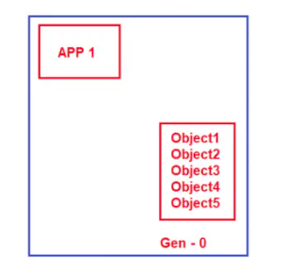

We know our hero Mr. Garbage Collector runs continuously as a background process thread to check whether there are any unused managed objects so that it reclaims the memory by cleaning those objects. Now, let’s say two objects (Object1 and Object2) are not needed by the application. So, Garbage Collector will destroy these two objects (Object1 and Object2) and reclaims the memory from Generation 0 bucket. But the remaining three objects (Object3, Object4, and Object5) are still needed by the application. So, the Garbage collector will not clean those three objects. What Garbage Collector will do is, he will move those three managed objects (Object3, Object4, and Object5) to Generation 1 bucket as shown in the below image.

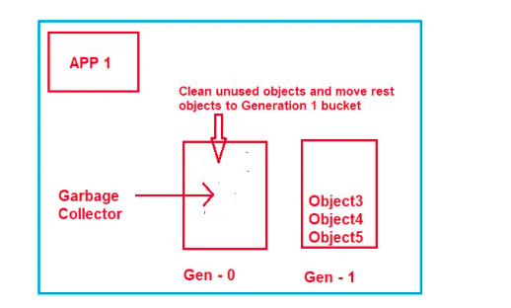

Now, let’s say your application creates two more fresh objects (Object6 and Object7). As fresh objects, they should be created in Generation 0 bucket as shown in the below image.

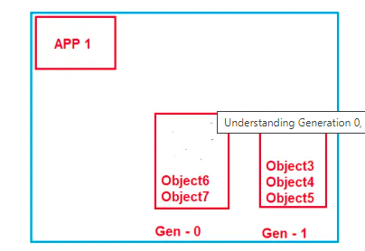

Now, again Garbage Collector runs and it comes to Generation 0 bucket and checks which objects are used. Let’s say both objects (Object6 and Object7) are unused by the application, so it will remove both objects and reclaims the memory. Now, it goes to the Generation 1 bucket, and checks which objects are unused. Let’s say Object4 and Object5 are still needed by the application while object3 is not needed. So, what Garbage Collector will do is, it will destroy Object3 and reclaims the memory as well as will move Object4 and Object5 to Generation 2 bucket which is shown in the below image.

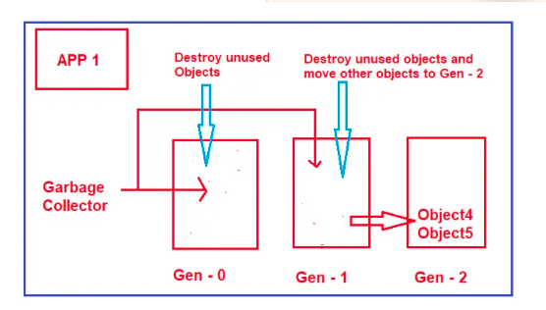

##### **What are Generations?**

Generations are nothing but, will define how long the objects are staying in the memory. Now the question that should come to your mind is why do we need Generations? Why do we have three different kinds of generations?

##### **Why do we need Generations?**

Normally, when we are working with big applications, they can create thousands of objects. So, for each of these objects, if the garbage collector goes and checks if they are needed or not, it’s really painful or it’s a bulky process. By creating such generations what does it mean if an object in Generation 2 buckets means the Garbage Collector will do fewer visits to this bucket? The reason is that if an object moves to Generation 2, it means it will stay more time in the memory. It’s no point going and checking them again and again.

So, in simple words, we can say that Generations 0, 1, and 2 will helps to increase the performance of the Garbage Collector. The more the objects in Gen 0, the better the performance and the more the memory will be utilized in an optimal manner.

**Note:**To give better clarity about the generations we are going to use a tool called **.NET Memory Profiler**. Now, I will show you how to download, install and use .NET Memory Profiler with C# Console Application to check and see how the objects are created in the different generations of Garbage Collector.

##### **What is .NET Memory Profiler?**

.NET Memory Profiler is a powerful tool for finding memory leaks and optimizing the memory usage in programs written in C#, VB.NET, or any other .NET Language. With the help of the profiling guides, the automatic memory analyzer, and specialized trackers, you can make sure that your program has no memory or resource leaks, and that the memory usage is as optimal as possible.

##### **How to Download .NET Memory Profiler?**

To download .NET Memory Profiler, please visit the following link.

[**https://memprofiler.com/**](https://memprofiler.com/)

Once you click on the above link, it will open the following webpage. From the below Page, click on the **Download Free Trial** button as shown in the below image.

Once you click on the **Download Free Trial** button, it will open another page where it is asking you to enter your email address. If you want you can enter the email address else simply click on the Download button which will download the .NET Memory Profiler as shown in the below image.

Once you click on the Download button, it will download the .NET Memory Profiler EXE and once you download the .NET Memory Profiler EXE, then click on the downloaded EXE file to install it. Once you click on the EXE file, it will open the following License Agreement Window. Simply check the checkbox and click on the Next button as shown in the below image.

Once you click on the Next button it will open the following Integrate with Visual Studio window. As I have installed Visual Studio 2017, 2019, and 2022, it shows me all the options and I want to use this .NET Memory Profiler with all the versions. So, I checked all the checkboxes and then click on the Next button as shown in the below image.

##### **Creating a C# Console Application:**

Now, create a console application with the name **GarbageCollectionDemo** in the **D:\Projects\** directory using C# Language as shown in the below image.

Now, copy and paste the following code into the Program class. Please note here we are not using a destructor.

using System;

namespace GarbageCollectionDemo

{

class Program

{

static void Main(string[] args)

{

for (int i = 0; i <= 1000000; i++)

{

MyClass1 obj1 = new MyClass1();

MyClass2 obj2 = new MyClass2();

MyClass3 obj3 = new MyClass3();

}

Console.Read();

}

}

public class MyClass1

{

}

public class MyClass2

{

}

public class MyClass3

{

}

}

Now, build the solution and make sure there are no errors. Now, we will run this application using .NET Memory Profiler and will see the different generations of Garbage Collectors.

##### **ow to use .NET Memory Profiler to Run C# Console Application?**

Open .NET Memory Profiler and once you open you will get the following window. From this window, click on the Profile Application option as shown in the below image.

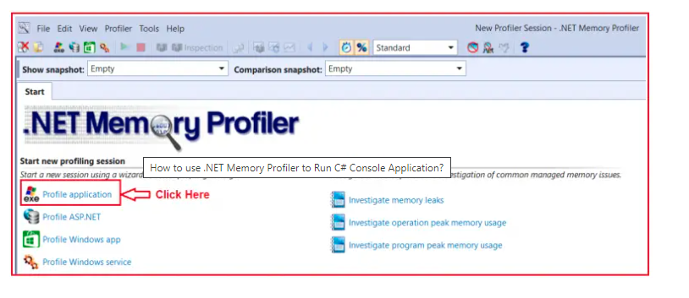

Once you click on the Profile Application Option, it will open the below window. From this window, click on the Browse button as shown in the below image.

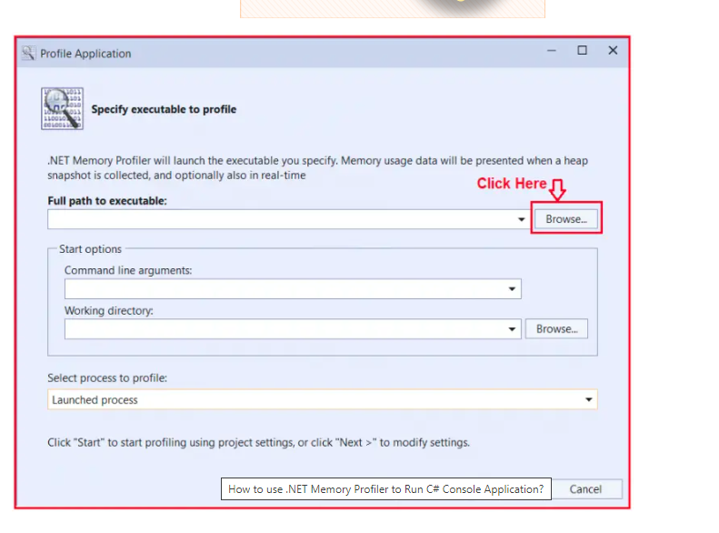

Once you click on the Browse button, select the EXE i.e. present inside the **Bin=>Deubg** folder or your project, and click on the Open Folder as shown in the below image.

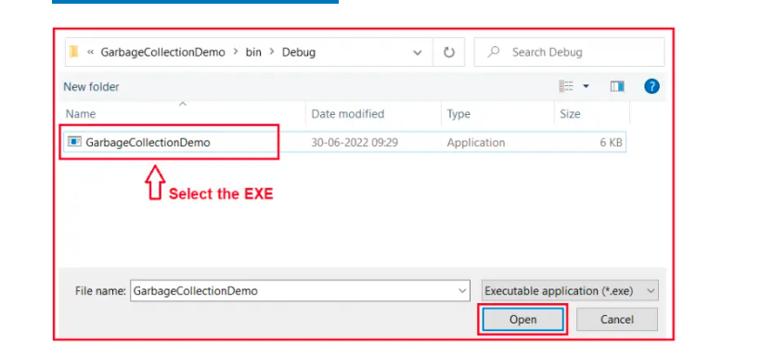

Once you click on the Open button, it will take you back to the Profile Application window and here, you just need to click on the Start button as shown in the below image.

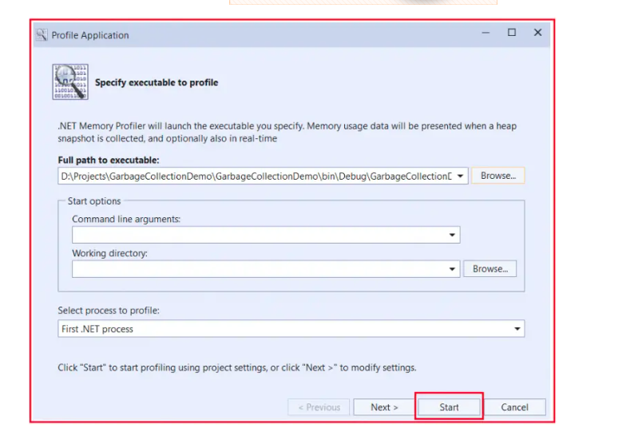

Once you click on the Start button, it will start executing your console application and you can also observe the generations. You can see most of the objects are in generation 0.

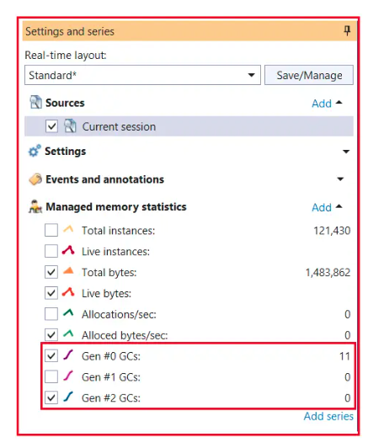

So, the more objects in generation 0 are the better the performance and the more the memory will be utilized in an optimal manner.

##### **How do using a Destructor in a Class end up in a Double Garbage Collector Loop?**

As we already discussed garbage collectors will only clean up the managed code. In other words, for any kind of unmanaged code, for those codes to clean up has to be provided by unmanaged code, and the garbage collector does not have any control over them to clean up the memory.

For example, let’s say you have a class called MyClass in VB6, then you have to expose some function let’s say CleanUp() and in that function, you have to write the logic to clean up the unmanaged code. From your dot net code, you simply need to call that method (CleanUp()) to initiate the clean-up.

The location from where you would like to call the Clean-Up is the destructor of a class. This looks to be the best place to write the clean-up code. But, there is a big problem associated with it when you write clean-up in a destructor. Let us understand what the problem is.

When you define a destructor in your class, the Garbage Collector before destroying the object, will go and ask the question to class, do you have a destructor, if you have a destructor, then move the object to the next generation bucket. In other words, it will not clean up the object having a destructor at that moment itself even though it is not used. So, it will wait for the destructor to run, and then it will go and clean up the object. Because of this, you will find more objects in generation 1 and Generation 2 as compared to Generation 0.

##### **Example using Destructor to Destroy the Unmanaged Resources:**

Please have a look at the below code. This is the same example as the previous one except we have added the respective destructors in the class.

using System;

namespace GarbageCollectionDemo

{

class Program

{

static void Main(string[] args)

{

for (int i = 0; i <= 1000000; i++)

{

MyClass1 obj1 = new MyClass1();

MyClass2 obj2 = new MyClass2();

MyClass3 obj3 = new MyClass3();

}

Console.Read();

}

}

public class MyClass1

{

~MyClass1()

{

//Here, you need to write the code for

//Unmanaged resource clean up

}

}

public class MyClass2

{

~MyClass2()

{

//Here, you need to write the code for

//Unmanaged resource clean up

}

}

public class MyClass3

{

~MyClass3()

{

//Here, you need to write the code for

//Unmanaged resource clean up

}

}

}

Now, rebuild the solution. Now, close .NET Memory Profile and follow the same steps to run the console application using this .NET Memory Profiler. This time you will observe that some of the objects are in generation 1 also as shown in the below image.

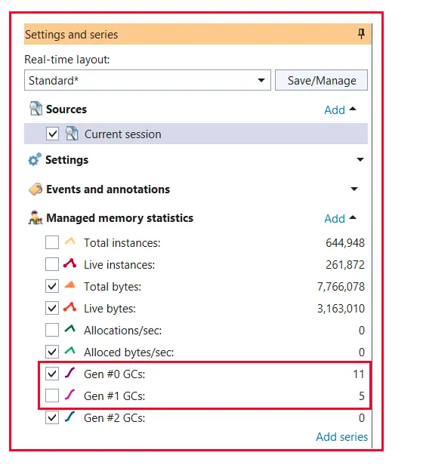

So, if you are writing the clean-up code in your destructor, then you will end up creating objects in Generation 1 and Generation 2 which means you are not utilizing the memory properly.

##### **How to Overcome the above Problem?**

This problem can be overcome by using something called Finalized Dispose pattern. In order to implement this, your class should implement the IDisposable interface and provide the implementation for the Dispose method. Within the Dispose method, you need to write the clean-up code for unmanaged objects and in the end, you need to call GC.SuppressFinalize(true) method by passing true as the input value. This method tells suppresses any kind of destructor and just goes and cleans up the objects. For a better understanding, please have a look at the following image.

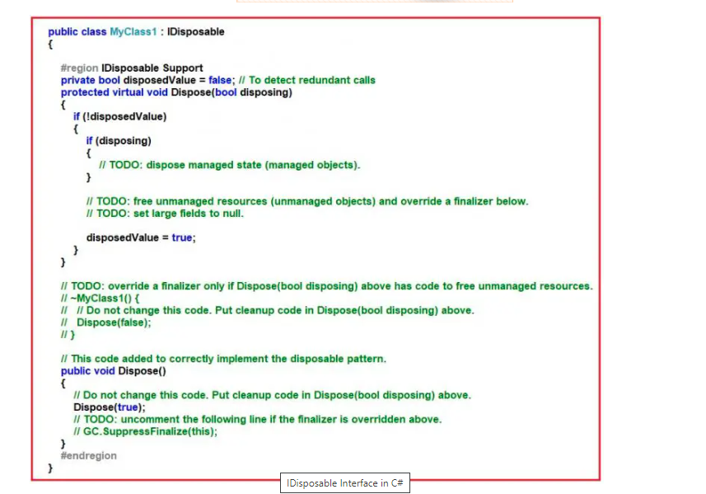

Once you have used to object, then you need to call the Dispose method so that the double garbage collector loop will not happen as shown below.

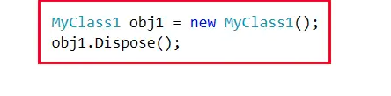

##### **Example using Dispose Pattern to Destroy the Unmanaged Object in C#:**

using System;

namespace GarbageCollectionDemo

{

class Program

{

static void Main(string[] args)

{

for (int i = 0; i <= 1000000; i++)

{

MyClass1 obj1 = new MyClass1();

obj1.Dispose();

MyClass2 obj2 = new MyClass2();

obj2.Dispose();

MyClass3 obj3 = new MyClass3();

obj3.Dispose();

}

Console.Read();

}

}

public class MyClass1 : IDisposable

{

#region IDisposable Support

private bool disposedValue = false; // To detect redundant calls

protected virtual void Dispose(bool disposing)

{

if (!disposedValue)

{

if (disposing)

{

// TODO: dispose managed state (managed objects).

}

// TODO: free unmanaged resources (unmanaged objects) and override a finalizer below.

// TODO: set large fields to null.

disposedValue = true;

}

}

// TODO: override a finalizer only if Dispose(bool disposing) above has code to free unmanaged resources.

~MyClass1()

{

// Do not change this code. Put cleanup code in Dispose(bool disposing) above.

Dispose(false);

}

// This code added to correctly implement the disposable pattern.

public void Dispose()

{

// Do not change this code. Put cleanup code in Dispose(bool disposing) above.

Dispose(true);

// TODO: uncomment the following line if the finalizer is overridden above.

GC.SuppressFinalize(this);

}

#endregion

}

public class MyClass2 : IDisposable

{

#region IDisposable Support

private bool disposedValue = false; // To detect redundant calls

protected virtual void Dispose(bool disposing)

{

if (!disposedValue)

{

if (disposing)

{

}

disposedValue = true;

}

}

// TODO: override a finalizer only if Dispose(bool disposing) above has code to free unmanaged resources.

~MyClass2()

{

// Do not change this code. Put cleanup code in Dispose(bool disposing) above.

Dispose(false);

}

// This code added to correctly implement the disposable pattern.

public void Dispose()

{

// Do not change this code. Put cleanup code in Dispose(bool disposing) above.

Dispose(true);

// TODO: uncomment the following line if the finalizer is overridden above.

GC.SuppressFinalize(this);

}

#endregion

}

public class MyClass3 : IDisposable

{

#region IDisposable Support

private bool disposedValue = false;

protected virtual void Dispose(bool disposing)

{

if (!disposedValue)

{

if (disposing)

{

}

disposedValue = true;

}

}

~MyClass3()

{

Dispose(false);

}

public void Dispose()

{

Dispose(true);

GC.SuppressFinalize(this);

}

#endregion

}

}

Now, rebuild the solution. Close .NET Memory Profile and follow the same steps to run the console application using this .NET Memory Profiler. This time you will observe that the objects are created in generation 0 only which improves the performance of your application by utilizing the memory effectively.

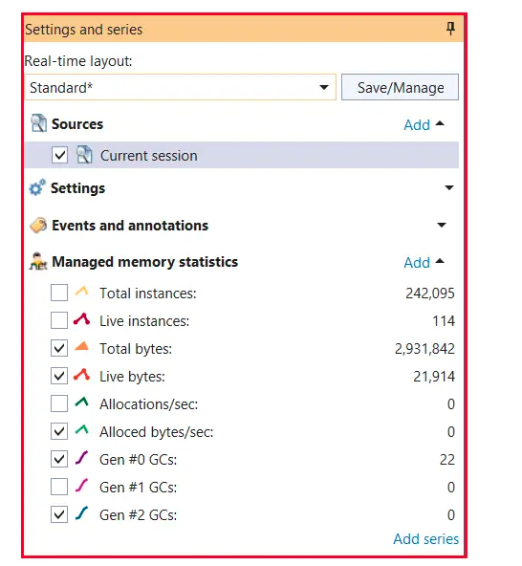

Now, the question that should come to your mind is why the destructor is there. The reason is as a developer you may forget to call the Dispose method once you use the object. In that case, the destructor will invoke and it will go and clean up the object.

## **Abstraction in C# with Real-Time Examples**

In this article, I am going to discuss **Abstraction in C#** with Real-Time Examples. Please read our previous article before proceeding to this article where we discussed [**Encapsulation in C#**](https://dotnettutorials.net/lesson/encapsulation-csharp/) with Examples. Abstraction in C# is one of the fundamental OOPs principles which acts as a supporting principle. That means the Abstraction Principle in C# makes sure that all other three principles (Encapsulation, Polymorphism, and Inheritance) are working together to give the final shape of the project.

##### **What is Abstraction in C#?**

The process of representing the essential features without including the background details is called Abstraction. In simple words, we can say that it is a process of defining a class by providing necessary details to call the object operations (i.e. methods) by hiding its implementation details is called abstraction in C#. It means we need to expose what is necessary and compulsory and we need to hide the unnecessary things from the outside world.

Programmatically we can define abstraction as the process of hiding implementation details of the object’s feature and showing only the essential information of the feature to the user. Abstraction lets you focus more on what an object does rather than how it does. That means what are the services available as part of the class, that we need to expose but how the services are implemented that we need to hide. Now, let us try to understand the concept abstraction principle with some real-time examples.

##### **Real-Time Example of Abstraction**

To take a real-time example, when we log in to any social networking site like Facebook, Twitter, LinkedIn, etc. we enter our user id and password and then we get logged in. Here we don’t know how they are processing the data or what logic or algorithm they are using for login. This information is abstracted/hidden from us since they are not essential to us. This is basically what abstraction is.

Another real-time example is an ATM machine. We all use the ATM machine for cash withdrawals, money transfers, retrieving min-statement, etc. in our daily life. But we don’t know internally what things are happening inside an ATM machine when we insert an ATM card for performing different kinds of operations. Information like where the server is, where the database server is, what programming language they use to write the logic, how they are validating the data, how they are implementing logic for various kinds of operations, and what SQL statements get executed on the database when we perform any operations, all these things are hidden from us. What they provide as part of the ATM machine is services (cash withdrawal, money transfer, retrieving min-statement, etc) but how these services are implemented is abstracted to us.

Another real-world example of abstraction could be your TV remote. The remote has different functions like on/off, changing the channel, increasing/decreasing volume, etc. You can use these functionalities by just pressing the button. But, the internal mechanism of these functionalities is abstracted from us as those are not essential for us to know.

Another example of abstraction is when you send SMS from your mobile, you only type the text and send the message. But you don’t know the internal processing or mechanism of the message delivery system. This is nothing but abstraction.

So, in simple words, we can say that abstraction means providing the necessary details to use the services or functionalities but how the services are implemented internally that you need to hide.

##### **Example to Understand Abstraction Principle in C#:**

Now, we are going to develop one application to implement the Banking functionality. First, we will develop the application without following the Abstraction Principle and then we will understand the problems then we will see what are the different mechanisms to implement the abstraction principle in C#. So, what we will do is, we will create two classes. One class is for SBI bank and another class is for AXIX Bank. As part of each class, we are going to provide 5 services, which are as follows:

1. ValidateCard
2. WithdrawMoney
3. CheckBalanace
4. BankTransfer
5. MiniStatement

Then from the Main method, we will create the instances of each class and will invoke the respective services i.e. respective methods. Here, you can consider the Main method is the user who is going to use the services provided by the Bank classes.

using System;

namespace GarbageCollectionDemo

{

class Program

{

static void Main(string[] args)

{

Console.WriteLine("Transaction doing SBI Bank");

SBI sbi = new SBI();

sbi.ValidateCard();

sbi.WithdrawMoney();

sbi.CheckBalanace();

sbi.BankTransfer();

sbi.MiniStatement();

Console.WriteLine("\nTransaction doing AXIX Bank");

AXIX AXIX = new AXIX();

AXIX.ValidateCard();

AXIX.WithdrawMoney();

AXIX.CheckBalanace();

AXIX.BankTransfer();

AXIX.MiniStatement();

Console.Read();

}

}

public class SBI

{

public void BankTransfer()

{

Console.WriteLine("SBI Bank Bank Transfer");

}

public void CheckBalanace()

{

Console.WriteLine("SBI Bank Check Balanace");

}

public void MiniStatement()

{

Console.WriteLine("SBI Bank Mini Statement");

}

public void ValidateCard()

{

Console.WriteLine("SBI Bank Validate Card");

}

public void WithdrawMoney()

{

Console.WriteLine("SBI Bank Withdraw Money");

}

}

public class AXIX

{

public void BankTransfer()

{

Console.WriteLine("AXIX Bank Bank Transfer");

}

public void CheckBalanace()

{

Console.WriteLine("AXIX Bank Check Balanace");

}

public void MiniStatement()

{

Console.WriteLine("AXIX Bank Mini Statement");

}

public void ValidateCard()

{

Console.WriteLine("AXIX Bank Validate Card");

}

public void WithdrawMoney()

{

Console.WriteLine("AXIX Bank Withdraw Money");

}

}

}

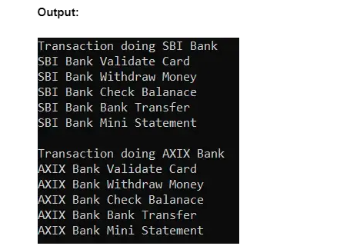

That is fine. We are getting output as expected. Then what is the problem with the above implementation? The problem is the user of our application accesses the SBI and AXIX classes directly. Directly means they can go to the class definition and see the implementation details of the methods. That is the user will come to know how the services or methods are implemented. This might cause security issues. We should not expose our implementation details to the outside.

##### **How to Implement Abstraction Principle in C#?**

In C#, we can implement the abstraction OOPs principle in two ways. They are as follows:

1. **Using Interface**
2. **Using Abstract Classes and Abstract Methods**
3. What are [**Interfaces**](https://dotnettutorials.net/lesson/inheritance-c-sharp/) and what are [**Abstract Methods and Abstract Classes**](https://dotnettutorials.net/lesson/abstract-class-abstract-methods-csharp/) that we will discuss in detail in our upcoming article? But for now, you just need to understand one thing, both interface and abstract classes and abstract methods provide some mechanism to hide the implementation details by only exposing the services. The user only knows what are services or methods available but the user will not know how these services or methods are implemented. Let us see this with examples.

##### **Example to Implement Abstraction Principle in C# using Interface:**

1. In the below example, I am using an interface to achieve the abstraction principle in C#. Using the interface, we can achieve 100% abstraction. Now, the user will only know the services which are defined in the interface but how the services are implemented, the user will never know. This is how we can implement abstraction in C# by hiding the implementation details from the user. Here, the user will only know about IBank, but the user will not know about the SBI and AXIX Classes

using System;

namespace GarbageCollectionDemo

{

class Program

{

static void Main(string[] args)

{

Console.WriteLine("Transaction doing SBI Bank");

IBank sbi = BankFactory.GetBankObject("SBI");

sbi.ValidateCard();

sbi.WithdrawMoney();

sbi.CheckBalanace();

sbi.BankTransfer();

sbi.MiniStatement();

Console.WriteLine("\nTransaction doing AXIX Bank");

IBank AXIX = BankFactory.GetBankObject("AXIX");

AXIX.ValidateCard();

AXIX.WithdrawMoney();

AXIX.CheckBalanace();

AXIX.BankTransfer();

AXIX.MiniStatement();

Console.Read();

}

}

public interface IBank

{

void ValidateCard();

void WithdrawMoney();

void CheckBalanace();

void BankTransfer();

void MiniStatement();

}

public class BankFactory

{

public static IBank GetBankObject(string bankType)

{

IBank BankObject = null;

if (bankType == "SBI")

{

BankObject = new SBI();

}

else if (bankType == "AXIX")

{

BankObject = new AXIX();

}

return BankObject;

}

}

public class SBI : IBank

{

public void BankTransfer()

{

Console.WriteLine("SBI Bank Bank Transfer");

}

public void CheckBalanace()

{

Console.WriteLine("SBI Bank Check Balanace");

}

public void MiniStatement()

{

Console.WriteLine("SBI Bank Mini Statement");

}

public void ValidateCard()

{

Console.WriteLine("SBI Bank Validate Card");

}

public void WithdrawMoney()

{

Console.WriteLine("SBI Bank Withdraw Money");

}

}

public class AXIX : IBank

{

public void BankTransfer()

{

Console.WriteLine("AXIX Bank Bank Transfer");

}

public void CheckBalanace()

{

Console.WriteLine("AXIX Bank Check Balanace");

}

public void MiniStatement()

{

Console.WriteLine("AXIX Bank Mini Statement");

}

public void ValidateCard()

{

Console.WriteLine("AXIX Bank Validate Card");

}

public void WithdrawMoney()

{

Console.WriteLine("AXIX Bank Withdraw Money");

}

}

}

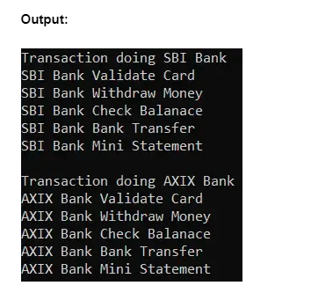

##### **Example to Implement Abstraction Principle in C# using Abstract Class and Abstract Methods:**

In the below example, we are using abstract class and abstract methods to achieve the abstraction principle in C#. Using the abstract class and abstract methods, we can achieve 0 to 100% abstraction. In the below example, the user will only know the services which are defined in the abstract class but how these services are implemented, the user will never know. This is how we can implement abstraction in C# by hiding the implementation details from the user.

using System;

namespace GarbageCollectionDemo

{

class Program

{

static void Main(string[] args)

{

Console.WriteLine("Transaction doing SBI Bank");

IBank sbi = BankFactory.GetBankObject("SBI");

sbi.ValidateCard();

sbi.WithdrawMoney();

sbi.CheckBalanace();

sbi.BankTransfer();

sbi.MiniStatement();

Console.WriteLine("\nTransaction doing AXIX Bank");

IBank AXIX = BankFactory.GetBankObject("AXIX");

AXIX.ValidateCard();

AXIX.WithdrawMoney();

AXIX.CheckBalanace();

AXIX.BankTransfer();

AXIX.MiniStatement();

Console.Read();

}

}

public abstract class IBank

{

public abstract void ValidateCard();

public abstract void WithdrawMoney();

public abstract void CheckBalanace();

public abstract void BankTransfer();

public abstract void MiniStatement();

}

public class BankFactory

{

public static IBank GetBankObject(string bankType)

{

IBank BankObject = null;

if (bankType == "SBI")

{

BankObject = new SBI();

}

else if (bankType == "AXIX")

{

BankObject = new AXIX();

}

return BankObject;

}

}

public class SBI : IBank

{

public override void BankTransfer()

{

Console.WriteLine("SBI Bank Bank Transfer");

}

public override void CheckBalanace()

{

Console.WriteLine("SBI Bank Check Balanace");

}

public override void MiniStatement()

{

Console.WriteLine("SBI Bank Mini Statement");

}

public override void ValidateCard()

{

Console.WriteLine("SBI Bank Validate Card");

}

public override void WithdrawMoney()

{

Console.WriteLine("SBI Bank Withdraw Money");

}

}

public class AXIX : IBank

{

public override void BankTransfer()

{

Console.WriteLine("AXIX Bank Bank Transfer");

}

public override void CheckBalanace()

{

Console.WriteLine("AXIX Bank Check Balanace");

}

public override void MiniStatement()

{

Console.WriteLine("AXIX Bank Mini Statement");

}

public override void ValidateCard()

{

Console.WriteLine("AXIX Bank Validate Card");

}

public override void WithdrawMoney()

{

Console.WriteLine("AXIX Bank Withdraw Money");

}

}

}

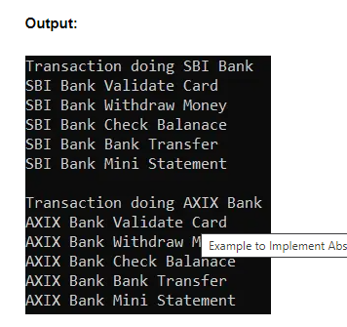

**Note:** Using abstract class we can achieve 0 to 100% abstraction. The reason is, that you can also provide implementation to the methods inside the abstract class. It does not matter whether you implement all methods or none of the methods inside the abstract class. This is allowed which is not possible with an interface.

##### **Encapsulation vs Abstraction in C#**

1. The Encapsulation Principle is all about data hiding (or information hiding). On the other hand, the Abstraction Principle is all about detailed hiding (implementation hiding).
2. Using the Encapsulation principle, we can protect our data i.e. from outside the class, nobody can access the data directly. We are exposing the data through publicly exposed methods and properties. The advantage is that we can validate the data before storing and returning it. On the other hand, using the Abstraction Principle, we are exposing only the services so that the user can consume the services but how the services/methods are implemented is hidden from the user. The user will never know, how the method is implemented.
3. With the Encapsulation Principle, we group data members and member functions into a single unit called class, interface, enum, etc. On the other hand, with the Abstraction Principle, we are exposing the interface or abstract class to the user and hiding implementation details i.e. hiding the child class information.
4. We can implement Encapsulation by declaring the data members as private and exposing the data members only through public exposed methods and properties with proper validation. On the other hand, we can implement abstraction through abstract classes and interfaces.
5. In abstraction, only the abstract view is presented to the user while complex and detailed data is hidden from the user. On the other hand, in encapsulation, data member and member functions are bundled as a single unit and can be protected or made accessible using access modifiers and getter and setter methods.
6. Abstraction in C# is used to hide unwanted data and shows only the required properties and methods to the user. Encapsulation in C# is used to bind data members and member functions into a single unit to prevent outsiders from accessing it directly.

##### **Advantages of Abstraction Principle in C#**

1. The Abstraction Principle reduces the complexity of viewing things. It only provides the method signature by hiding how the method is actually implemented.
2. The Abstraction Principle helps to increase the security of an application or program as we are only providing the necessary details to call the method by hiding how the methods are actually implemented.
3. With the Abstraction Principle, the enhancement will become very easy because without affecting end-users we can able to perform any type of changes in our internal system.
4. Without the Abstraction principle, maintaining application code is very complex. Abstraction gives one structure to program code.

##### **What is Inheritance in C#?**

Inheritance in C# is a mechanism of consuming the members that are defined in one class from another class. See, we are aware that a class is a collection of members. And the members defined in one class can be consumed from another class by establishing a parent/child relationship between the classes.

Generally, all of us know one thing that all of our parent properties belong to us. So, children get rights on the Parent’s property. Why, because this is a law. According to the law, all the properties of parents belong to their children.

Exactly the same principle is applied in inheritance. Suppose, I have a class (A) with a set of members and I want the same members in another class (B). One way to do this is, I need to copy and paste the same code from class A into class B. But if we copy and paste the code, then it is called rewriting the code. Rewriting the code has an impact on the size of the application. If the size of the application grows, ultimately it will affect the performance of the application.

So, if you want to overcome that rewriting process, and reuse the code, the best option that is available for us is Inheritance in C#. Simply. what we need to do is, established a Relation between the two classes. What relation? Parent/Child relation. Once you established the parent/child relationship, then all the members of the parent class (A) can be consumed under the child class (B). For a better understanding, please have a look at the following diagram.

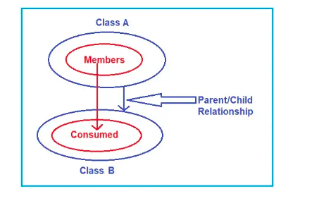

So, Inheritance in C# is a mechanism of consuming the members of one class in another class by establishing a parent/child relationship between the classes which provides re-usability.

##### **How to Implement Inheritance in C#?**

To Implement Inheritance in C#, we need to establish a Parent/Child relationship between classes. Let us understand how to establish a Parent/Child relationship in C#. Suppose we have a class called A with a set of members. And we have another class B and we want this class B to be inherited from class A. The following code shows how to establish the Parent-Child relationship between class A and Class B.

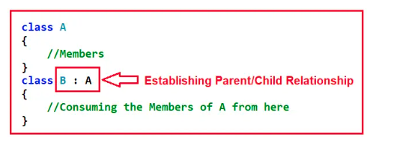

So, this is the basic process for establishing a Parent/Child relationship in C#. Now, let us see the basic syntax to establish a Parent/Child relationship between classes. The syntax is given below.

**[<modifiers>] class <child class> : <parent class>**

Here, the terminology Parent class and Child Class can also be called Base Class (Superclass) and Derived Class (Subclass). So, in our example,  
A => Parent/ Base/ Superclass (all are meaning the same; you can use any term)  
B => Child/ Derived/ Subclass (all are meaning the same; you can use any term)

**Note:** In Inheritance, the Child class can consume members of its Parent class as if it is the owner of those members (expect private members of the parent).

##### **Why Child Cannot Consume Private Members of Parent?**

Generally, Children have rights to their Parent’s Property. As a Child, tomorrow I can take over my father’s business. I can take over my Father’s Properties (Car, Buildings, Money, whatever it is). But I cannot take over my father’s job. The reason is the Job whatever my father is doing may be based on his qualifications and his experiences. And tomorrow I cannot take over his particular job. So, the Job is completely private to my father. And that is not inherited to me. But remain everything, business, money, properties, whatever I will take. Take over everything except the private members.

The same principle is also applied to Inheritance. So, the child class will consume all the members of the Parent class except the private members.

##### **Example to Understand Inheritance in C#:**

Let us see a simple example to understand Inheritance in C#. Let us create a class, with two methods as shown below.

class A

{

public void Method1()

{

Console.WriteLine("Method 1");

}

public void Method2()

{

Console.WriteLine("Method 2");

}

}

Here, we have created class A with two public methods i.e. Method1 and Method2. Now, I want the same two methods in another class i.e. class B. One way to do this is to copy the above two methods and paste them into class B as follows.

class B

{

public void Method1()

{

Console.WriteLine("Method 1");

}

public void Method2()

{

Console.WriteLine("Method 2");

}

}

If we do this, then it is not code re-usability. It is code rewriting that affects the size of the application. So, without rewriting what we need to do is, we need to perform inheritance here as follows. Here, class B is inherited from class A and hence inside the Main method, we create an instance of class B and invoke the methods which are defined in Class A.

class B : A

{

static void Main()

{

B obj = new B();

obj.Method1();

obj.Method2();

}

}

Once you perform the Inheritance, class B can take the two members defined in class A. Why? Because all the properties of a Parent belong to Children. Here, class A is the Parent/Super/Base class and Class B is the Child/Sub/Derived class.

Let us understand one more thing. Please observe the following image. When we say obj. you can see the intelligence it is showing the two Methods i.e. Method1 and Method2. So, the child class can consume the members of the parent class as if it is the owner. Now, if you see the description of either Method1 or Method2, it is showing void A.Method1() and void A.Method2(). That means Method1 or Method2 belongs to class A only. But class B can consume the member as if it is the owner. See, I can drive my father’s car as if I am the owner, but still, the registration name is my father. Similarly, class B can call the methods as the method is it’s own but internally the methods belong to Class A.

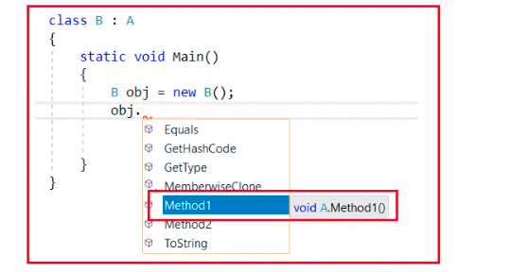

The complete code example is given below. In the below example, class A defined two members, and class B is inherited from Class A. In class B, within the Main method, we created an instance of class B and called the two methods.

using System;

namespace InheritanceDemo

{

class A

{

public void Method1()

{

Console.WriteLine("Method 1");

}

public void Method2()

{

Console.WriteLine("Method 2");

}

}

class B : A

{

static void Main()

{

B obj = new B();

obj.Method1();

obj.Method2();

Console.ReadKey();

}

}

}

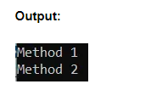

Now, let us add a new method i.e. Method3 in Class B as follows. And inside the Main method if you see the method description it is showing that the method belongs to class B.

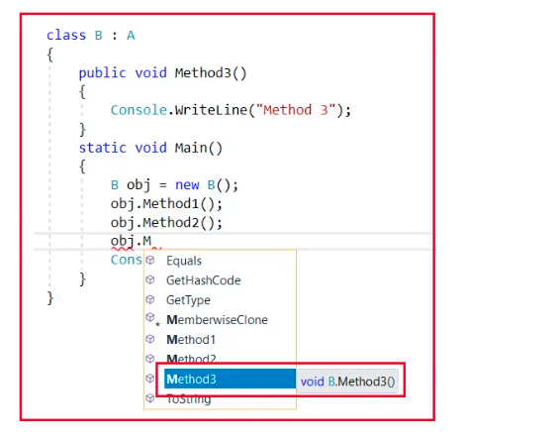

**The complete example is given below.**

using System;

namespace InheritanceDemo

{

class A

{

public void Method1()

{

Console.WriteLine("Method 1");

}

public void Method2()

{

Console.WriteLine("Method 2");

}

}

class B : A

{

public void Method3()

{

Console.WriteLine("Method 3");

}

static void Main()

{

B obj = new B();

obj.Method1();

obj.Method2();

obj.Method3();

Console.ReadKey();

}

}

}

##### 

##### **How many methods are there in class B?**

Now, you may have one question, how many methods are there in class B? The answer is 3. See all the properties that my father has given to me plus all the properties that I am earning are whole my property only. So, what is my property means I don’t say what I earned, I also say what my father has given to me. So, in the same way, how many methods are there in class B means 3 methods. Two methods were inherited from the parent class A plus one method which we defined in class B. So, we can say Class A contains two methods and class B contains 3 methods.

This is the simple process of Inheritance in C#. Simply put a colon (:) between the Parent and Child class. But when you are working with Inheritance 6 things or rules are required to learn and remember. Let us learn those 6 important Rules one by one.

##### **Rule1:**

In C#, the parent classes constructor must be accessible to the child class, otherwise, the inheritance would not be possible because when we create the child class object first it goes and calls the parent class constructor so that the parent class variable will be initialized and we can consume them under the child class.

Right now, in our example, both class A and class B have implicitly constructors. Yes, every class in C# contains an implicit constructor if as a developer we did not define any constructor explicitly. We already learned it in our constructor section.

If a constructor is defined implicitly, then it is a public constructor. In our example, class B can access class A implicitly constructor as it is public. Now, let us define one explicit constructor in Class A as follows.

class A

{

public A()

{

Console.WriteLine("Class A Constructor is Called");

}

public void Method1()

{

Console.WriteLine("Method 1");

}

public void Method2()

{

Console.WriteLine("Method 2");

}

}

With the above changes in place, if you run the application code, you will get the following output.

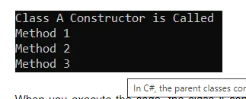

When you execute the code, the class A constructor is first called and that is what you can see in the output. Why? This is because, whenever the child class instance is created, the child class constructor will implicitly call its parent class constructors. This is a rule.

Right now, the child class contains an implicit constructor, and that implicit constructor calls the parent class constructor. But Parent class A constructor is not implicitly, it is explicitly now and inside that parent class constructor, we have written print statement and print statement printing some message on the console window.

But remember, if you are defining an explicit constructor, if you make that constructor private and if you don’t provide an access specifier then by default the class member’s access specifier is private in C#. For example, modify class A as follows. As you can see, we have removed the access specifier from the constructor which makes it private.

class A

{

A()

{

Console.WriteLine("Class A Constructor is Called");

}

public void Method1()

{

Console.WriteLine("Method 1");

}

public void Method2()

{

Console.WriteLine("Method 2");

}

}

As you can see in the code, the Class A constructor is private, so it is not accessible to class B. Now, if you try to run the code, you will get the following compile-time error as shown in the below image which tells **Class** **A Constructor is inaccessible due to its protection level**.

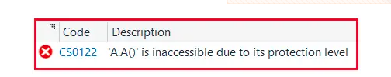

We are getting the above error because, when we create an instance of the child class, the child class constructor will implicitly call its parent class constructors. Right now, the class B constructor trying to call the Class A constructor which is not accessible because that constructor is private.

Let us do one more thing. Let us define a constructor in Class B also as follows. Let us make the class A constructor public otherwise, the inheritance would not be possible.

using System;

namespace InheritanceDemo

{

class A

{

public A()

{

Console.WriteLine("Class A Constructor is Called");

}

public void Method1()

{

Console.WriteLine("Method 1");

}

public void Method2()

{

Console.WriteLine("Method 2");

}

}

class B : A

{

B()

{

Console.WriteLine("Class B Constructor is Called");

}

public void Method3()

{

Console.WriteLine("Method 3");

}

static void Main()

{

B obj = new B();

obj.Method1();

obj.Method2();

obj.Method3();

Console.ReadKey();

}

}

}

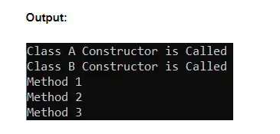 As you can see in the above output, first Class A constructor is called and then the class B constructor is called. So, the point that you need to remember is execution always starts from the Parent class constructor. Why? Because when we create an instance of a child class, the child class constructor will implicitly call the parent class constructor. If that Parent class has a Parent class, then that Parent class constructor will call its Parent class constructor, and so on. Suppose, you have 5 classes in inheritance, and if you are creating an instance of the 5th class, then the 5th class constructor will call the 4th class constructor and 4th class constructor will call the 3rd class constructor and the 3rd class constructor will call the 2nd class constructor and 2nd class constructor will call the 1st class constructor. So, the execution, in this case, will start from the class 1 constructor, then the class 2 constructor, and the last constructor, in this case, will be the 5th class constructor.

##### **Why Class B Constructor is not Public?**

Here, you may have one question the Class B constructor is not public. Why? See, the class B constructor does not need to be public why because the class A constructor should be accessible to B, not Class B to class A. When the class B constructor is to be public if Class B has a child class, then the class B constructor must be public. If class B does not have a child class, then there is no point in declaring the constructor as public. If you want then you can also declare the constructor as public. In this case, that’s not a matter at all.

So, always child class constructor implicitly calls the Parent class constructor, and hence the parent class constructor should be accessible to the child class otherwise inheritance would not be possible. Now, you may have one question why is the parent class constructor accessible to the child class?

##### **Why is Parent Class Constructor Accessible to Child Class?**

The reason is when the Parent class constructor is called, then only the parent class members will be initialized, and then only they can be consumed under the child class. If the parent class members are not initialized then you cannot consume them under the child class. If you want to consume them in the child class, they must be initialized. See, Child Class is dependent on Parent Class, so the Parent class must be initialized first, then only the consumption is possible in the child class.

This is the first rule of Inheritance. Let us proceed and understand the second rule of Inheritance in C# with examples.

##### **Rule2:**

In inheritance, the child class can access the parent class members but the parent classes can never access any members that are purely defined in the child class.

See, according to law, children have rights to their Parent’s Property. But the Parent does not have rights to the Children’s property. It is only the children’s responsibility to take care of their parents. But legally, the Parent does not have rights to the child’s property. Exactly, in the same way, the Parent class can never access the child class members which are purely defined in the child class.

Let us understand this with an example. Please have a look at the below code. Here, you can see inside the Main method we are creating an instance of Parent class i.e. A, and trying to invoke Parent class as well as child class methods. When we try to invoke the Method3 which is purely defined in the child class, we will get a compile-time error.

using System;

namespace InheritanceDemo

{

class A

{

public A()

{

Console.WriteLine("Class A Constructor is Called");

}

public void Method1()

{

Console.WriteLine("Method 1");

}

public void Method2()

{

Console.WriteLine("Method 2");

}

}

class B : A

{

public B()

{

Console.WriteLine("Class B Constructor is Called");

}

public void Method3()

{

Console.WriteLine("Method 3");

}

static void Main()

{

A obj = new A();

obj.Method1();

obj.Method2();

//The following line of code gives you compile time error

obj.Method3();

Console.ReadKey();

}

}

}

When you try to run the above code, you will get the following Compile Time Error.

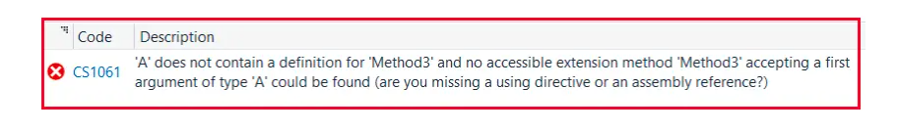

It is complaining that class **‘A’ does not contain a definition for ‘Method3’ and no accessible extension method ‘Method3’ accepting a first argument of type ‘A’ could be found (are you missing a using directive or an assembly reference?)** and this makes sense.

So, this is the second rule of inheritance that a Parent class can never access any members of the child class who are purely defined in the child class. In this case, Method3 is purely defined in the child class B and hence we can not access this method using the Parent class object.

##### **Rule3:**

We can Initialize a Parent class variable by using the child class instance to make it a reference variable so that the reference will be consuming the memory of the child class instance. But in this case, also, we cannot call any pure child class members using the reference.

Now, you may have one question, what is a reference? The answer is a Reference is a pointer to an instance that does not have any memory allocation.

Let us understand this with an example. Please have a look at the below code. Inside the Main method, first, we create a variable p of class A and here p is a reference variable., It’s not an instance, it’s a variable i.e. uninitialized copy

using System;

namespace InheritanceDemo

{

class A

{

public A()

{

Console.WriteLine("Class A Constructor is Called");

}

public void Method1()

{

Console.WriteLine("Method 1");

}

public void Method2()

{

Console.WriteLine("Method 2");

}

}

class B : A

{

public B()

{

Console.WriteLine("Class B Constructor is Called");

}

public void Method3()

{

Console.WriteLine("Method 3");

}

static void Main()

{

A p; //p is a variable of class A

p.Method1();

p.Method2();

Console.ReadKey();

}

}

}

Now, if try to run the above code, you will get the following Compile Time Error i.e. **Use of unassigned local variable ‘p’**.

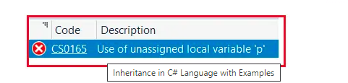

This makes sense. The variable p is unassigned and hence we can not call any methods. It is not initialized. How to Initialize a reference variable? Initialization can be done by using the new keyword in C#. Let us see this. In the below example we have initialized the parent class reference variable p using the child class instance and then call the parent class members. In the below example, the Main method code is self-explained, so please go through the comment lines.

using System;

namespace InheritanceDemo

{

class A

{

public A()

{

Console.WriteLine("Class A Constructor is Called");

}

public void Method1()

{

Console.WriteLine("Method 1");

}

public void Method2()

{

Console.WriteLine("Method 2");

}

}

class B : A

{

public B()

{

Console.WriteLine("Class B Constructor is Called");

}

public void Method3()

{

Console.WriteLine("Method 3");

}

static void Main()

{

A p; //p is a variable of class A

B q = new B(); //q is an instance of Class B

//We can initialize a Parent class variable using child class instance as follows

p = q; //now, p is a reference of parent class created by using child class instance

//Now you can call members of A class as follows

p.Method1();

p.Method2();

//We cannot call any pure child class members using the reference p

//p.Method3();

Console.ReadKey();

}

}

}

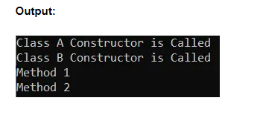

##### **So, what is a Reference in C#?**

References of a class will not have any memory allocation. They will be consuming the memory of the instance that is assigned to initialize them. For a better understanding, please have a look at the below diagram. Here, whenever we created an instance memory is allocated for q. And this instance will contain information about both Parent A and Child B classes. And p is a reference. And p is consuming the memory of q.

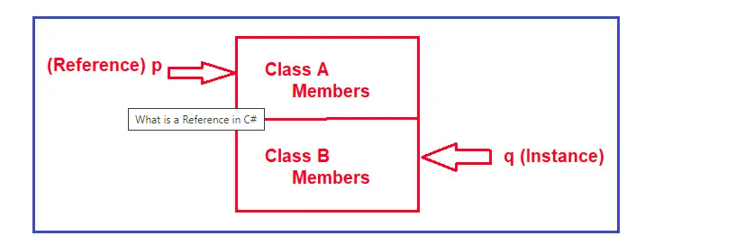

**Note:** The point that you need to remember is memory allocation is done for instances, not for references in C#. References are just pointers to instances.

Now, if observe both p and q are accessing the same memory. But the point to understand is that even though p and q are accessing the same memory, using p, I cannot call any child class members. See the following diagram. As you can see in the below diagram, using p we cannot call class B members but using q we can call both A and B class members.

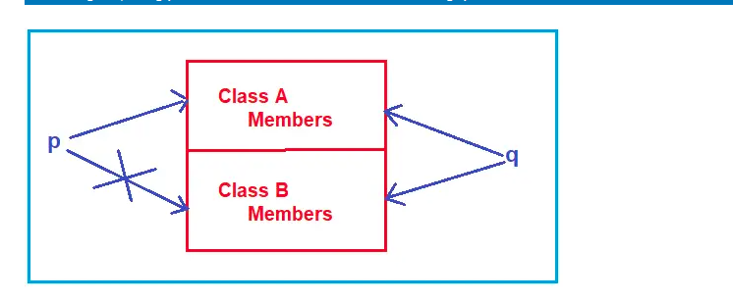

##### **Rule4:**

Every class that is defined by us or predefined in the libraries of the language has a default parent class i.e. Object class of the System namespace, so the members (Equals, GetHashCode, GetType, and ToString) of the Object class are accessible from anywhere.

Generally, when we defined a class, we think that we did not inherit it from any class. But by default, our class is Inherited from the Object class. So, Object is the parent class for all the classes defined in our Base Class Library as well as all the classes that we defined in our application.

Because Object is the parent class, four important methods (Equals, GetHashCode, GetType, and ToString) of the Object class can be called or accessed from anywhere. For a better understanding, please have a look at the below image. Here, we have created an instance of Object class and when we say obj., the intelligence shows the four methods.

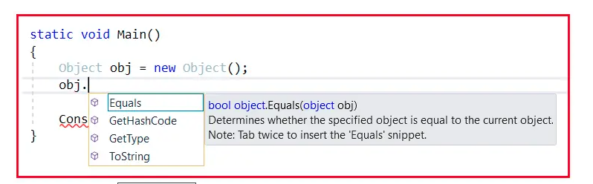

Remember the above four methods can be accessed from everywhere. Every class can contain the Equals, GetHashCode, GetType, and ToString methods and this is possible because every class in the .NET framework is inherited from the Object class.

Now, let us create an object of class A and when you type obj., then the intelligence shows 6 methods i.e. 2 methods (Method1 and Method2) from class A and four methods (Equals, GetHashCode, GetType, and ToString) from Object class shown in the below image.

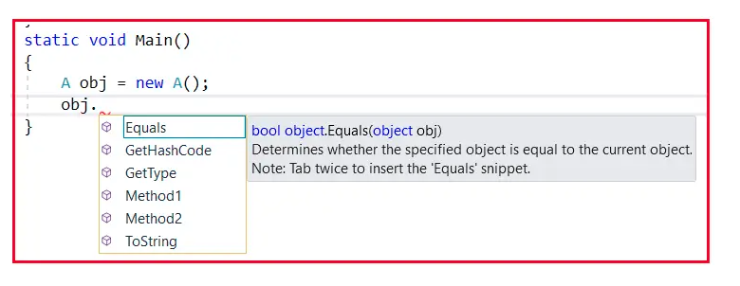

Generally, when you compile your code, the compiler verifies if this class is inheriting from any other class. If yes, no issues. If no, automatically compiler makes this class gets inherited from the Object class. In our example, class A is not inherited from any class. At the time of compilation, this class will automatically inherit from the Object class.

On the other hand, when compiling class B, it will check whether class B is inherited from any other class? Yes, class B is inherited from class A. No, need to inherit from Object. The reason is that class A is already inheriting from Object. Because class A is already inherited from Object, for class B also Object is the Parent class, maybe it is a grandparent.

So, the point that you need to remember is every class in .NET Framework is either directly or indirectly inherited from the Object class.

**Note:** Object class supports all classes in the .NET Framework class hierarchy and provides low-level services to derived classes. This is the ultimate base class of all classes in the .NET Framework; it is the root of the type hierarchy.

##### **What is the Default Parent Class in C#?**

The Default Parent class is the Object class present in the System namespace.

Now, please have a look at the below example. Here we have created three instances that are instances of Object class, A class, and B class and calling the GetType method. The GetType method returns the exact runtime type of the current instance. It will tell you the fully qualified name i.e. the namespace and class name.

using System;

namespace InheritanceDemo

{

class A

{

public A()

{

Console.WriteLine("Class A Constructor is Called");

}

public void Method1()

{

Console.WriteLine("Method 1");

}

public void Method2()

{

Console.WriteLine("Method 2");

}

}

class B : A

{

public B()

{

Console.WriteLine("Class B Constructor is Called");

}

public void Method3()

{

Console.WriteLine("Method 3");

}

static void Main()

{

Object obj1 = new Object();

Console.WriteLine($"obj1 type: {obj1.GetType()}");

A obj2 = new A();

Console.WriteLine($"obj2 type: {obj2.GetType()}");

B obj3 = new B();

Console.WriteLine($"obj3 type: {obj3.GetType()}");

Console.ReadKey();

}

}

}

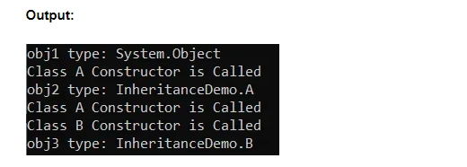

##### **Constructor Execution in the above Example:**

1. When we create an instance of the Object class, only the Object class constructor is called.
2. But when we create an instance of Class A, two constructors are called. First, it will execute the Object class constructor and then it will execute the Class A constructor.
3. When we create an instance of Class B, then three constructors are executed. First, it will execute the Object class constructor, then it will execute the class A constructor, and last it will execute the class B Constructor.

##### **Rule5:**

In C# we don’t have support for multiple inheritances through classes, what we are provided is only Single Inheritance through classes. That means with classes, only one immediate parent class is allowed (i.e. Single, Multilevel and Hierarchical supported), and more than one immediate parent class is not allowed in C# with classes (i.e. Multiple and Hybrid are not supported). In our next article, we will discuss this rule in detail.

##### **Rule6:**

In Rule1 we learned whenever the child class instance is created, the child class constructor will implicitly call its parent classes constructor but if the parent classes constructor is parameterless. If the constructor of the Parent class is parameterized, then the Child class constructor cannot implicitly call its Parent’s constructor. So, to overcome this problem it is the responsibility of the programmer to explicitly call the Parent classes constructor from the child class constructor and pass values to those parameters. To call Parent’s constructor from the child class we need to use the base keyword.

Let us understand this with an example. Let us make the Parent class constructor parameterized as follows. Here, the constructor takes an integer parameter and printing that value on the console window.

using System;

namespace InheritanceDemo

{

class A

{

public A(int number)

{

Console.WriteLine($"Class A Constructor is Called : {number}");

}

public void Method1()

{

Console.WriteLine("Method 1");

}

public void Method2()

{

Console.WriteLine("Method 2");

}

}

class B : A

{

public B()

{

Console.WriteLine("Class B Constructor is Called");

}

public void Method3()

{

Console.WriteLine("Method 3");

}

static void Main()

{

B obj = new B();

Console.ReadKey();

}

}

}

Now, if you compile the code, then you will see that class B is giving one error as shown in the below image.

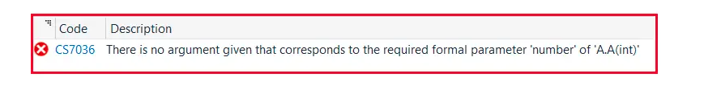

is complaining that “**There is no argument given that corresponds to the required formal parameter ‘number’ of ‘A.A(int)’”**and this makes sense. This is because the class B constructor implicitly calls the class A constructor. But, if you want to call the class A constructor, it requires an integer parameter now. Without passing the parameter we cannot call the class A constructor. So, now the class B constructor is unable to call the class A constructor.

##### **Why it is unable to call the constructor?**

Earlier the constructor was parameterless, so it directly calls the Parent class constructor. Right now, the constructor is parameterized. If you want to call it, you require a value now. And class B constructor does not know what value to pass the class A constructor. This is the reason why we are getting an error in class B, not in class A. Why because class B is not able to call the class A constructor.

So, what to do? Implicitly calling is not working. So, to resolve the error we need to go for explicit calling. How to call? See the following code. Here, the keyword base refers to the parent class i.e. class A. And here we need to pass the value for the Base class or Parent class constructor.

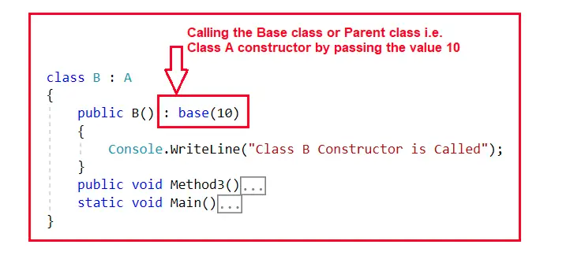

So, here we are passing the value 10 to the Parent class i.e. A constructor. And this value 10 will be received by the parent class constructor. The complete code is given below.

using System;

namespace InheritanceDemo

{

class A

{

public A(int number)

{

Console.WriteLine($"Class A Constructor is Called : {number}");

}

public void Method1()

{

Console.WriteLine("Method 1");

}

public void Method2()

{

Console.WriteLine("Method 2");

}

}

class B : A

{

public B() : base(10)

{

Console.WriteLine("Class B Constructor is Called");

}

public void Method3()

{

Console.WriteLine("Method 3");

}

static void Main()

{

B obj = new B();

Console.ReadKey();

}

}

}

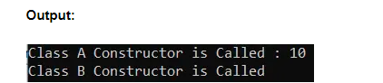

##### **How to pass dynamic value to Parent class constructor in C#?**

In our previous example, we have hardcoded the value i.e. 10. So, every time we create an instance the same value will be assigned to the parent constructor. But if we want then we can also pass dynamic value. Let us see this with an example. In the below example, the child class i.e. class B constructor takes one parameter and passes that parameter value to the parent class i.e. Class A constructor. And when we are creating the instance of Class B, we need to pass the parameter value.

using System;

namespace InheritanceDemo

{

class A

{

public A(int number)

{

Console.WriteLine($"Class A Constructor is Called : {number}");

}

public void Method1()

{

Console.WriteLine("Method 1");

}

public void Method2()

{

Console.WriteLine("Method 2");

}

}

class B : A

{

public B(int num) : base(num)

{

Console.WriteLine("Class B Constructor is Called");

}

public void Method3()

{

Console.WriteLine("Method 3");

}

static void Main()

{

B obj1 = new B(10);

B obj2 = new B(20);

B obj3 = new B(30);

Console.ReadKey();

}

}

}

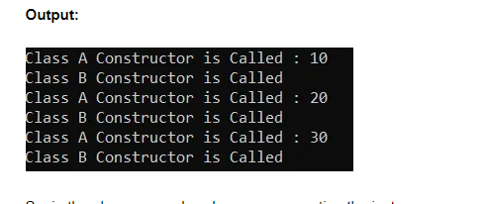

So, in the above example, when we are creating the instance, we are passing the value. The value first reaches the child class constructor and the child class constructor passes the same value to the parent class constructor. If you want, then you can also use the same value in child class also.

So, these are the six rules that you should remember while working with Inheritance in C#.

##### **Advantages of Inheritance in C#:**

**Code reusability:** We can reuse the members of the parent class or base class in the child class or derived class. So, there is no need to re-define the members again in the child class. So, less code is required in the class.

## **IsA and HasA Relationship in C# with Examples**

In this article, I am going to discuss **IsA and HasA Relationships in C#** with Examples. Please read our [**Inheritance in C#**](https://dotnettutorials.net/lesson/inheritance-c-sharp/) article before proceeding to this article. It is very important to understand the concept of IS-A and HAS-A relationship between classes. Many students, many developers, especially beginners and freshers get confused between the IS-A and HAS-A relationship and because of this, they are making the relationship between classes in the wrong order. So, today, I will explain what is exactly IS-A and HAS-A relationships, what is the differences between them, and when to use and how to use IS-A and HAS-A relationships in real-time application. Here, I am going to show the examples using the C# language but this is also applicable to any other object-oriented programming language Java, C++, etc.

##### **IsA and HasA Relationship in C# with Examples:**

Let us understand IS-A and HAS-A Relationship in C# with one example. Please have a look at the below example.

class Rectangle{  
          Some Data Members  
          Some Member Functions  
}

This is a class called Rectangle. Let us assume data we have some data members and member functions there inside this class. Next, we have a class called Cuboid which is inheriting from the above Rectangle class as follows.

class Cuboid : Rectangle{  
          Some Data Members  
          Some Member Functions  
}

This is the Cuboid class which is inherited from the Rectangle class. Also, assume that this class also has some data members and member functions inside it. Now let us write one more class as follows.

class Table{  
       Rectangle top;  
       int legs;  
}

This is the Table class which is not inherited from any class. This class has two data members. One of the data members is of class Rectangle and the other is of integer type variable i.e. top and legs.

So first we have created a class called Rectangle. Then we created another class called Cuboid which is inherited from the Rectangle class and then we created another class called Table. Inside the Table class, we have created one variable of the type Rectangle as well as another variable of integer type.

The class **Cuboid** is inherited from the **Rectangle** class. So, can we say that a **Cuboid IA A Rectangle?** **Yes**. So, the relationship between the Rectangle class and Cuboid class is the **Is A** relationship. So, the point that you need to remember is whenever we are making the Inheritance relationship or Parent-Child relationship, then we can say that relationship as IS-A relationship in object-oriented programming languages.

Next, our Table class, it is having a top variable that is of the type **Rectangular**. That means the **Table** class is having an object of the Rectangle class. So, can we say that the **Table class HAS A Rectangle? Yes**, the Table class Has a Rectangle. So, the relationship between the Table class and the Rectangle class is the **Has A** relationship.

So, we can use our class in two ways that are ‘**Is A**’ and ‘**Has A**’. This is common in object-oriented programming languages just not for C#, it is available in C++, Java, and other Object-Oriented Programming Language.

So, a class in C# can be used in two ways. One way is by using the Inheritance relationship i.e. one class is inheriting from that class. The second approach is that you can create an object of that class and use it. So, there are two ways of using one class. Either you can create the object and use it or you can inherit it from that class.

##### **Real-time Example to Understand Is-A and Has-A Relationship:**

Let us understand **IS-A** and **HAS-A** relationships with one Real-time Example. Let us take an example. Please have a look at the below image.

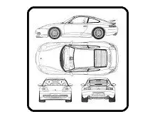

Let us assume that the above image shows the design of my car. Now I can manufacture any number of cars from the above design and I can sell them on the market. Let us assume we have manufactured the following cars from the above design.

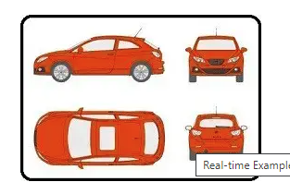

Manufacturing the Cars means, these are objects. Now I can sell my design (not the manufactured cars or objects, only the design) to your company and you can manufacture your car with some changes in the above design which I sell to you.

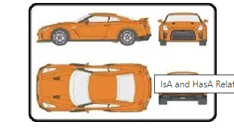

##### **So, what are the uses of design class?**

What is the use of the design class means in how many ways we can use the design class? We can use the design class in two ways. Either we share it with the derived classes or create an object. If a class is inheriting from some other class, then it is having an ‘**IS A**’ relationship with that class or if a class is having an object of some other class, then it is having a ‘**HAS A**’ relationship with that class. So, **Table has a Rectangle,** and a **Cuboid is a Rectangle**.

Next, important thing is that a class can have different types of members i.e. we have six types of members such as public, private, protected, internal, protected internal, and private protected. But, let us assume that we have three types of members in our class such as **private**, **protected,** and **public**.

Now when you have those three types of members then which members are accessible inside the class, which members are accessible in the class which is having ‘**IS A**’ relationship, and which members are accessible in the class which is having ‘**HAS A**’ relationship? So, it means what is accessible inside the class and what is accessible in derived classes, and what is accessible upon an object. We already discussed this in our Access Specifiers article. All the members are accessible within the class, public and protected members are accessible in the derived classes (IS-A relationship) and public members are only accessible from non-derived classes (HAS-A relationship).

##### **Example to Understand IS-A Relationship in C#**

Please have a look at the below example. In the below example, the relation between Rectangle and Cuboid is IS-A relationship, so we can say that Cuboid IS-A Rectangle.

using System;

namespace IsAHasADemo

{

public class Program

{

static void Main()

{

Cuboid cuboid = new Cuboid(3, 5, 7);

Console.WriteLine($"Volume is : {cuboid.Volume()}");

Console.WriteLine($"Area is : {cuboid.Area()}");

Console.WriteLine($"Perimeter is : {cuboid.Perimeter()}");

Console.ReadKey();

}

}

class Rectangle

{

//Data Members

public int Length;

public int Breadth;

//Member Functions

public int Area()

{

return Length * Breadth;

}

public int Perimeter()

{

return 2 * (Length + Breadth);

}

}

//Establishing Parent-Child Relationship

//IS-A Relationship i.e. Cuboid IS-A Rectangle

class Cuboid : Rectangle

{

public int Height;

public Cuboid(int l, int b, int h)

{

Length = l;

Breadth = b;

Height = h;

}

public int Volume()

{

return Length * Breadth * Height;

}

}

}

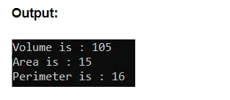

##### **Example to Understand HAS-A Relationship in C#**

Please have a look at the below example. In the below example, within the Employee class, we have created one variable of Address type which is nothing but a HAS-A relationship between Employee and Address. So, we can say that Employee HAS-A Address.

using System;

namespace IsAHasADemo

{

public class Program

{

static void Main()

{

Address address = new Address("B1-3029", "BBSR", "Odisha");

Employee employee = new Employee(1001, "Ramesh", address);

employee.Display();

Console.ReadKey();

}

}

class Address

{

public string AddressLine, City, State;

public Address(string addressLine, string city, string state)

{

AddressLine = addressLine;

City = city;

State = state;

}

}

class Employee

{

//Using Address in Employee class

//Establishing Has-A relationship i.e. Employee HAS-A Address

public Address address;

public int Id;

public string Name;

public Employee(int id, string name, Address adrs)

{

Id = id;

Name = name;

address = adrs;

}

public void Display()

{

Console.WriteLine($"Employee Id: {Id}");

Console.WriteLine($"Employee Name: {Name}");

Console.WriteLine($"AddressLine: {address.AddressLine}");

Console.WriteLine($"City: {address.City}");

Console.WriteLine($"State: {address.State}");

}

}

}

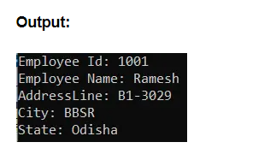

In the above example, if we inherit the Employee Class from the Address class, then it does not make any sense. Because if we inherit then it will establish an IS-A relationship between Employee and Address classes and it does not make any sense to say Employee IS-A Address rather if we implement HAS-A relationship, then it makes sense to say Employee HAS-A Address.

How to Decide What to Implement between IS-A and HAS-A?

Simply, ask the question yourself. For example, If I ask you the questions which statement gives you more sense from the below two statements?  
Employee IS-A Address  
Employee HAS-A Address

Then definitely, you will tell Employee HAS-A Address gives more sense than Employee IS-A Address. Now, again If I ask you, which statement gives you a better sense of the below two statements?

BMW IS-A Car  
BMW HAS-A Car  
Then definitely your answer will be BMW IS-A Car.

Note: In C#, the IS-A relationship is implemented using Inheritance and the HAS-A relationship is implemented using Composition i.e. declaring a variable. So, whenever we declare a variable of one class inside another class, we called it a Composition or you can say HAS-A relationship.

## **Generalization and Specialization in C# with Examples**

In this article, I am going to discuss **Generalization and Specialization in C#** with Examples. Please read our previous article where we discussed [**IS-A and HAS-A Relationships in C#**](https://dotnettutorials.net/lesson/isa-and-hasa-relationship-in-csharp/) with Examples. This is a very interesting topic that is generalization vs specialization. This is related to inheritance. Let us understand what you mean by Generalization and Specialization in C# with Examples.

##### **Specialization in C#**

Let’s say we have a class called Rectangle. Then, can we create the object of the Rectangle class? Yes, we can create objects of Rectangle and call the functions of the Rectangle class. Now, we have a class called Cuboid which is inherited from the Rectangle class.

Now, for the Cuboid class also we can create objects and call the functions of Cuboid and Rectangle. These two things i.e. **Rectangle and Cuboid really exist in the world**. Can you show me a Rectangle? Yes, you can show me some shapes that are rectangular or paper that is rectangular. So, rectangles exist in the real world. And what about Cuboid? Yes, it also exists in the real world. Any box shape thing is a cuboid.

So, these two things exist in the real world. Now, if I say, which one is existing first in our example? Then the answer will be Rectangle. And from the Rectangle class, we have derived the Cuboid class. So, the Rectangle class is already existing and from the Rectangle class, we have defined a new class with some extra features i.e. we have a specialized class that is Cuboid. This is a specialization in C#.

##### **Example to Understand Specialization in C#:**

In the below example first, we created the Rectangle class and from the Rectangle class, we have created a specialized class with some extra features called the Cuboid class. So, Cuboid is a specialization class of Rectangle.

using System;

namespace IsAHasADemo

{

public class Program

{

static void Main()

{

Cuboid cuboid = new Cuboid(3, 5, 7);

Console.WriteLine($"Volume is : {cuboid.Volume()}");

Console.WriteLine($"Area is : {cuboid.Area()}");

Console.WriteLine($"Perimeter is : {cuboid.Perimeter()}");

Console.ReadKey();

}

}

class Rectangle

{

public int Length;

public int Breadth;

public int Area()

{

return Length * Breadth;

}

public int Perimeter()

{

return 2 * (Length + Breadth);

}

}

class Cuboid : Rectangle

{

public int Height;

public Cuboid(int l, int b, int h)

{

Length = l;

Breadth = b;

Height = h;

}

public int Volume()

{

return Length * Breadth * Height;

}

}

}

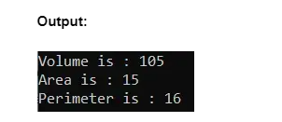

##### **Another Example to Understand specialization in C#:**

Let us take another example of cars. We have a class Innova, Innova car from Toyota company. Then there is another class called Fortuner.

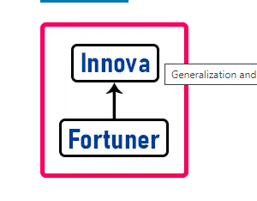

If you know about these then you should know that first Innova was launched by Toyota and then a new car called Fortuner was launched which is an extension of Innova. As a common man if you see Fortuner as an extension of Innova then it is having same seating capacity but with a lot of extra features compared to Innova. So, it means that the Fortuner car is an extension of the Innova car.

Innova is a base class and Fortuner is a derived class. Innova was already existing and Fortuner is the specialized form of Innova. This is specialization. **Something is already existing and then we are deriving something from that existing one by adding some extra features.** In the real world, we can take a lot of examples of specialization.

##### **Generalization in C#**

Let’s say we have 3 classes that are Square, Rectangle, and Circle. Then for all of these three classes, we are defining one class that is Shape. And Square, Rectangle, and Circle are inherited from the Shape class. For a better understanding, please have a look at the following diagram.

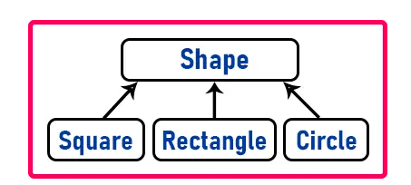

So, among these classes which one is existing first? We know that all the shapes i.e. square, rectangle and circle really exist in the real world. So, we are calling them shapes.

Do you think Shape really exists in the real world? No. It is just a virtual term. If I asked you to show me some shapes, then you’ll be drawing a rectangle, a circle, a square, a Rhombus, etc. but you cannot show me just a shape. So, Shape is a term or generic term, or generalized term which does not exist in the real world.

These child classes which are already existing in the real world and to bring them on a common platform, we have given the word Shape which is a logical term or virtual term, it is not a real term, it does not really exist in the real world.

Can you find the area or perimeter of a rectangle? Yes. Can you find the area or perimeter of the square? Yes. Can you find the area or perimeter of the circle? Yes. Does every shape have an area and perimeter? Yes.

This is a common feature, so we have brought it into shape. Now can you calculate the area and perimeter of the Shape? No, you can’t. There are no dimensions for shape. It’s a generalized term. So, this is an example of Generalization in C#.

##### **Another Example to understand Generalization:**

Suppose you have Innova, BMW, and Audi cars. So, you can start, stop, accelerate, and change gears in any of these. So, what these are all? These all are cars. Innova, BMW, and Audi are physically available in the real world. All these are nothing but cars.

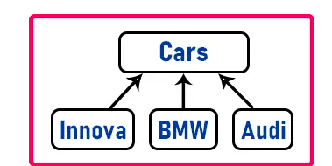

So, they all are inheriting from Cars. What can you do in a car? You can drive, start, stop, change gears, etc. all these features are available in these cars. Then what about Cars? Does it really exist? No, it is a general term. Just a general term that is the logical definition of a group of things.

So, we have given a superclass to a group of classes for refereeing something. It is just like if I am looking at Innova so I can say it is a car. So, for any 4-wheelers we use the term, Car.

We are using this term generalization for refereeing them. We don’t have to know the brand name or the product name perfectly. When it looks like a car, we can say that’s a car. So, in the real world or in daily life we define such general terms.

using System;

namespace IsAHasADemo

{

public class Program

{

static void Main()

{

Innova innova = new Innova();

innova.Start();

innova.Stop();

BMW bmw = new BMW();

bmw.Start();

bmw.Stop();

Console.ReadKey();

}

}

interface ICar

{

void Start();

void Stop();

}

public class Innova : ICar

{

public void Start()

{

Console.WriteLine($"Innova Start");

}

public void Stop()

{

Console.WriteLine($"Innova Stop");

}

}

public class BMW : ICar

{

public void Start()

{

Console.WriteLine($"BMW Start");

}

public void Stop()

{

Console.WriteLine($"BMW Stop");

}

}

}



##### **Summary of Generalization and Specialization in C#**

So, the point that you need to remember is both generalization and specialization achieve using only inheritance. We have seen four examples in which 2 are of specialization and 2 are of generalization. In specialization, the parent was existing and the child was defined later. In generalization, the child class was existing then we define the base class. So, specialization is a top-down approach and generalization is a bottom-up approach.

In specialization, the base class has something to give to the child class whereas, in generalization, the base class doesn’t have anything to give to their child classes. Just their purpose is to group them together so that we can easily manage all those things.

The purpose of generalization is to achieve polymorphism and the purpose of specialization is to share its features with its child classes. What is polymorphism and how to implement polymorphism will discuss in our coming articles?

So, there are two purposes of inheritance. One is to share features with child classes and the second one is to achieve polymorphism. So here I have given you a clear idea of what is a specialization and what is a generalization.

In the next article, I am going to discuss the [**Interface in C#**](https://dotnettutorials.net/lesson/interface-c-sharp/) with Examples. Here, in this article, I try to explain **Generalization and Specialization in C#** with Examples and I hope you enjoy this Generalization and Specialization in C# with Examples article. I would like to have your feedback. Please post your feedback, question, or comments about this article.

**Abstract Classes and Abstract Methods in C# with Examples**

In this article, I am going to discuss Abstract Classes and Abstract Methods in C# with Examples. Please read our previous article, where we discussed [Generalization and Specialization in C#](https://dotnettutorials.net/lesson/generalization-and-specialization-in-csharp/) with Examples. In this article, we will discuss what are abstract classes and what is the use of abstract classes in our application. Let us first understand what are abstract methods and abstract classes in C#.

What are Abstract Methods in C#?

A method without the body is known as Abstract Method, what the method contains is only the declaration of the method. That means the abstract method contains only the declaration, no implementation. The following method is a non-abstract method as this method contains a body.  
public void Add(int num1, int num2)  
{  
}

But without writing the method body, if we end the method with a semicolon as follows, then it is called an Abstract Method.  
public void Add(int num1, int num2);

But, remember if you want to make any method an abstract method, then you should explicitly use the abstract modifier as follows. And once you use the abstract modifier, automatically the method is going to be called an abstract method.  
public abstract void Add(int num1, int num2);

Then what are abstract classes?

What are Abstract Classes in C#?

A class under which we define abstract methods is known as an abstract class. As per object-oriented programming, we need to define a method inside a class. And, we cannot define the abstract methods directly anywhere, we need to define the abstract method inside an abstract class only. Suppose, we need to write the above Add abstract method inside a class called Calculator, then that class needs to be declared using the abstract modifier as follows.  
public abstract class Calculator  
{  
        public abstract void Add(int num1, int num2);  
}  
So, when a class contains any abstract methods, then it must and should be declared using the abstract modifier and when a class is created using an abstract modifier then it is called an Abstract class in C#. So, this is how exactly we define an abstract class and abstract methods in C#.

Generally, when we define an abstract class we have a doubt, without a method body what will be the use of that method? Let us understand this.

##### **What is the use of the Abstract Method in C#?**

If a method is declared as abstract under any class, then the child class of that abstract class is responsible for implementing the abstract method without fail.

In [**inheritance**](https://dotnettutorials.net/lesson/inheritance-c-sharp/), we see that the Parent class provides some properties to the Child class for consumption. Here also inheritance comes into the picture, but the point that you need to remember is that the Parent class is an abstract class, and he will not be providing any properties to the Child class for consumption, rather it imposes some restrictions on the Child classes. And children or Child classes have to be followed or fulfill those restrictions. And that is the basic idea of abstract class in C#. We will come to this point later.

**Note:** Every abstract method declared within an abstract class must and should be implemented by the Child classes without fail else we will get compile time error.

##### **Is Abstract Class Containing Only Abstract Methods in C#?**

No, don’t think that an abstract class can contain only abstract methods. It can also contain non-abstract methods. The point that you need to remember is, that if a class is non-abstract then it contains only non-abstract methods but if a class is abstract then it contains both abstract and non-abstract methods in C#.

##### **Who will Provide Implementation of Abstract Methods in C#?**

The Answer is Child Class. If you have a child class of an abstract class, then it is the responsibility of the child class to provide the implementation for all the abstract methods of the parent class. You cannot escape. Every method should be implemented. If you implement all the abstract methods, then only you can consume the non-abstract method of the Parent class.

Generally, what we saw in Inheritance is that the child class can directly consume the members of the parent class. But here this is not possible. You cannot consume directly. The property is under restrictions. Until and unless the restrictions are fulfilled by the child class, the child class cannot consume the members of the parent class.

So, the point that you need to remember is, that in the child class, you need to implement each and every abstract method of the parent class, and then only you can consume the non-abstract methods of the parent class.

Let us compare this with one real-time example. Suppose, the father promised his son, that if you bring 90% of the mark in the annual exam, then he will be rewarded with a laptop. So, the laptop is going to be given to you only if you bring 90% in the annual exam. Now, if the son wants to get the laptop, then the son has to fulfill the requirement set by his father. What is the requirement, the requirement is achieving 90% of the mark. Once the son fulfills the requirement i.e. once the son achieves 90% marks in the annual exam, then the laptop is given to him until then he will not get the laptop.

This is exactly the same in the case of an abstract class. Abstract class contains both abstract and non-abstract methods. You can consider the abstract method as Marks obtained on the annual exam and the non-abstract method as the laptop. So, if you want to get the laptop (i.e. to consume non-abstract method), you need to fulfill the requirements i.e. get 90% marks in the annual exam (i.e. implement all the abstract methods).

**Note:** To define a method as abstract or class as abstract, we require to use the abstract keyword on them.

##### **Example to Understand Abstract Class and Abstract Methods in C#:**

Let us understand Abstract Class and Abstract Methods in C# with an Example. Please have a look at the following class. This is going to be our parent abstract class. In this class, we have defined two non-abstract methods i.e. Add and Sum, and two abstract methods i.e. Mul and Div. Further, if you notice we create the class AbsParent using the abstract keyword as this class contains two abstract methods.

public abstract class AbsParent

{

public void Add(int x, int y)

{

Console.WriteLine($"Addition of {x} and {y} is : {x + y}");

}

public void Sub(int x, int y)

{

Console.WriteLine($"Subtraction of {x} and {y} is : {x - y}");

}

public abstract void Mul(int x, int y);

public abstract void Div(int x, int y);

}

##### **Can we create an instance of an abstract class in C#?**

No. We cannot create an instance of an abstract class. Whether the abstract class contains any abstract methods or not, it is not possible to create an instance of the abstract class. If you try, you will get a compile-time error as shown in the below image.

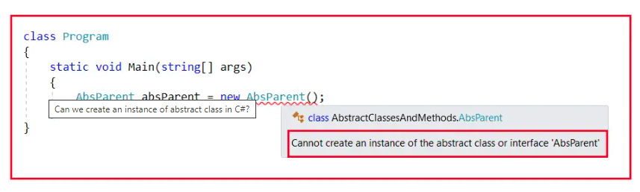

As you can see in the above image, it is clearly saying that you cannot create an instance of an abstract class and this makes sense. This is because, if it will allow us to create an instance of the abstract class, then using the instance you can call the abstract class abstract methods which do not have a body and this is the reason why it is not allowing us to create an instance of the abstract class in C#.

Currently, the abstract class does not have any static members. If there are any static members, you can call them directly using the class name. But, for calling non-static members we need an instance. Then who can consume the above members? The answer is child class.

Suppose, there is a child class for the above AbsParent class, then the child class has to implement the Mul and Div abstract methods before consuming the Add and Sub method. Please observe the following code. Here, we have created the AbsChild class inheriting from the AbsParent class. And here we have not implemented the two abstract methods. So, it is giving us a compile-time error.

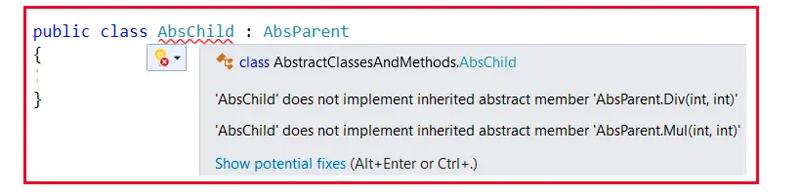

Here, we are getting two errors. One for not implementing the parent class Div method and another error for not implementing the Parent class Mul method. That means it is mandatory for the child class to provide the implementation for all the abstract methods of the parent class.

##### **Why Abstract Class Cannot Be Instantiated in C#?**

Because it is not a fully implemented class as its abstract methods cannot be executed. If the compiler allows us to create the object for an abstract class, we can invoke the abstract method using that object which cannot be executed by CLR at runtime. Hence to restrict calling abstract methods, the compiler does not allow us to instantiate an abstract class.

Now, let us implement the two abstract methods inside the child class. How to implement the abstract methods means using the override modifier as follows.

public class AbsChild : AbsParent

{

public override void Mul(int x, int y)

{

Console.WriteLine($"Multiplication of {x} and {y} is : {x * y}");

}

public override void Div(int x, int y)

{

Console.WriteLine($"Division of {x} and {y} is : {x / y}");

}

}

Now, you can see there is no more compile-time error. Now, the child class fulfills the requirements of the parent class by implementing the abstract methods, and hence the child class can now consume the non-abstract methods of the parent class. So, you can now, create an instance of the Child class and consume all the members as follows.

using System;

namespace AbstractClassesAndMethods

{

class Program

{

static void Main(string[] args)

{

AbsChild absChild = new AbsChild();

absChild.Add(10, 5);

absChild.Sub(10, 5);

absChild.Mul(10, 5);

absChild.Div(10, 2);

Console.ReadKey();

}

}

public abstract class AbsParent

{

public void Add(int x, int y)

{

Console.WriteLine($"Addition of {x} and {y} is : {x + y}");

}

public void Sub(int x, int y)

{

Console.WriteLine($"Subtraction of {x} and {y} is : {x - y}");

}

public abstract void Mul(int x, int y);

public abstract void Div(int x, int y);

}

public class AbsChild : AbsParent

{

public override void Mul(int x, int y)

{

Console.WriteLine($"Multiplication of {x} and {y} is : {x * y}");

}

public override void Div(int x, int y)

{

Console.WriteLine($"Division of {x} and {y} is : {x / y}");

}

}

}

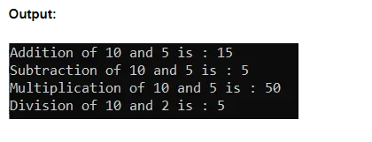

##### **Can we Create a Reference for the Abstract Class in C#?**

Yes, we can create a reference for the abstract class in C#. But we cannot create an instance of an abstract class in C#. For a better understanding, please have a look at the below image. Here, we created an instance of child class i.e. AbsChild, and then we created a reference of abstract class i.e. AbsParent which is holding the child class instance and then using the reference we can also access the members.

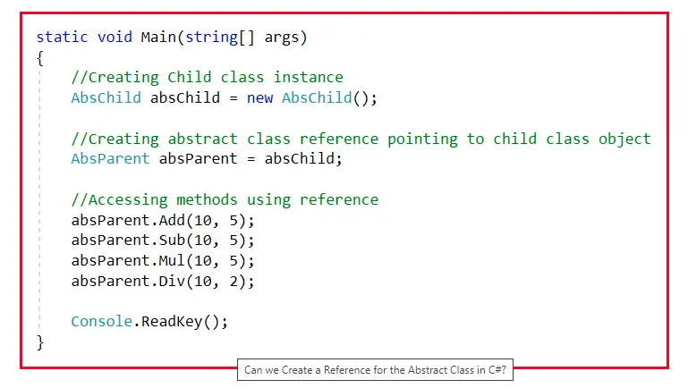

The important point that you need to remember is, parent class references even if created by using child class instances cannot call child class methods provided the methods are purely defined in the child class. Overridden methods are not pure child class methods. If a method is overridden in the child class means it has taken permission from the parent class. So, the parent is completely aware of that method. So, the parent class references can also call the child class overridden members but cannot call the pure child class members.

For a better understanding of this concept, please have a look at the below example. Here, the child class overrides the parent class members as well as we defined a pure child class method i.e. Mod in the child class. As this method is purely defined in the child class, we cannot call this method using the Parent class reference variable. Using the parent class reference variable, we can call the parent class non-abstract methods, child class overridden methods but not the pure child class methods.

using System;

namespace AbstractClassesAndMethods

{

class Program

{

static void Main(string[] args)

{

//Creating Child class instance

AbsChild absChild = new AbsChild();

//Creating abstract class reference pointing to child class object

AbsParent absParent = absChild;

//Accessing methods using reference

absParent.Add(10, 5);

absParent.Sub(10, 5);

absParent.Mul(10, 5);

absParent.Div(10, 2);

//You cannot call the Mod method using Parent reference as it is a pure child class method

//absParent.Mod(100, 35);

Console.ReadKey();

}

}

public abstract class AbsParent

{

public void Add(int x, int y)

{

Console.WriteLine($"Addition of {x} and {y} is : {x + y}");

}

public void Sub(int x, int y)

{

Console.WriteLine($"Subtraction of {x} and {y} is : {x - y}");

}

public abstract void Mul(int x, int y);

public abstract void Div(int x, int y);

}

public class AbsChild : AbsParent

{

public override void Mul(int x, int y)

{

Console.WriteLine($"Multiplication of {x} and {y} is : {x * y}");

}

public override void Div(int x, int y)

{

Console.WriteLine($"Division of {x} and {y} is : {x / y}");

}

public void Mod(int x, int y)

{

Console.WriteLine($"Modulos of {x} and {y} is : {x % y}");

}

}

}

##### **Summary of Abstract Class and Abstract Methods in C#**

1. A method that does not have a body is called an abstract method and the class that is declared by using the keyword abstract is called an abstract class. If a class contains an abstract method, then it must be declared as abstract.
2. An abstract class can contain both abstract and non-abstract methods. If a child class of an abstract class wants to consume any non-abstract methods of its parent, should implement all abstract methods of its parent.
3. An abstract class is never usable to itself because we cannot create the object of an abstract class. The members of an abstract class can be consumed only by the child class of the abstract class.

**Interface in C# with Examples**

In this article, I am going to discuss one of the most important concepts i.e. Interface in C# with Examples. Please read our previous article where we discussed [Abstract Classes and Abstract Methods in C#](https://dotnettutorials.net/lesson/abstract-class-abstract-methods-csharp/) with Examples. At the end of this article, I am sure, you will understand what is Interface, why we need an interface, and how to use an interface in C# with Examples.

**What is an Interface in C#?**

The Interface in C# is a Fully Un-Implemented Class used for declaring a set of operations/methods of an object. So, we can define an interface as a pure abstract class which allows us to define only abstract methods. The abstract method means a method without a body or implementation.

It is used to achieve multiple inheritances which can’t be achieved by class. It is used to achieve full abstraction because it cannot have a method body.

Till now we are learning classes. So, what is a class? A class is a user-defined data type. Then what is an interface? An interface is also a user-defined data type. Then what is the difference between them? Let us understand this first.

Differences between Class, Abstract Class, and Interface in C#:

A class can contain only the methods which contain the method body. Do we have a method without the body? Yes, we have methods without a body and that are called abstract methods. So, simply we can say class contains a method with a method body or you can say non-abstract methods. Abstract class contains both abstract and non-abstract methods and the interface contains only abstract methods.

Class: Contains only the Non-Abstract Methods (Methods with Method Body).

Abstract Class: Contains both Non-Abstract Methods (Methods with Method Body) and Abstract Methods (Methods without Method Body).

Interface: Contain only Abstract Methods (Methods without Method Body).

What are abstract methods, why do we need abstract methods, and how do implement abstract methods we have already discussed this in our [Abstract Classes and Abstract Methods in the C#](https://dotnettutorials.net/lesson/abstract-class-abstract-methods-csharp/) article.

Note: Every abstract method of an interface should be implemented by the child class of the interface without fail (Mandatory)

In [Inheritance](https://dotnettutorials.net/lesson/interface-c-sharp/), we already learned that a class inherits from another class, and the child class consumes the members of the Parent class. Please observe the following diagram. Here, we have class A with a set of members and class B is inheriting from class A. And there is a relationship called Parent/Child relation between them. And once the Parent/Child relationship is established, then the members of class A can be consumed under class B. So, this is what we learned in Inheritance.

Now, just like a class is having another class as a Parent, a class can also have an Interface as a Parent. And if a class has an interface as a Parent, the class is responsible for providing the implementation for all the abstract methods of the interface. For a better understanding, please have a look at the below diagram.

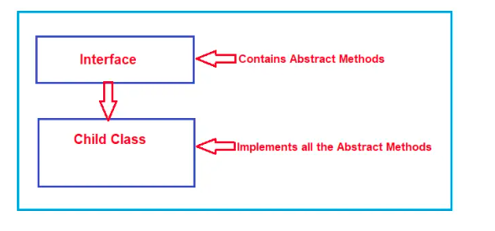

Simply speaking, the Parent Interface imposes restrictions on the Child Classes. What restrictions? The restrictions are to implement each and every method of the interface under the child class.

Generally, a class inherits from another class to consume members of its Parent. On the other hand, if a class is inheriting from an interface, it is to implement the members of its Parent (Interface), not for consumption.

Note: A class can inherit from a class and interface(s) at a time.

**How to Define an Interface in C#?**

The way we define a class, in the same way, we need to define an interface in C#. In a class declaration, we need to use the class keyword whereas in an interface declaration, we need to use the interface keyword. Moreover, in an interface, we can only declare abstract members. For a better understanding, please have look at the below diagram.

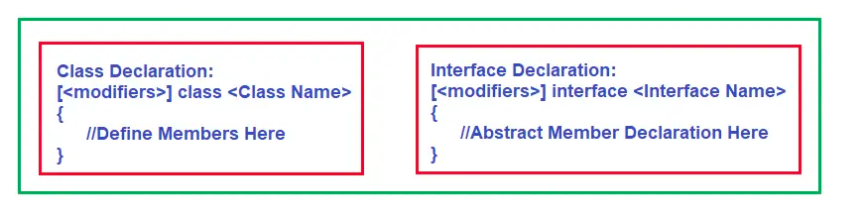For a better understanding please have a look at the below example. Here, we have created one interface with the name ITestInterface by using the interface keyword.

interface ITestInterface

{

//Abstract Member Declarations

}

**How to Define Abstract Methods in an Interface in C#?**

In a class (i.e. Abstract Class), we generally use the abstract keyword to define abstract methods as follows.  
public abstract void Add(int num1, int num2);

If you want to write the above abstract method in an interface, then you don’t require public and abstract keywords in the method signature as follows:  
void Add(int num1, int num2);

While working with Interface we need to remember some Rules. Let us discuss those rules one by one with Examples.

**Point 1:** The first point that you need to remember is the default scope for the members of an interface is public whereas it is private in the case of a class.

**Point 2:** The second point that you need to remember is by default every member of an interface is abstract, so we don’t require to use the abstract modifier on it again just like we do in the case of an abstract class. For a better understanding, please have a look at the below example. By default, the Add method is going to be public and abstract.

interface ITestInterface

{

//By default, the following method is public and abstract

void Add(int num1, int num2);

}

**Point 3:** The third point that you need to remember is we cannot declare fields/variables, constructors, and destructors in an interface in C#.

Please have a look at the below code. Here, we are trying to declare a variable and as soon as we declare we get one compile-time error i.e. Interfaces cannot contain fields as shown in the below image.

**What are the Members we can and can’t define in an interface in C#?**

An interface can contain

Abstract methods

Properties

Indexes

Events

An interface cannot contain

Non-abstract functions

Data fields

Constructors

Destructors

**Point 4:** The fourth point that you need to remember is if require an interface can inherit from another interface in C# just like a class inherits from another class.

For a better understanding, please have a look at the below code. Here, we have two interfaces i.e. Interface1 and Interface2. Interface2 is inherited from Interface1 and now interface2 has two abstract methods i.e. Add (from interface 1) and Sub.

Now, the Child class who is inheriting from Interface1 has to implement one method i.e. Add and the child class who is inheriting from Interface2 has to implement two methods i.e. Add, and Sub.

Now, you may have one question why do we need two separate interfaces, why not one? Yes, you can use one interface and define all the methods as long as they are related to one task. If you put not related methods in a single interface then it is against the SOLID – Interface Segregation Principle. If you want to learn the [SOLID – Interface Segregation Principle](https://dotnettutorials.net/lesson/interface-segregation-principle/) please click [here](https://dotnettutorials.net/lesson/interface-segregation-principle/).

**Point 5:** The fifth point that you need to remember is every member of an interface should be implemented under the child class without fail (mandatory), but while implementing we don’t require to use the override modifier just like we have done in the case of an abstract class.

For a better understanding, please have a look at the following code. Here, we have two interfaces and two implementation classes. Interface2 is inherited from Inteface1 and hence it has two abstract methods. ImplementationClass1 inherits from Interface1 and hence implements the Add method only. ImplementationClass2 inherits from Interface1 and Interface2 inherits from Interface1 and hence this class needs to implement both the abstract methods. That is what you can see in the below code.

interface ITestInterface1

{

void Add(int num1, int num2);

}

interface ITestInterface2 : ITestInterface1

{

void Sub(int num1, int num2);

}

public class ImplementationClass1 : ITestInterface1

{

//Implement only the Add method

public void Add(int num1, int num2)

{

Console.WriteLine($"Sum of {num1} and {num2} is {num1 + num2}");

}

}

public class ImplementationClass2 : ITestInterface2

{

//Implement Both Add and Sub method

public void Add(int num1, int num2)

{

Console.WriteLine($"Sum of {num1} and {num2} is {num1 + num2}");

}

public void Sub(int num1, int num2)

{

Console.WriteLine($"Divison of {num1} and {num2} is {num1 - num2}");

}

}

In the above example, you can see that while implementing the method we are using the public modifier and this is required. If you don’t use public, then it will treat the method as private and you will get a compiler error ‘ImplementationClass1’ does not implement interface member ‘ITestInterface1.Add(int, int)’. ‘ImplementationClass1.Add(int, int)’ cannot implement an interface member because it is not public. as shown in the below image.

**Example to Understand Interface in C#:**

Whatever we discussed as of now, we have put all these things in the below example. Please go through the comment lines.

using System;

namespace AbstractClassMethods

{

class Program

{

static void Main()

{

ImplementationClass1 obj1 = new ImplementationClass1();

//Using obj1 we can only call Add method

obj1.Add(10, 20);

//We cannot call Sub method

//obj1.Sub(100, 20);

ImplementationClass2 obj2 = new ImplementationClass2();

//Using obj2 we can call both Add and Sub method

obj2.Add(10, 20);

obj2.Sub(100, 20);

Console.ReadKey();

}

}

interface ITestInterface1

{

void Add(int num1, int num2);

}

interface ITestInterface2 : ITestInterface1

{

void Sub(int num1, int num2);

}

public class ImplementationClass1 : ITestInterface1

{

//Implement only the Add method

public void Add(int num1, int num2)

{

Console.WriteLine($"Sum of {num1} and {num2} is {num1 + num2}");

}

}

public class ImplementationClass2 : ITestInterface2

{

//Implement Both Add and Sub method

public void Add(int num1, int num2)

{

Console.WriteLine($"Sum of {num1} and {num2} is {num1 + num2}");

}

public void Sub(int num1, int num2)

{

Console.WriteLine($"Divison of {num1} and {num2} is {num1 - num2}");

}

}

}

**Point 6:** We cannot create an instance of an interface, but we can create a reference of an interface. The interface reference is going to hold the child class instance. Using the interface reference, we can only invoke the methods which are declared in the interface.

For a better understanding, please have a look at the below example. In the below example, ITestInterface1 declared one abstract method i.e. Add. This interface is then implemented by the ImplementationClass and this class provides the implementation for the Add interface method. Again, in this class, we defined a new method i.e.Sub. Next, inside the Main method, we are creating a reference of the interface which is pointing to the child class instance. And using this reference we can only invoke the Add method and we cannot invoke the Sub method. This is because the Add method signature is there inside the interface but the Sub method signature is not there in the interface.

**Example to Understand Interface Reference in C#:**

using System;

namespace AbstractClassMethods

{

class Program

{

static void Main()

{

//Creating Reference of an Interface point to the

//child class instance

ITestInterface1 obj = new ImplementationClass();

//Add method signature declared in ITestInterface1, so we can

//Invoke the Add method

obj.Add(10, 20);

//Sub method signature is not declared in ITestInterface1,

//so, we cannot Invoke the Sub method

//obj.Sub(100, 20);

Console.ReadKey();

}

}

interface ITestInterface1

{

void Add(int num1, int num2);

}

public class ImplementationClass : ITestInterface1

{

//Interface Method Implementation

public void Add(int num1, int num2)

{

Console.WriteLine($"Sum of {num1} and {num2} is {num1 + num2}");

}

//This method purely belongs to ImplementationClass

public void Sub(int num1, int num2)

{

Console.WriteLine($"Divison of {num1} and {num2} is {num1 - num2}");

}

}

}

**Explicit Interface Implementation in C#**

When each interface method is implemented separately under the child class by providing the method name along with the interface name then it is called Explicit Interface Implementation. But in this case, while calling the method we should compulsorily use the interface reference that is created using the object of a class or typecast the object to the appropriate interface type.

You can also implement an interface in another way without using the public access modifier. In this case, we need to specify the interface name before the method name using the dot operator as shown in the below code. This is called Explicit Implementation of Interface Methods.

As you can see in the above code, the Add method is implemented using public access specifier and the Sub is implemented using the interface name. The Sub method belongs to Interface2 and hence we prefix the Sub method with Interface2 followed by the dot operator. Here, if you want to implement Add method in an explicit manner then you need to prefix the Add method with Interface1 as the Add method belongs to Interface1.

In this case when we use the Interface name while implementing the interface method then we don’t require to use the public access specifier anymore. The reason is that it is very clear that interface members are public and hence we don’t require to use the public access specifier. So, these are the two ways of implementing interface members in C#.

Now, if the method is implemented using the public access specifier, then you can create the object and call them directly. But if the method is implemented using the interface name, then while calling the method we need to typecast the object to the interface type or you can create an interface reference and call the method. So, in our case, we call Add method directly using obj1 but while calling the Sub method we need to typecase the obj1 to Interface2 type as this is an instance of ImplementationClass or you can call directly using reference variable obj2 as shown in the below image.

**Explicit Interface Implementation Example in C#**

using System;

namespace AbstractClassMethods

{

class Program

{

static void Main()

{

ImplementationClass obj1 = new ImplementationClass();

//Using obj1 we can call the Add method directly because

//It is implemented using public access specifier

obj1.Add(10, 20);

//We need to typecast obj1 to ITestInterface1 to call the Sub

//method because Sub method is implemented using Interface name

((ITestInterface1)obj1).Sub(100, 20);

//We can call the method directly using the interface reference

//Typecasting is not required in this case

ITestInterface1 obj2 = new ImplementationClass();

obj2.Add(200, 50);

obj2.Sub(200, 50);

Console.ReadKey();

}

}

interface ITestInterface1

{

void Add(int num1, int num2);

void Sub(int num1, int num2);

}

public class ImplementationClass : ITestInterface1

{

//Interface Method Implementation

public void Add(int num1, int num2)

{

Console.WriteLine($"Sum of {num1} and {num2} is {num1 + num2}");

}

//This method purely belongs to ImplementationClass

void ITestInterface1.Sub(int num1, int num2)

{

Console.WriteLine($"Divison of {num1} and {num2} is {num1 - num2}");

}

}

}

## **Polymorphism in C# with Real-Time Examples**

In this article, I am going to discuss **Polymorphism in C#** with Real-Time Examples. Please read our previous where we discussed [**Multiple Inheritance in C#**](https://dotnettutorials.net/lesson/multiple-inheritance-csharp/) with Examples. Polymorphism in C# is one of the core concepts of object-oriented programming languages (OOPs).  At the end of this article, you will understand the following pointers in detail.

1. **What is Polymorphism?**
2. **Why do we need Polymorphism?**
3. **Types of Polymorphism in C#?**
4. **What is Compile-Time Polymorphism?**
5. **What is Runtime Polymorphism?**

**Note:** Polymorphism is one of the primary pillars of object-oriented programming.

##### **What is Polymorphism in C#?**

Polymorphism is one of the fundamental OOPs concepts and is a term used to describe situations where something takes various roles or forms. In the programming world, these things can be operators or functions.

The word polymorphism is derived from two Greek words: poly and morphs. The word “Poly” means many and “morphs” means forms. Therefore, polymorphism means “many forms” or we can say that the word polymorphism means the ability to take more than one form. That is one thing that can take many forms.

Polymorphism is a concept by which we can perform a single task in different ways. That is, when a single entity behaves differently in different cases, it is called polymorphism in C#. The term polymorphism is an object-oriented programming term that means a function, or an operator behaves differently in different scenarios.

Technically we can say that when a function shows different behaviors when we passed different types and numbers of input values, then it is called Polymorphism in C#. So, behave in different ways depending on the input received is known as polymorphism i.e. whenever the input changes, automatically the output or the behavior also changes.

We can achieve flexibility in our code using polymorphism because we can perform various operations by using methods with the same names according to our business requirements. Let’s understand Polymorphism with some real-time examples.

##### **Real-Time Examples of Polymorphism:**

Let us understand a few real-time examples to understand this Polymorphism concept.

##### **Example1:**

Suppose you are in a classroom, then at that time you will behave like a student. But when you are in the shopping mall, at that time you will behave like a customer. Again, when you are traveling on a bus, then you will behave like a passenger. And when you are at your home at that time you will behave like a son or daughter. Here you are one person, but performing different behaviors. This is nothing but polymorphism. The behaviors changes based on the places.

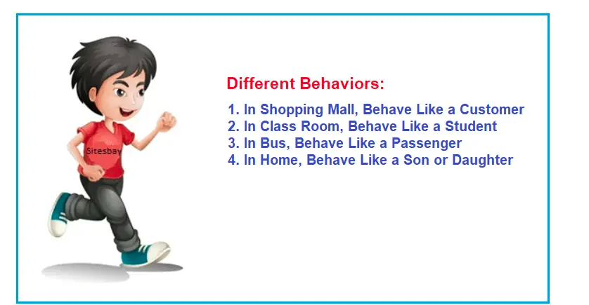

##### **Example2:**

A security guard in an organization behaves differently with different people entering the organization. The security behaves in a different way when the Boss comes and, in another way when the employees come. And when the customers enter, the same security guard will respond differently. So here, the behavior of the security guard changes from person to person. It depends on the member who is entering the organization.

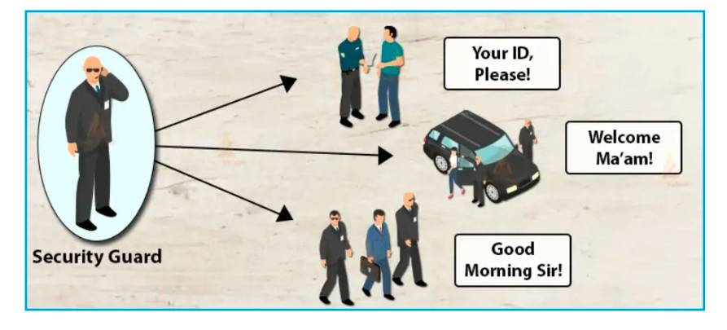

##### **Example3:**

Another good real-time example of polymorphism is water. We all know that water is a liquid at normal temperature, but it changes to a solid when it is frozen, and the same water changes to a gas when it is heated at its boiling point. This is also polymorphism.

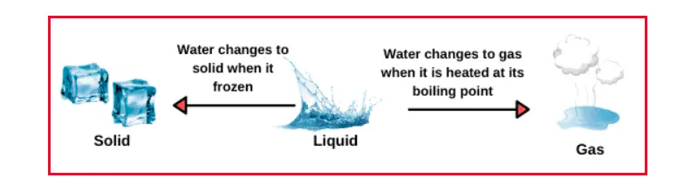

##### **Example4:**

One of the best real-time examples of polymorphism is Women in society. The same woman performs a different role in society. The woman can be the wife of someone, the mother of her child, can be doing a job in an organization, and many more at the same time. But the Woman is only one. So, the same woman performing different roles is nothing but performing polymorphism.



##### **Types of Polymorphism in C#:**

There are two types of polymorphism in C#. They are as follows:

1. **Static Polymorphism / Compile-Time Polymorphism / Early Binding**
2. **Dynamic Polymorphism / Run-Time Polymorphism / Late Binding**

The following diagram shows different types of polymorphisms in C# with their examples.

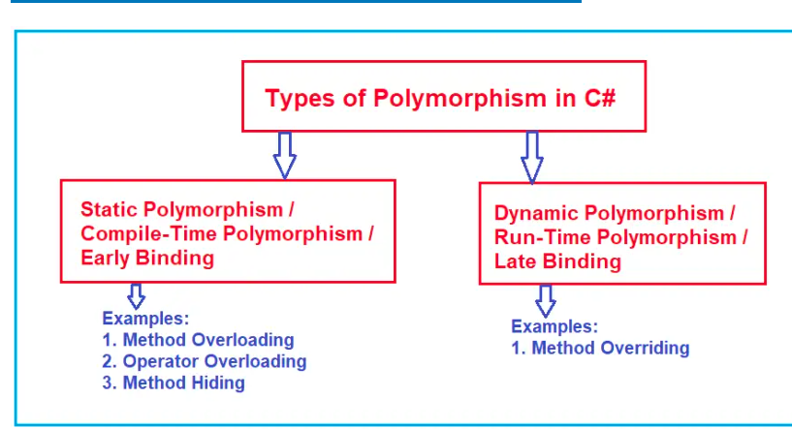

he polymorphism in C# can be implemented using the following three ways.

1. [**Method Overloading**](https://dotnettutorials.net/lesson/function-overloading-csharp/)
2. [**Operator Overloading**](https://dotnettutorials.net/lesson/operator-overloading-in-csharp/)
3. [**Method Overriding**](https://dotnettutorials.net/lesson/function-overriding-csharp/)
4. [**Method Hiding**](https://dotnettutorials.net/lesson/function-hiding-csharp/)

**Note:** While working with Polymorphism in C# we need to understand two things i.e. what happens at the time of compilation and what happens at the time of execution for a given method call. Is the method going to be executed from the same class at run-time which is bounded to the class at the compile time or is the method going to be executed from a different class at run-time rather than the class bounded at compile time?

##### **What is Compile-Time Polymorphism in C#?**

The function call is bounded to the class at the time of compilation, if the function is going to be executed from the same bounded class at run-time, then it is called Compile-Time Polymorphism in C#. This happens in the case of Method Overloading because, in this case, each method will have a different signature, and based on the method call, we can easily recognize the method which matches the method signature.

In static polymorphism, the behavior of a method is decided at compile time. That means the C# compiler binds method calls with method definition/body during compilation time only. Therefore, this type of polymorphism is also called compile-time polymorphism in C#. As the binding (the link between the function call and function definition) is performed at compile time, it is also known as early binding.

##### **Example to Understand Compile Time Polymorphism in C#:**

In the below example, within the Program class, we have defined three overloaded versions of the Add method but with different signatures. In this case, at compilation time only we will come to know and the method binding is resolved at runtime which method is going to be executed. If this is not clear at the moment, then don’t worry, we will discuss this concept in detail in our [**Method Overloading**](https://dotnettutorials.net/lesson/function-overloading-csharp/) article.

using System;

namespace MethodOverloading

{

class Program

{

public void Add(int a, int b)

{

Console.WriteLine(a + b);

}

public void Add(float x, float y)

{

Console.WriteLine(x + y);

}

public void Add(string s1, string s2)

{

Console.WriteLine(s1 + " " + s2);

}

static void Main(string[] args)

{

Program obj = new Program();

obj.Add(10, 20);

obj.Add(10.5f, 20.5f);

obj.Add("Pranaya", "Rout");

Console.ReadKey();

}

}

}

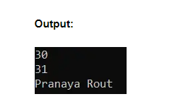

##### **What is Runtime Polymorphism in C#?**

In dynamic polymorphism, the behavior of a method is decided at runtime, therefore, the CLR (Common Language Runtime) binds the method call with method definition/body at runtime and invokes the relevant method during runtime when the method is called.

The function call is bounded to the class at the time of compilation, if the function is going to be executed from a different class at run-time rather than the class bounded at compilation time, then it is called Run-Time Polymorphism. This happens in the case of Method Overridingbecause, in the case, we have multiple methods with the same signature i.e. Parent Class and the Child class have the same method implementation. So, in this case, we will be able to know at runtime from which class the method is going to be executed.

It is also called Dynamic Polymorphism or Late Binding as at Run-time we will be able to know from which class the method is going to be executed.

##### **Example to Understand Dynamic Polymorphism in C#:**

In the below example, we have created one virtual method in the class Class1 and we have re-implement that method inside the class Class2. That means the same Show method implementation is available in both Parent and Child classes. In the Main method, then we are creating an instance of the child class but storing that instance in the Parent class reference variable, in this case, from which class, the Show method to be executed will decide at runtime only. This is nothing but dynamic polymorphism. If this is not clear at the moment, then don’t worry, we will discuss this concept in detail in our [**Method Overriding**](https://dotnettutorials.net/lesson/function-overriding-csharp/) article.

using System;

namespace PolymorphismDemo

{

class Class1

{

//Virtual Function (Overridable Method)

public virtual void Show()

{

//Parent Class Logic Same for All Child Classes

Console.WriteLine("Parent Class Show Method");

}

}

class Class2 : Class1

{

//Overriding Method

public override void Show()

{

//Child Class Reimplementing the Logic

Console.WriteLine("Child Class Show Method");

}

}

class Program

{

static void Main(string[] args)

{

Class1 obj1 = new Class2();

obj1.Show(); //Resolve at Runtime

Console.ReadKey();

}

}

}

**Output: Child Class Show Method**

## **Partial Class and Partial Methods in C# with Examples**

In this article, I am going to discuss **Partial Class and Partial Methods in C#** with Examples. Please read our previous article, where we discussed [**Method Hiding in C#**](https://dotnettutorials.net/lesson/function-hiding-csharp/). At the end of this article, you will understand what are Partial classes and Partial Methods and when and how to use Partial Classes and Partial Methods in C# with Examples.

##### **What is Partial Class in C#?**

Partial Class is the new feature that has been added in C# 2.0 which allows us to define a class on multiple files i.e. we can physically split the content of the class into different files but even physically they are divided but logically it is one single unit only. A class in which code can be written in two or more files is known as a partial class. To make any class partial we need to use the keyword partial.

According to Microsoft, It is possible to split the definition of a class over two or more source files. It is also possible to split the definition of a struct or an interface over two or more source files which we will discuss when we discuss the C# 8 new features. Each source file contains a section of the type i.e. class definition, and all parts are combined when the application is compiled.

##### **Understanding Partial Class in C# with an Example:**

Now, let us understand Partial Class with an example. First, create a console application and then add a class file with the name Employee.cs. Once you add the class file, then copy and paste the following code into it. Here, please notice the class name is Employee and in this class, we have declared 4 auto-implemented properties i.e. FirstName, LastName, Gender, and Salary. Here, we have also declared 2 public methods i.e. DisplayFullName and DisplayEmployeeDetails.

using System;

namespace PartialClassDemo

{

public class Employee

{

public string FirstName { get; set; }

public string LastName { get; set; }

public string Gender { get; set; }

public double Salary { get; set; }

public void DisplayFullName()

{

Console.WriteLine($"Full Name is : {FirstName} {LastName}");

}

public void DisplayEmployeeDetails()

{

Console.WriteLine("Employee Details : ");

Console.WriteLine($"First Name : {FirstName}");

Console.WriteLine($"Last Name : {LastName}");

Console.WriteLine($"Gender : {Gender}");

Console.WriteLine($"Salary : {Salary}");

}

}

}

This is a very simple Employee class having 4 auto-implemented public properties, and 2 public methods. Now, let us consume the above class. Please modify the Program class which contains the Main method as shown below. Here, we are creating an instance of the Employee class and setting values for the four properties, and then invoking the DisplayFullName and DisplayEmployeeDetails method which is going to display the employee’s full name and employee information on the console window.

using System;

namespace PartialClassDemo

{

class Program

{

static void Main(string[] args)

{

Employee emp = new Employee

{

FirstName = "Pranaya",

LastName = "Rout",

Salary = 100000,

Gender = "Male"

};

emp.DisplayFullName();

emp.DisplayEmployeeDetails();

Console.ReadKey();

}

}

}

This is a very simple Employee class having 4 auto-implemented public properties, and 2 public methods. Now, let us consume the above class. Please modify the Program class which contains the Main method as shown below. Here, we are creating an instance of the Employee class and setting values for the four properties, and then invoking the DisplayFullName and DisplayEmployeeDetails method which is going to display the employee’s full name and employee information on the console window.

using System;

namespace PartialClassDemo

{

class Program

{

static void Main(string[] args)

{

Employee emp = new Employee

{

FirstName = "Pranaya",

LastName = "Rout",

Salary = 100000,

Gender = "Male"

};

emp.DisplayFullName();

emp.DisplayEmployeeDetails();

Console.ReadKey();

}

}

}

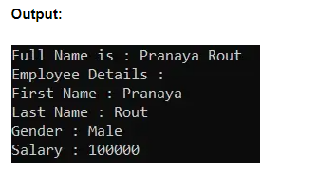

##### **Splitting Above Class Definition into 2 Files using Partial Classes in C#.**

Now what we are going to do is, we will split the above Employee class definition into two different class files. One class file is going to contain all 4 public auto-implemented properties (FirstName, LastName, Gender, and Salary), and the other class file is going to contain the two public methods i.e. DisplayFullName and DisplayEmployeeDetails that we have defined inside the Employee class.

First, delete the Employee.cs class file from the project. Then we need to add two class files with the name PartialEmployeeOne and PartialEmployeeTwo. The PartialEmployeeOne class file going to contain all 4 public auto-implemented properties (FirstName, LastName, Gender, and Salary), and the PartialEmployeeTwo class file going to contain the two public DisplayFullName and DisplayEmployeeDetails methods. Even though the class file names are different, the class name is going to be the same, and in this case, we are providing the class name as  PartialEmployee in both the class file as well as we are making the class as partial by using the partial keyword.

###### ****Adding**** ****PartialEmployeeOne.cs****

In order to add the PartialEmployeeOne.cs class file, right-click on the project and then add a class file with the name PartialEmployeeOne.cs and then copy and paste the following code into it. Notice that in the below code, the PartialEmployee class is marked with the partial keyword and it contains only the 4 public properties as per our requirements.

namespace PartialClassDemo

{

public partial class PartialEmployee

{

public string FirstName { get; set; }

public string LastName { get; set; }

public string Gender { get; set; }

public double Salary { get; set; }

}

}

**Note:** Here the class file name is PartialEmployeeOne.cs but the class name is PartialEmployee and the class is marked with the partial keyword which makes it a partial class.

###### ****Adding**** ****PartialEmployeeTwo.cs****

Now let us add the PartialEmployeeTwo.cs class file to our project. To do so, right-click on the project and add a class file with the name PartialEmployeeTwo.cs and then copy and paste the following code into it. Notice that in the below code, the PartialEmployee class is also marked with the partial keyword and it contains only the two public methods as per our requirements. But the point that you need to observe is, here, we are able to access the properties that are defined in PartialEmployeeOne.cs class file and this is possible because of the partial class

using System;

namespace PartialClassDemo

{

public partial class PartialEmployee

{

public void DisplayFullName()

{

Console.WriteLine($"Full Name is : {FirstName} {LastName}");

}

public void DisplayEmployeeDetails()

{

Console.WriteLine("Employee Details : ");

Console.WriteLine($"First Name : {FirstName}");

Console.WriteLine($"Last Name : {LastName}");

Console.WriteLine($"Gender : {Gender}");

Console.WriteLine($"Salary : {Salary}");

}

}

}

Here the class file name is PartialEmployeeTwo.cs but the class name is PartialEmployee and we also marked this class as partial by using the partial keyword. Even though the PartialEmployee class definition is split into multiple class files, after compilation, they will be grouped together and will become a single class only.

##### **Using the Partial Class in C#:**

Now, we are going to use the Partial classes whose definition is split across two different class files. We need to use the Partial class just like a normal class. We can create an instance and we can also invoke the members using the instance. So, modify the Main method of the Program class as shown below to use the PartialEmployee class. Here, you can see that we are creating an instance of the PartialEmployee class, setting the 4 property values, and then invoking the two public methods.

using System;

namespace PartialClassDemo

{

class Program

{

static void Main(string[] args)

{

PartialEmployee emp = new PartialEmployee()

{

FirstName = "Pranaya",

LastName = "Rout",

Salary = 100000,

Gender = "Male"

};

emp.DisplayFullName();

emp.DisplayEmployeeDetails();

Console.ReadKey();

}

}

}

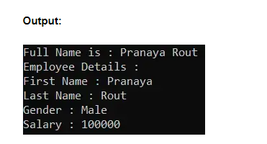

Now, you can see we are getting the same output as the previous example. Now, even though we have created two class files and split the class definition inside two class files, after compilation both the partial classes are combined into a single class. To prove this, open Visual Studio Developer Command Prompt and then open the ILDASM tool and see the IL Code of the above program. Once you open the ILDASM code, then you will see that there is only one PartialEmployee class as shown in the below image.

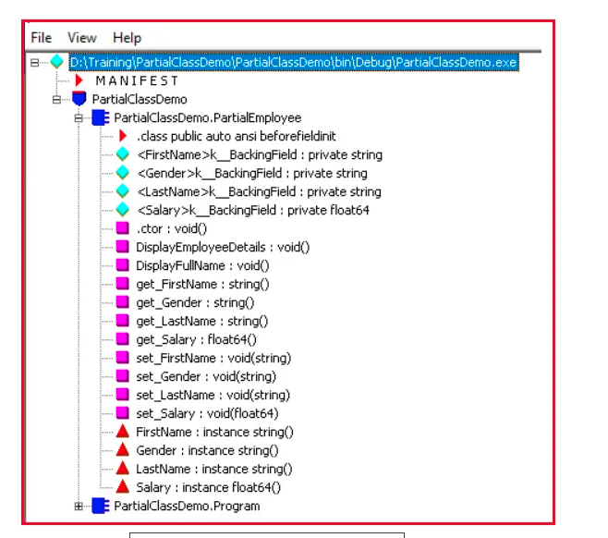

So, the point that you need to remember is that even though the partial class definition splits into multiple files, after compilation they will become a single class.

##### **When do we need to use Partial Class in C#?**

There are several situations when splitting a class definition is desirable

1. When working on large projects, splitting a class over separate files allows multiple programmers to work on it simultaneously.
2. When working with automatically generated source code, the code can be added to the class without having to recreate the source file. Visual Studio uses this approach when creating windows form, Web service wrapper code, and so on.

In My Project, I am using Entity Framework Database First Approach. In that case, the Entity Framework will create the models i.e. the classes based on the database and it creates the classes as partial classes. Next, I want to do some modifications with the auto-generated partial classes like adding some additional properties or adding some attributes. But, if I do the modification with the auto-generated partial classes, then my changes will be lost when I update the EDMX file. So, what I generally do is, create a partial class, and in that partial class, I do all the customization.

##### **Rules to follow while working with Partial Classes in C#:**

**Rule1:**All the parts that contain the class definition must use the partial keyword. All the parts must be available at compile time to form the final type. Otherwise, we will get a compilation error stating **Missing partial modifier. Another partial declaration of this type exists.**For a better understanding, please have a look at the below example code. Here, we can see that in this first definition we have uses the partial keyword and but in the second definition of the class, we have not used the partial keyword, and hence the compiler throws one compilation error.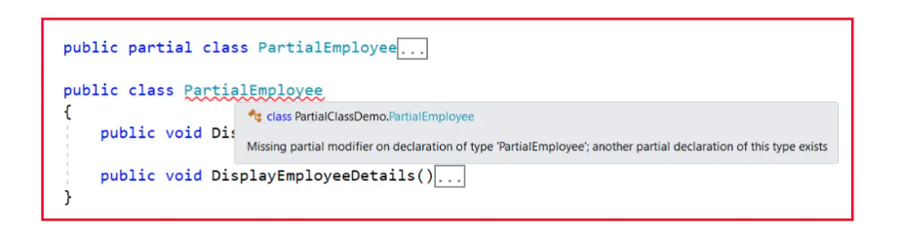

**Rule2:** All the parts of the partial class must have the same access modifier. If we try to use different access modifiers in different parts of the partial class, then we will get a compilation error saying that **Partial declarations have conflicting accessibility modifiers.** For a better understanding, please have a look at the below example code. Here, you can see that in the first definition of the PartialEmployee class we have used public access specifier, and in the second definition of the PartialEmployee class we have used internal access specifier and hence the compiler throws one compilation error.

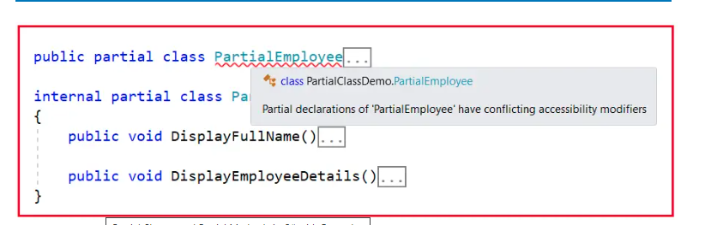

**Rule3:** If any of the parts are declared as abstract, then the entire type is considered as abstract or if any of the parts are declared as sealed, then the entire type is considered as sealed or if any of the parts inherit a class, then the entire type inherits that class**.** Here, you can see, one of the parts we declared as abstract, and hence the complete class becomes abstract and as we know we cannot create an instance of an abstract class. And here when we are trying to create an instance of the PartialEmployee class which is an abstract class, the compiler throws one compilation error.

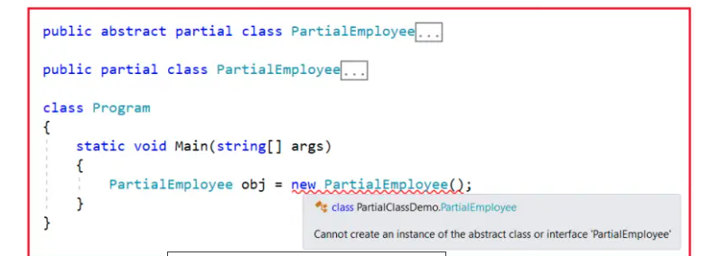**Rule4:**C#.NET does not support multiple class inheritance that we already discussed in our [**Multiple Inheritance**](https://dotnettutorials.net/lesson/multiple-inheritance-csharp/) article become of the ambiguity problem. That means different parts of the partial class must not specify different base classes. If we specify different bases class, then we will get a compilation error saying **Partial declarations must not specify different base classes**. For a better understanding, please have a look at the below example code. Here, you can see that one part of the Partial Class inherits from the Employee base class and the other part of the Partial class inherits from the Customer base. That means now the Partial class has two base classes making this multiple inheritance with classes which is not possible in C# and hence the compiler throws one compilation error.

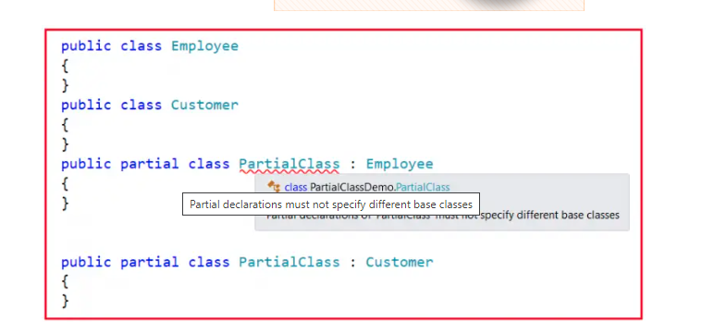**Rule5:** But it is possible with Partial classes that the different parts of the partial class can specify different base interfaces and the final type should and must implement all the interface methods. In the following example, the PartialClass needs to provide the implementation for both IEmployee and ICustomer interface methods. This is possible because a class can not have more than one base class, but a class can have more than one base interface and this is how we can implement multiple inheritances in C# with interfaces.

namespace PartialClassDemo

{

public interface IEmployee

{

void EmployeeMethod();

}

public interface ICustomer

{

void CustomerMethod();

}

public partial class PartialClass : IEmployee

{

public void EmployeeMethod()

{

//Method Implementation

}

}

public partial class PartialClass : ICustomer

{

public void CustomerMethod()

{

//Method Implementation

}

}

}

**ote:** Any members that are declared in a partial definition are available to all of the other parts of the partial class. Once we understand Partial Classes, now let’s move further and try to understand Partial Methods in C#.

##### **What are Partial Methods in C#?**

A partial class may contain a partial method. One part of the class contains the signature of the method. An implementation of the Partial Method can be defined in the same part or other parts of the Partial Class. If the implementation is not supplied, then the method and all calls to the partial method are removed by the compiler at the time of compilation.

Let us understand partial methods with an example. Create a console application. Add a class file with the name PartialClassOne.cs to the project and then copy and paste the following code into it.

using System;

namespace PartialClassDemo

{

partial class PartialClass

{

// Declaration of the partial method.

partial void PartialMethod();

// A public method calling the partial method

public void PublicMethod()

{

Console.WriteLine("Public Method Invoked");

PartialMethod();

}

}

}

ethod, and further notice this partial method does not have its body, it contains only the method signature. The implementation of this Partial you can provide in this class definition or you can also provide the implementation in other parts of this partial class. But the most important point that you need to remember is that the implementation of a partial method is optional. If we don’t provide the implementation, then the method and all calls to the partial method are simply removed by the compiler at the time of compilation. Now, if you build the application and if you see the IL code using the ILDASM tool, then you will see that the Partial method is removed from the Partial class as well as the call to the partial method from the public method is also removed as shown in the below image.

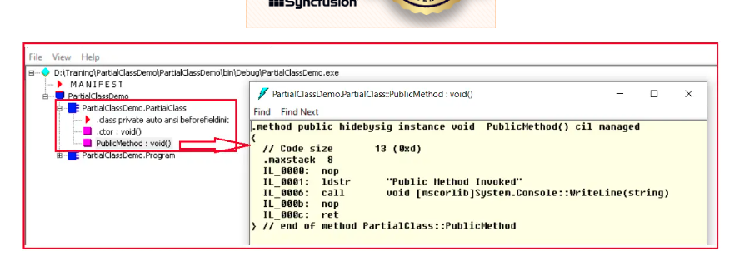

In this example, the partial PartialMethod() is invoked within the PublicMethod() but we don’t have the partial method implementation. To prove this, copy and paste the following code in the Main() method of the Program class. Here, we are creating an instance of the Partial Class and invoking the public method.

using System;

namespace PartialClassDemo

{

class Program

{

static void Main(string[] args)

{

PartialClass SC = new PartialClass();

SC.PublicMethod();

Console.ReadKey();

}

}

}

**Output:** **Public Method Invoked**

When we run the above application, notice that we don’t get a compiler error, in spite of not having an implementation for the partial PartialMethod(). Since the implementation of the partial method is missing, the compiler will remove the signature and all calls to the method.

The implementation of the Partial Methods as discussed can be provided in the same part or in other parts of the partial class. Now, let us add a class file with the name PartialClassTwo.cs and then copy and paste the following code into it. The implementation of the partial method is provided here.

using System;

namespace PartialClassDemo

{

partial class PartialClass

{

// Partial method implemented

partial void PartialMethod()

{

Console.WriteLine("Partial PartialMethod Invoked");

}

}

}

Now, run the console application again, and please observe the output. This time, both the partial method and the public method messages are printed on the console as shown below.



##### **Rules to Follow while working with Partial Methods in C#:**

While working with Partial Methods in C#, we need to follow some rules and regulations. Let us understand all those rules and regulations one by one with examples.

**Rule1:** Partial methods in C# are private by default and we can use any access specifier explicitly, and if we try to use any access specifier explicitly like public, private, protected, etc, then we will get a compiler stating **A partial method cannot have access modifiers or the virtual, abstract, override, new, sealed, or extern modifiers.**For a better understanding, please have a look at the below example code. Here, we are explicitly trying to use a private access modifier with the partial method, and hence the compiler throws an error.

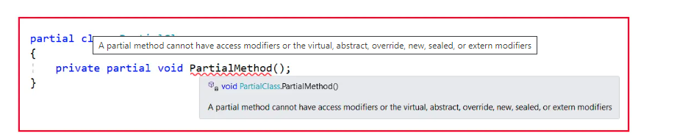

**Rule2:** Partial method declaration and implementation should not be at the same time. Its declaration should be at one place and its implementation must be at a different place either in the same part or in other parts of the partial class. If we include both declaration and implementation at the same time, then we will get a compiler error saying **No defining declaration found for implementing declaration of partial method ‘PartialDemo.PartialClass.partialMethod()’**. For a better understanding, please have a look at the below example code. Here, we are declaring and implementing the partial method at the same time and hence we are getting a compiler error.

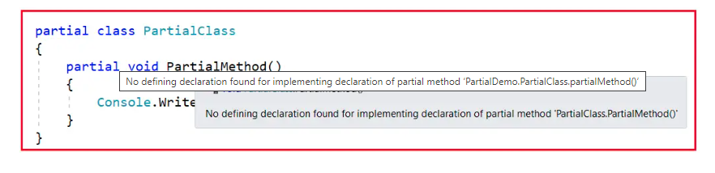

**Rule3:** A partial method return type must be void. If we try to use any other return type like int, string, bool, etc. then we will get a compiler error saying **Partial methods must have a void return type.**For a better understanding, please have a look at the below example code. Here, we are trying to make the return type as int and hence the compiler throws an error.

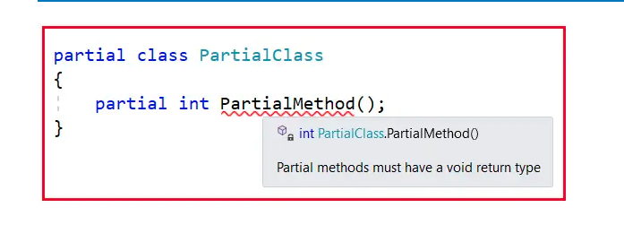

**Rule4:** A partial method must and should be declared within a partial class or partial struct. A non-partial class or struct cannot include partial methods. If we try to define a partial method under a non-partial class or struct, then we will get a compile-time error saying **A partial method must be declared within a partial class or partial struct**. For a better understanding, please have a look at the below code. Here, we are trying to define a partial method under a non-partial class and hence the compiler throws an error.

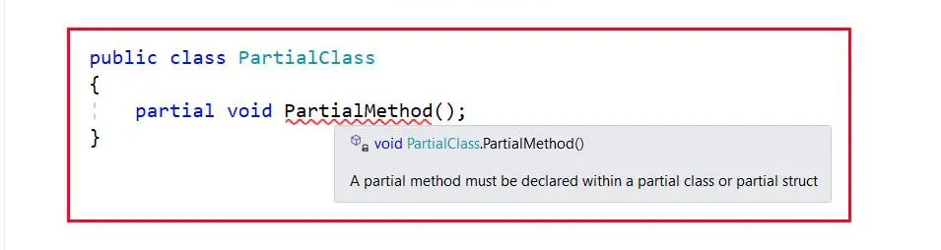

**Rule5:** The signature of the partial method declaration must match the signature of the implementation else we will get a compilation error. For a better understanding, please have a look at the following code. Here, in the first part of the partial class, we have defined the partial method with one integer parameter and in the second part of the partial class where we are providing the implementation, we are not including the integer parameter and hence the compiler throws an error.

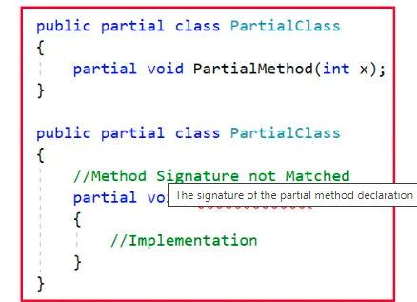

**Rule6:** A partial method can be implemented only once either in the same part or in other parts of the partial class. If we try to implement a partial method more than once, then we will get a compilation error saying **A partial method may not have multiple implementing declarations.**For a better understanding, please have a look at the below example code. Here, in the first part, we have declared the partial method and in the second part and in the part we are providing implementation to the partial method, and as we are providing two implementations we are getting the compilation error. This is because, in a class, we cannot define two methods with the same name and same parameters i.e. method overriding is not possible in a single class.

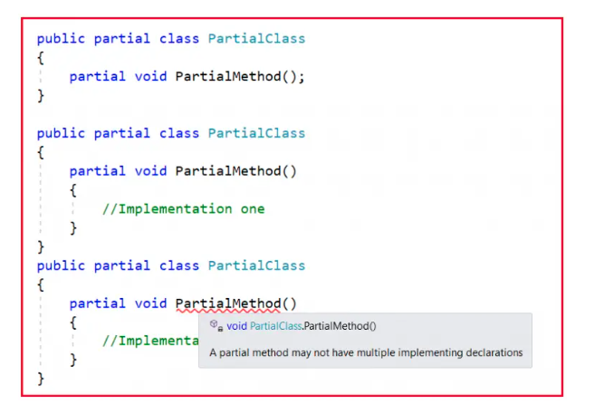

## **Sealed Class and Sealed Methods in C# with Examples**

In this article, I am going to discuss **Sealed Class and Sealed Methods in C#**with Examples. Please read our previous article where we discussed [**Partial Classes and Partial Methods in C#**](https://dotnettutorials.net/lesson/partial-classes-partial-methods-csharp/). At the end of this article, you will understand what exactly Sealed Class and Sealed Methods in C# are and when and how to use them with examples.

##### **Sealed Class in C#**

A class from which it is not possible to create/derive a new class is known as a sealed class. In simple words, we can say that when we define the class using the sealed modifier, then it is known as a sealed class and a sealed class cannot be inherited by any other classes.

To make any class a sealed class we need to use the keyword sealed. The keyword sealed tells the compiler that the class is sealed, and therefore, cannot be extended. No class can be derived from a sealed class. For a better understanding, please have a look at the below code.

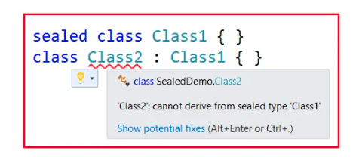

##### **Points to Remember while working with Sealed Class in C#**

1. A sealed class is completely the opposite of an abstract class.
2. The sealed class cannot contain any abstract methods.
3. It should be the bottom-most class within the inheritance hierarchy.
4. A sealed class can never be used as a base class.
5. The sealed class is specially used to avoid further inheritance.
6. The keyword sealed can be used with classes, instance methods, and properties.

**Note:** Even if a sealed class cannot be inherited, we can still consume the class members from any other class by creating the object of the class.

##### **Example to Understand Sealed Class in C#:**

Please have a look at the following example to understand the sealed class in C#. Here, first, we created the Employee class, and then we created the Manager class inherited from the Employee class. And here we marked the Manager class as sealed and hence no further inheritance. Here, you can see while creating the TempManager class from the Manager class, we will get compile time error saying that **‘TempManager’: cannot derive from sealed type ‘Manager’**. See, inheritance is not possible, but we can create an instance of the sealed and consume the members from outside the class. So, inside the Main method, we are creating an instance of the Manager class and invoking the two methods.

using System;

namespace SealedDemo

{

public class Employee

{

protected int Eid, Eage;

protected string Ename, Eaddress;

public virtual void GetEmployeeData()

{

Console.WriteLine("Enter Emplpyee Details:");

Console.Write("Enter Employee ID:");

Eid = int.Parse(Console.ReadLine());

Console.Write("Enter Employee Name:");

Ename = Console.ReadLine();

Console.Write("Enter Employee Address:");

Eaddress = Console.ReadLine();

Console.Write("Enter Employee Age:");

Eage = int.Parse(Console.ReadLine());

}

public virtual void DisplayEmployeeData()

{

Console.WriteLine("\nEmplpyee Details Are:");

Console.WriteLine($"Employee ID: {Eid}");

Console.WriteLine($"Employee Name: {Ename}");

Console.WriteLine($"Employee Address: {Eaddress}");

Console.WriteLine($"Employee Age: {Eage}");

}

}

public sealed class Manager : Employee

{

double Bonus, Salary;

public override void GetEmployeeData()

{

Console.WriteLine("Enter Manager Details:");

Console.Write("Enter Manager ID:");

Eid = int.Parse(Console.ReadLine());

Console.Write("Enter Manager Name:");

Ename = Console.ReadLine();

Console.Write("Enter Manager Salary:");

Salary = Convert.ToDouble(Console.ReadLine());

Console.Write("Enter Manager Bonus:");

Bonus = double.Parse(Console.ReadLine());

}

public override void DisplayEmployeeData()

{

Console.WriteLine("\nManager Details Are:");

Console.WriteLine($"Manager ID: {Eid}");

Console.WriteLine($"Manager Name: {Ename}");

Console.WriteLine($"Manager Salary: {Salary}");

Console.WriteLine($"Manager Bonus: {Bonus}");

}

}

//Further No Inheritance is Possible as we marked the class as sealed

//public class TempManager : Manager

//{

//}

class Program

{

static void Main(string[] args)

{

Manager m1 = new Manager();

m1.GetEmployeeData();

m1.DisplayEmployeeData();

Console.ReadKey();

}

}

}

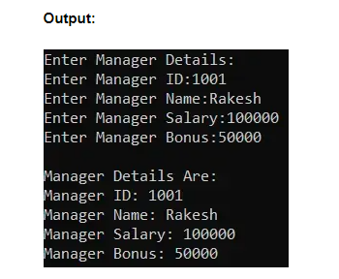

##### **Sealed Methods in C#**

The method that is defined in a parent class, if that method cannot be overridden under a child class, we call it a sealed method. That means by default, every method is a sealed method because overriding is not possible unless the method is not declared as virtual in the parent class. If a method is declared as virtual in a class, any child class of it can have the right to override that method. For example:

namespace SealedDemo

{

class Parent

{

public virtual void Show() { }

}

class Child : Parent

{

public override void Show() { }

}

class GrandChild : Child

{

public override void Show() { }

}

}

As you can see in the above code, the class Child overrides the Parent class Show method and again the GrandChild class also overrides the Show method. Now, if you want to restrict the GrandChild class not to override the Show method, then you need to use the sealed modifier along with the override modifier in the Child class. This will restrict the method to be overridden in the derived classes. For a better understanding, please have a look at the below example.

namespace SealedDemo

{

class Parent

{

public virtual void Show() { }

}

class Child : Parent

{

public sealed override void Show() { }

}

class GrandChild : Child

{

//'GrandChild.Show()': cannot override inherited member 'Child.Show()' because it is sealed

public override void Show() { }

}

}

So, the point that you need to remember is every method by default is sealed in C# and hence they cannot be overridden under the child class. But if you declare a method as virtual then that method can be overridden under the child classes as well as under the grandchild classes also. If you want to restrict the method, not be overridden under the grandchild classes then you need to make the method sealed inside the child class. S, the point that you need to remember is that if you want to declare a method as sealed, then it has to be declared as virtual in its base class.

##### **Real-Time Example to Understand Sealed Class and Sealed Method in C#:**

Now, let us understand the sealed class and sealed method with one real-time example. In the following example, the Printer is the Parent class and, in this class, we have defined two virtual methods. The Printer class Display method displays the unit with a dimension of 5×5 and the print method simply prints the same. Then the LaserJet class overrides the Display method to have the dimension of 10×10. If any class is going to inherit from the LaserJet class, then that class in our example InkJet class will have the same dimension of 10×10 and cannot implements its own, like 15×15, 16×16, or anything, because the Display method is marked as sealed. The following example code is self-explained and please go through the comment lines.

using System;

namespace SealedDemo

{

public class Printer

{

//The Printer class declaring two virtual methods

public virtual void Display()

{

Console.WriteLine("Display Dimension: 5x5");

}

public virtual void Print()

{

Console.WriteLine("Printer Printing...\n");

}

}

public class LaserJet : Printer

{

//The LaserJet class Overriding the two parent class virtal methods

//But making the Display method as sealed, so the child classes of LaserJet class

//will not override this method

public sealed override void Display()

{

Console.WriteLine("Display Dimension: 10x10");

}

//The Print method can be override under the Child class of LaserJet class

public override void Print()

{

Console.WriteLine("LaserJet Printer Printing...\n");

}

}

//The InkJet class can not override the Display Method as it is marked sealed in LaserJet class.

//So, InkJet will have same Display feature i.e it also has "Display Dimention: 10x10".

public sealed class InkJet : LaserJet

{

//The following method overriding will give compile time error

//'InkJet.Display()': cannot override inherited member 'LaserJet.Display()' because it is sealed

//public override void Display()

//{

// Console.WriteLine("Some Different Display Dimension");

//}

public override void Print()

{

Console.WriteLine("InkJet Printer Printing...");

}

}

//As we marked the InkJet class as sealed so more inheritance using InkJet class

//The following inheritance will give you compile time error

//'DotMatrix': cannot derive from sealed type 'InkJet'

//class DotMatrix : InkJet

//{

//}

class Program

{

static void Main(string[] args)

{

Printer printer = new Printer();

printer.Display();

printer.Print();

LaserJet laserJet = new LaserJet();

laserJet.Display();

laserJet.Print();

InkJet inkJet = new InkJet();

inkJet.Display();

inkJet.Print();

Console.ReadKey();

}

}

}

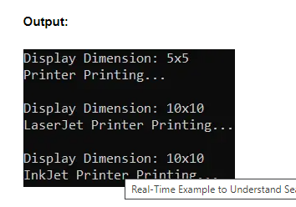

**Note:** In Inheritance, the sealed class is the bottom-most class because from this class no more inheritance is possible.

##### **When should a method be declared as sealed in C#?**

If we don’t allow subclasses to override the superclass method and ensure that all sub-classes use the same superclass method logic then that method should be declared as sealed. The sealed method cannot be overridden in sub-classes violation leads to a compile-time error.

##### **What is the difference between the private and sealed methods in C#?**

The private method is not inherited whereas the sealed method is inherited but cannot be overridden in C#. So, a private method cannot be called from sub-classes whereas a sealed method can be called from sub-classes. The same private method can be defined in sub-class and it does not lead to error. For a better understanding, please have a look at the following example. The following example code is self-explained, so please go through the comment lines

using System;

namespace SealedDemo

{

public class Class1

{

public virtual void Method1()

{

Console.WriteLine("Class1 Method1");

}

}

public class Class2 : Class1

{

//Private Method

private void Method2()

{

Console.WriteLine("Class2 Private Method2");

}

//Sealed Method

public sealed override void Method1()

{

Console.WriteLine("Class2 Sealed Method1");

}

}

public class Class3 : Class2

{

//We cannot override Method1 because it is sealed in Class2

//But this method is inherited and hence we can access this method

//using Class3 instance

//public override void Method1()

//{

// Console.WriteLine("InkJet Printer Printing...");

//}

//Class2 Private Method Method2 is not inherited to child class and hence

//you can define the same method here

public void Method2()

{

Console.WriteLine("Class3 public Method2");

}

}

class Program

{

static void Main(string[] args)

{

Class2 obj1 = new Class2();

obj1.Method1();

Class3 obj3 = new Class3();

obj3.Method1();

obj3.Method2();

Console.ReadKey();

}

}

}

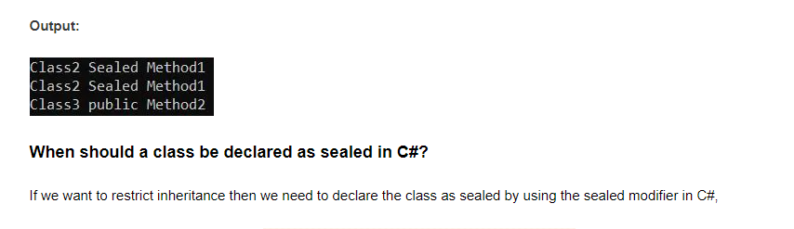

##### **What are the differences between an abstract class and a sealed class in C#?**

###### ****Abstract Class in C#:****

1. A class that contains one or more abstract methods is known as an abstract class.
2. The abstract class can contain abstract and non-abstract methods.
3. Creating a new class from an abstract class is compulsory to consume the abstract class non-abstract members.
4. An abstract class cannot be instantiated directly; we need to create the object for its child classes to consume an abstract class.
5. We need to use the keyword abstract to make any class abstract.
6. An abstract class cannot be the bottom-most class within the inheritance hierarchy.

###### ****Sealed Class in C#:****

1. A class from which it is not possible to derive a new class is known as a sealed class.
2. The sealed class can contain non-abstract methods; it cannot contain abstract and virtual methods.
3. It is not possible to create a new class from a sealed class.
4. We should create an object for a sealed class to consume its members.
5. We need to use the keyword sealed to make any class sealed.
6. The sealed class should be the bottom-most class within the inheritance hierarchy.

## **Method Overloading in C# with Examples**

In this article, I am going to discuss **What is Method Overloading in C#** and what is the use of method overloading in our application development with Examples. Please read our previous article before proceeding to this article where we discussed the basics of [**Polymorphism in C#**](https://dotnettutorials.net/lesson/polymorphism-csharp/). At the end of this article, you will have a very good understanding of the following pointers related to Method Overloading.

1. **What is Method Overloading in C#?**
2. **When should we Overload Methods?**
3. **What are the advantages of using Method Overloading in C#?**
4. **When is a method Considered an overloaded method?**
5. **What is Inheritance Based Method Overloading?**
6. **Real-Time Scenarios where you need to use Method Overloading?**
7. **What is Constructor Overloading in C#?**
8. **Real-Time Example Logging using Method Overloading in C#?**

**Note:** The point that you need to keep in mind is function overloading and method overloading terms are interchangeably used. Method overloading is one of the common ways to implement Compile-Time Polymorphism in C#.

##### **What is Method Overloading or Function Overloading in C#?**

Method Overloading means it is an approach to defining multiple methods under the class with a single name. So, we can define more than one method with the same name in a class. But the point that you need to remember the parameters of all those methods should be different (different in terms of number, type, and order of the parameters).

So, if we are defining multiple methods with the same name but with a different signature in a class or in the Parent and Child Classes, then it is called Method Overloading in C#. That means C#.NET not only allows method overloading in the same class but also allows method overloading in Parent and Child classes. So, we can create a method in the Derived/Child class with the same name as the method name defined in the Base/Parent class in C#.

In simple words, we can say that the Method Overloading in C# allows a class to have multiple methods with the same name but with a different signature. The functions or methods can be overloaded based on the number, type (int, float, etc), order, and kind (Value, Ref or Out) of parameters. For a better understanding, please have a look at the below image. All the Methods are going to be valid and based on the method call, the compiler will automatically decide which overloaded version to be invoked.

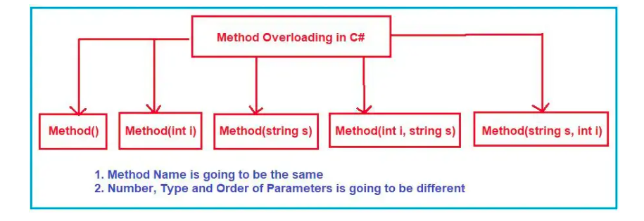

As you can see in the above image, all the methods are having the same name i.e. Method but with different parameters. If you look at the first two methods the number of parameters is different. The first method takes zero parameters while the second method takes one parameter. Then if you compare the second method with the third method, both are taking the same number of parameters but of different types. The second method takes an integer parameter while the Third method takes a string parameter. Further, if you compare the fourth and fifth method, both are having the same number of parameter but the order of the parameters are different. The fourth method takes the first parameter as an integer and the second parameter as a string while the Fifth method takes the first parameter as a string and the second parameter as an integer. So, every method is different in terms of number, type, and order of parameters, and this is called method overloading in C#.

The signature of a method consists of the name of the method and the data type, number, order, and kind (Value, Ref or Out) of parameters. The point that you need to keep in mind is that the signature of a method does not include the return type and the params modifiers. So it is not possible to overload a method just based on the return type and params modifier. We will discuss Params modifier in our upcoming article.

##### **Example to Understand Method Overloading in C#:**

using System;

namespace MethodOverloading

{

class Program

{

static void Main(string[] args)

{

Program obj = new Program();

obj.Method(); //Invoke the 1st Method

obj.Method(10); //Invoke the 2nd Method

obj.Method("Hello"); //Invoke the 3rd Method

obj.Method(10, "Hello"); //Invoke the 4th Method

obj.Method("Hello", 10); //Invoke the 5th Method

Console.ReadKey();

}

public void Method()

{

Console.WriteLine("1st Method");

}

public void Method(int i)

{

Console.WriteLine("2nd Method");

}

public void Method(string s)

{

Console.WriteLine("3rd Method");

}

public void Method(int i, string s)

{

Console.WriteLine("4th Method");

}

public void Method(string s, int i)

{

Console.WriteLine("5th Method");

}

}

}

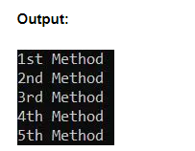

##### **Why Return Type is not considered as part of Method Overloading in C#?**

Let us understand why return type is not considered as part of method overloading with an example. Please have a look at the following image. Here, I have written two methods with the same name but one method’s return type is void, and the other method’s return type is a string. See, as soon as we create the second method, the compiler itself gives the compile time error saying **Type ‘Program’ already defines a member called ‘Method’ with the same parameter types.**

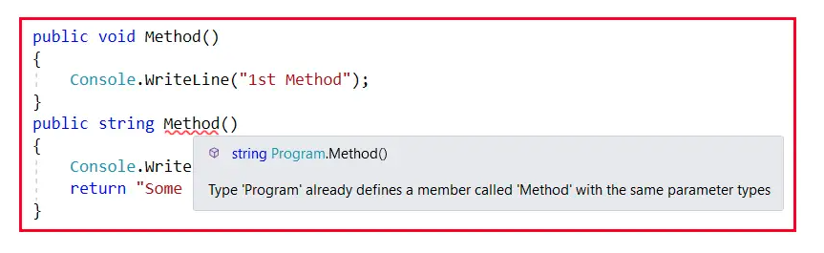

So, at the time of defining the method, only the compiler gave us an error. Now, still, you may have doubt, return types are different, then why it is going to be invalid. To understand, let us try to invoke the Method as shown in the below image. So, when we invoke the method, can you tell me which version of the Method is going to be invoked? Because we have two methods that do not take any parameter. So, here we will get the ambiguity problem and see the compiler also giving the same ambiguity error **The call is ambiguous between the following methods or properties: ‘Program.Method()’ and ‘Program.Method()’** while invoking the method.

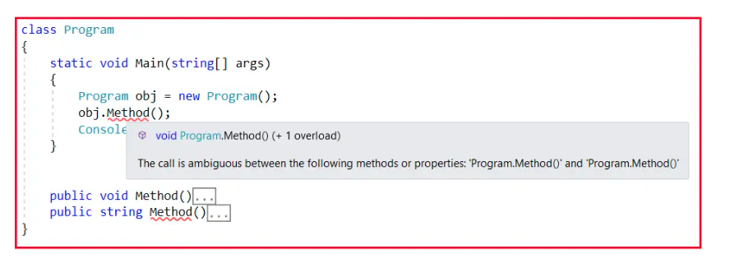

Still, you have doubts, the return types are different. See, the return types come into the picture at the end of the method execution. But here, the confusion is not at the end of the method execution, but the confusion is about where to start, and which method to invoke. So, the compiler does not have any clarity to start the method execution, and talking about the end of the method execution does not make any sense. So, this is the reason why return type is never taken into consideration while defining method overloading in C#.

##### **When should we Overload Methods in C#?**

We have understood what is Method Overloading and how to implement the Method Overloading in C#. But, the important question is when we need to implement or when we need to go for Method Overloading in C#. Let us understand this with an example.

The concept of Method Overloading falls under the Polymorphisms OOPs principle. Object Oriented Programming is based on four principles i.e. Encapsulation, Abstraction, Inheritance, and Polymorphism.

What is Polymorphism? Polymorphism is a mechanism of changing the behavior based on the inputs. That means when the input changes, automatically the output or behavior changes. The best example of polymorphism is ourselves. For example, when we hear something interesting or something which is good for us, we feel happy. And when we hear something which is not good for us, we feel sad. Suppose, you asked your father to purchase a bike, and if your father purchases a bike for you then you will feel happy. And if your father says that I am not going to purchase a bike for you, then you will feel sad. So, you are the same person, when you received something good, you feel happy and when you receive something which is not good, you feel sad. This is called polymorphism. Behaving in different ways based on the input received i.e. whenever the input changes the output automatically changes.

Here, the input changes mean don’t think that the values changes. Input changes mean when we change the number, type, and order of input the values are going to be changed. Don’t think that, if I pass 10, I will get a value, if I pass 20, I will get a different value. For this, if else condition is sufficient, overloading is not required. When you expect the output to be changed based on the number, type, and order of inputs, then only you need to go for Method overloading in C#.

For a better understanding, please have a look at the following example. Here, we have created three methods with the same name to perform the addition of two integers, two floats, and two strings. So, when we give two integer numbers we will get one output and when we provide two string values, then we will get a different output, and similarly, when we give two float numbers we will get another output. That means when the input changes the output or behavior also automatically changes. This is called polymorphism in C#.

using System;

namespace MethodOverloading

{

class Program

{

public void Add(int a, int b)

{

Console.WriteLine(a + b);

}

public void Add(float x, float y)

{

Console.WriteLine(x + y);

}

public void Add(string s1, string s2)

{

Console.WriteLine(s1 +" "+ s2);

}

static void Main(string[] args)

{

Program obj = new Program();

obj.Add(10, 20);

obj.Add(10.5f, 20.5f);

obj.Add("Pranaya", "Rout");

Console.ReadKey();

}

}

}

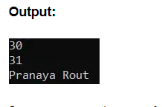

Suppose you are the user of the Program class and when you create the Program class instance and when you type the object name and dot operator, then you will not see three different Add methods, rather you will see only one Add method with two overloaded versions of the Add method as shown in the below image.

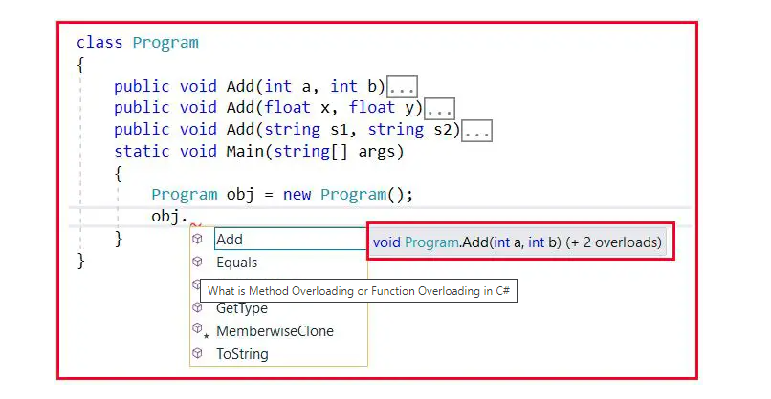

So, the advantage of using Method overloading is that if we overload the methods, then the user of our application gets a comfortable feeling in using the method with an impression that he/she calling one method by passing different types of values. The best example for us is the system-defined “**WriteLine()**” method. It is an overloaded method, not a single method taking different types of values. If you go to the definition of the Console class, then you will see the following overloaded versions of the WriteLine method defined inside the Console class.

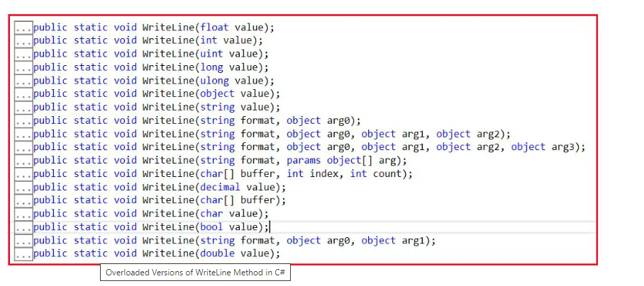

##### **When is a method considered an overloaded method in C#?**

If two methods have the same method name but with different signatures, then those methods are considered overloaded methods. Then the rule we should check is both methods must have different parameter **Types/Numbers/Orders**. But there is no rule on return type, access specifier and access modifier means overloading methods can have their own return type (void, float, int, string, etc), own access specifier (public, private, protected, etc.), and access modifier (sealed, static, virtual, etc.) because overloading methods are different methods

##### **Can we Overload Methods in the Same Class?**

Yes, it is possible. No Compile Time Error, and No Runtime Error. Methods can be overloaded in the same or in super and sub classes because overloaded methods are different methods. But we can’t override a method in the same class it leads to Compile Time Error: “**Method is Already Defined**” because overriding methods are the same methods with a different implementation. In our next article, we are going to discuss [**Method Overriding in C#**](https://dotnettutorials.net/lesson/function-overriding-csharp/) with Examples.

##### **What is Inheritance-Based Method Overloading in C#?**

A method that is defined in the parent class can also be overloaded under its child class. It is called Inheritance Based Method Overloading in C#. See the following example for a better understanding. As you can see in the below code, we have defined the Add method twice in the class Class1 and also defined the Add method in the child class Class1. Here, notice every Add method takes different types of parameters.

using System;

namespace MethodOverloading

{

class Class1

{

public void Add(int a, int b)

{

Console.WriteLine(a + b);

}

public void Add(float x, float y)

{

Console.WriteLine(x + y);

}

}

class Class2 : Class1

{

public void Add(string s1, string s2)

{

Console.WriteLine(s1 +" "+ s2);

}

}

class Program

{

static void Main(string[] args)

{

Class2 obj = new Class2();

obj.Add(10, 20);

obj.Add(10.5f, 20.7f);

obj.Add("Pranaya", "Rout");

Console.ReadKey();

}

}

}

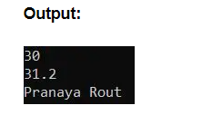

**Note:** To overload a parent class method under its child class the child class does not require any permission from its parent class.

##### **Real-Time Scenario where you Can use Method Overloading in C#**

Suppose you are working on a maintenance project. And you are going to work on a class where already some parameterized constructors have been defined and you need to pass some additional parameters. So what you will do, whether you will add the required parameter with one of the already defined constructors or add a new constructor as per your requirement? In such cases, you should not add the required parameter with the already defined constructor because this may disturb your other class dependency structure. So what you will do is create a new constructor with the required parameter. That new constructor that you are creating is nothing but the Constructor Overloading in C#.

##### **Example to Understand Constructor Method Overloading in C#**

Please have a look at the following example. Here, we are creating three different versions of the Constructor, and each constructor takes a different number of parameters, and this is called Constructor Overloading in C#.

using System;

namespace ConstructorOverloading

{

class ConstructorOverloading

{

int x, y, z;

public ConstructorOverloading(int x)

{

Console.WriteLine("Constructor1 Called");

this.x = 10;

}

public ConstructorOverloading(int x, int y)

{

Console.WriteLine("Constructor2 Called");

this.x = x;

this.y = y;

}

public ConstructorOverloading(int x, int y, int z)

{

Console.WriteLine("Constructor3 Called");

this.x = x;

this.y = y;

this.z = z;

}

public void Display()

{

Console.WriteLine($"X={x}, Y={y}, Z={z}");

}

}

class Test

{

static void Main(string[] args)

{

ConstructorOverloading obj1 = new ConstructorOverloading(10);

obj1.Display();

ConstructorOverloading obj2 = new ConstructorOverloading(10, 20);

obj2.Display();

ConstructorOverloading obj3 = new ConstructorOverloading(10, 20, 30);

obj3.Display();

Console.ReadKey();

}

}

}

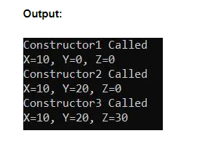

##### **Method Overloading Realtime Example using C# Language:**

Suppose, you are working on a real-time project. One of the mandatiory things that we need to do is logging. Whenever a request comes, when a method call, we need to capture the request details, we need to log the necessary information either on a text file or in the database. Even when some exceptions occurred we also need to log the exception detail so that later we can verify the log and need to identify the reasons for the exception. In the below example, we are creating a class called Logger with many overloaded versions of the Log method. So, as per our requirement, we can call the appropriate method.

using System;

namespace MethodOverloading

{

public class Logger

{

public static void Log(string ClassName, string MethodName, string Message)

{

Console.WriteLine($"DateTime: {DateTime.Now.ToString()}, ClassName: {ClassName}, MethodName:{MethodName}, Message:{Message}");

}

public static void Log(string uniqueId, string ClassName, string MethodName, string Message)

{

Console.WriteLine($"DateTime: {DateTime.Now.ToString()}, UniqueId: {uniqueId}, ClassName: {ClassName}, MethodName:{MethodName}, Message:{Message}");

}

public static void Log(string Message)

{

Console.WriteLine($"DateTime: {DateTime.Now.ToString()}, Message: {Message}");

}

public static void Log(string ClassName, string MethodName, Exception ex)

{

Console.WriteLine($"DateTime: {DateTime.Now.ToString()}, ClassName: {ClassName}, MethodName:{MethodName}, Exception Message:{ex.Message}, \nException StackTrace: {ex.StackTrace}");

}

//You create many overloaded versions as per your business requirements

}

class Program

{

static void Main(string[] args)

{

string ClassName = "Program";

string MethodName = "Main";

string UniqueId = Guid.NewGuid().ToString();

Logger.Log(ClassName, MethodName, "Message 1");

Logger.Log(UniqueId, ClassName, MethodName, "Message 2");

Logger.Log("Message 3");

try

{

int Num1 = 10, Num2 = 0;

int result = Num1 / Num2;

Logger.Log(UniqueId, ClassName, MethodName, "Message 4");

}

catch(Exception ex)

{

Logger.Log(ClassName, MethodName, ex);

}

Console.ReadKey();

}

}

}

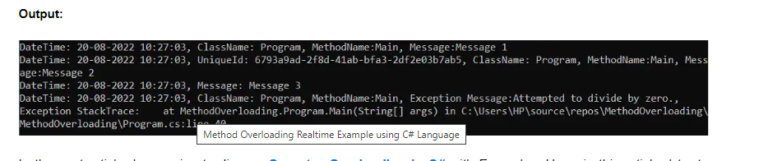

## **Operator Overloading in C# with Examples:**

In this article, I am going to discuss **Operator Overloading in C#**with Examples. Please read our previous article where we discussed [**Function Overloading in C#**](https://dotnettutorials.net/lesson/function-overloading-csharp/)with Examples. By overloading the operators, we can give additional meaning to the operators like +-*/=.,= etc., which by default is supposed to work with only on standard data types like int, float, char, void, etc. It’s a type of polymorphism in which an operator is overloaded to give it the user-defined meaning.

##### **What is Operator Overloading in C#?**

In C#, it is possible to make operators work with user-defined data types like classes. That means C# has the ability to provide the operators with a special meaning for a data type, this ability is known as operator overloading. For example, we can overload the + operator in a class like String so that we can concatenate two strings by just using +.

Using operator overloading in C# we can specify more than one meaning for an operator in one scope. The purpose of operator overloading is to provide a special meaning of an operator for a user-defined data type.

##### **The syntax for C# Operator Overloading:**

To overload an operator in C#, we use a special operator function. We define the function inside the class or structure whose objects/variables we want the overloaded operator to work with. The Syntax for Operator Overloading in C# is shown below.

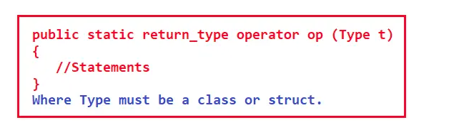

Here,

1. The return type is the return type of the function.
2. the operator is a keyword.
3. Op is the symbol of the operator that we want to overload. Like: +, <, -, ++, etc.
4. The type must be a class or struct. It can also have more parameters.
5. It should be a static function.

##### **Operator Overloading in C#**

We have operators for performing addition (+), multiplication (*), subtraction (-), increment and decrement operator (++, –), and so on. That means to perform various kinds of things there are operators available in C#. And these operators are meant for some specific data types. The following table describes the overloading ability of the various operators available in C#:

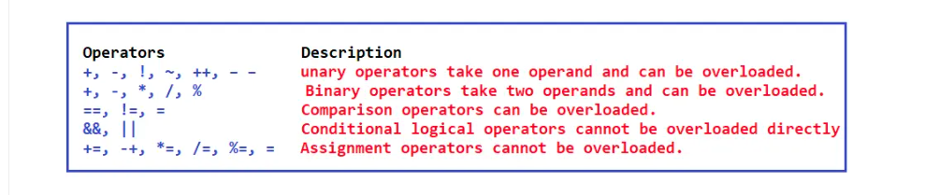

The above image shows some built-in operators and these operators are operating on built-in data types or primitive data types available in C#. Like additions can be performed on integer, float, and so on. If we are defining our own data type like if we are writing a class Matrix.

class Matrix {

…

}

Then can we use the + operator for adding two matrices and store the result in another object of type matrix (C = A + B)? So, can we overload + operator for the matrix class? Yes, + operator can be overloaded for the matrix class.

So, for our own data type which is a user-defined data type, we can overload + operator. There are various operators that you can overload in C#. So, let us learn how to overload these operators.

Examples to Understand Operator Overloading in C#

Let us take an example of a complex number to understand Operator Overloading in C#. In mathematics, we have a complex number that is written in the form of a + ib as shown in the below image.

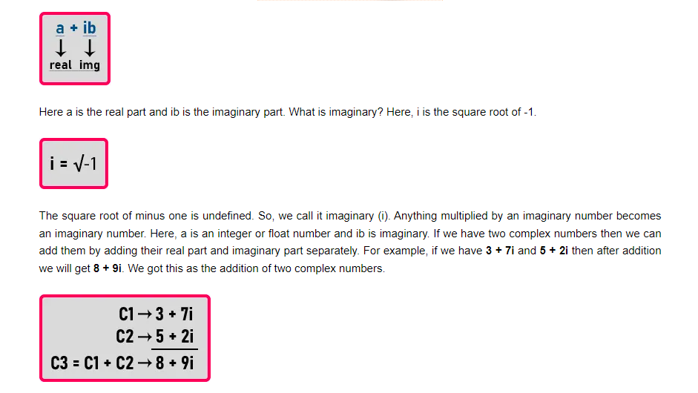

Yes, we can perform addition on two complex numbers in mathematics. The same thing we want to achieve programmatically then we want to have + operator overloaded. So let us write a class for a complex number as shown below and see how we can overload the + operator.

public class Complex

{

private int real;

private int img;

public Complex(int r = 0, int i = 0)

{

real = r;

img = i;

}

};

Here, we have created a class called Complex. Inside the Complex class, we have created two integer-type private data members that are real and img. Then we have created a parameterized constructor as public. We can pass the two integer values as parameters to the constructor and the constructor will assign those integer values to real and img private data members of the class.

We have also provided some default values to the constructor arguments so that if the user doesn’t pass any values, then the constructor will automatically assign 0 to real and img data members. This constructor will work as a parameterized constructor as well as a non-parameterized constructor.

Now let us overload + operator. For learning operator overloading we have to learn two things. First, how to write a function, and second, what should be the signature of a function. Signature of a function we will show you afterward, first, let us see how to write a function.

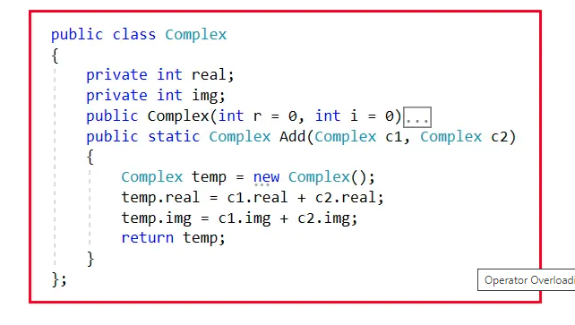

Here inside the Complex class, we have written Add function and the return type of this function is Complex. This function will add the real and img values of two Complex objects. Now let us write the main function as follows:

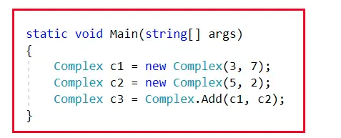

Here inside the main function, we have created two objects C1 and C2 of class Complex. C1 will have the values of 3 and 7 and C2 will have the values of 5 and 2. Then we have called the Add function by passing C1 and C2 objects and as this method returns an object of type Complex, so we are storing that object in the C3 reference variable.

##### **How Add function is working?**

Now let us understand how the add function is working.  
**Complex c3 = Complex.Add(c1, c2);**

In the above statement, we called the static Add function using the class name by passing C1 and C2 as parameters. Once we call the Add method, then the Add method starts executing the code as follows. Inside the Add function, we are creating a temporary complex object by executing the below statement.  
**Complex temp = new Complex();**

Then, we execute the below statement.  
**temp.real = c1.real + c2.real;**

This statement will store the addition of values of C1’s real and C2’s real in temp’s real. Then, the following statement will be executed.  
**temp.img = c1.img + c2.img;**

The above statement will store the addition of values of C1’s img and C2’s img in temp’s img. Finally, we return the temp object from the Add method by executing the below return statement.  
**return temp;**

Then we have returned the temp object from the function. We can understand the above statement with the help of the below diagram.

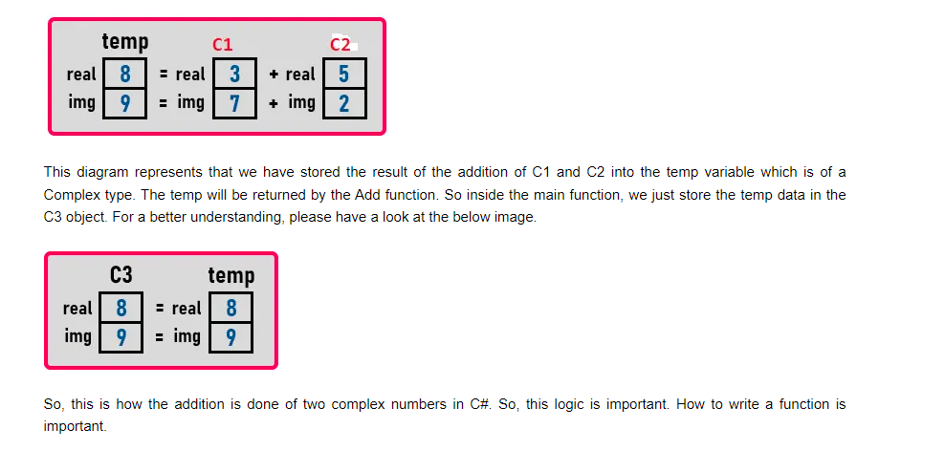

##### **Complete Example to add two Complex Numbers in C#:**

using System;

namespace OperatorOverloadingDemo

{

class Program

{

static void Main(string[] args)

{

Complex c1 = new Complex(3, 7);

c1.Display();

Complex c2 = new Complex(5, 2);

c2.Display();

Complex c3 = Complex.Add(c1, c2);

c3.Display();

Console.ReadKey();

}

}

public class Complex

{

private int real;

private int img;

public Complex(int r = 0, int i = 0)

{

real = r;

img = i;

}

public static Complex Add(Complex c1, Complex c2)

{

Complex temp = new Complex();

temp.real = c1.real + c2.real;

temp.img = c1.img + c2.img;

return temp;

}

public void Display()

{

Console.WriteLine($"{real} + i{img}");

}

};

}

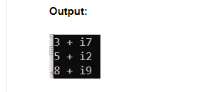

Understanding logic is the most important thing. So, we have finished it. Now let us see how to make it as operator overloading. Now we want to convert Add function into an operator. So, instead of writing **Complex c3 = Complex.Add(c1, c2);,**we want to write **Complex c3 = C2 + C1;**

So, for writing like this, we have to modify the function signature as follows:

**public static Complex operator +(Complex c1, Complex c2){}**

Here, we just replace the **Add** word with **operator +**. For a better understanding, please have a look at the below image.

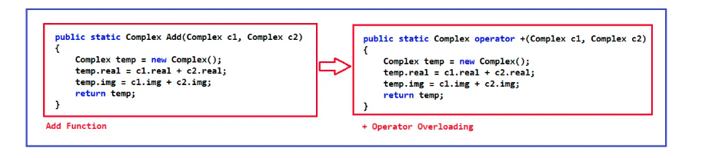

Everything inside the function will remain the same. With the above changes in place, now the + operator is overloaded for class Complex. This is Operator Overloading in C#. So instead of writing dot (.), you can just write ‘+’ to get the addition of two Complex objects. Now let us look at the complete program for operator overloading in C#.

##### **Example to add two Complex Numbers in C# using Operator Overloading:**

using System;

namespace OperatorOverloadingDemo

{

class Program

{

static void Main(string[] args)

{

Complex c1 = new Complex(3, 7);

c1.Display();

Complex c2 = new Complex(5, 2);

c2.Display();

Complex c3 = c1 + c2;

c3.Display();

Console.ReadKey();

}

}

public class Complex

{

private int real;

private int img;

public Complex(int r = 0, int i = 0)

{

real = r;

img = i;

}

public static Complex operator +(Complex c1, Complex c2)

{

Complex temp = new Complex();

temp.real = c1.real + c2.real;

temp.img = c1.img + c2.img;

return temp;

}

public void Display()

{

Console.WriteLine($"{real} + i{img}");

}

};

}

**Note:** The terms Function Overriding and Method Overriding are interchangeably used. Method Overriding is an approach to implementing Polymorphism (i.e. Run-Time Polymorphism or Dynamic Polymorphism) in C#

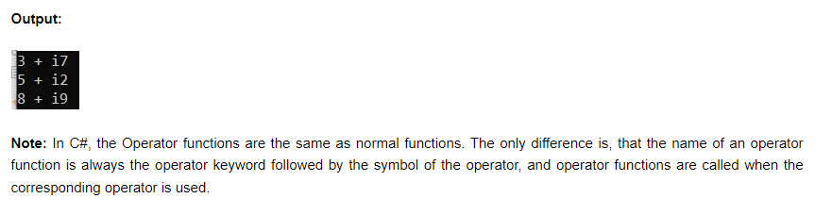

## **Method Overriding in C# with Examples**

In this article, I am going to discuss **Method Overriding in C#** with Examples. Please read our previous article where we discussed [**Operator Overloading in C#**](https://dotnettutorials.net/lesson/operator-overloading-in-csharp/) with Examples. Here in this article, we are going to discuss the following pointers with examples.

1. **What is Method Overriding in C#?**
2. **When do we need to override a method in C#?**
3. **When a subclass method is treated as an overridden method in C#?**
4. **How a method is Overridden in C#?**
5. **Multiple Examples to Understand Method Overriding in C#?**
6. **How to execute the superclass method if it is overridden in the subclass?**
7. **Method Overriding Realtime Example in C#.**
8. **What are the differences between Method Overloading and Method Overriding in C#?**

##### **What is Method Overriding in C#?**

The process of re-implementing the superclass non-static, non-private, and non-sealed method in the subclass with the same signature is called Method Overriding in C#. The same signature means the name and the parameters (type, number, and order of the parameters) should be the same.

##### **When do we need to override a method in C#?**

If the Super Class or Parent Class method logic is not fulfilling the Sub Class or Child Class business requirements, then the Sub Class or Child Class needs to override the superclass method with the required business logic. Usually, in most real-time applications, the Parent Class methods are implemented with generic logic which is common for all the next-level sub-classes.

##### **When is a Sub Class Method treated as an Overriding Method in C#?**

If a method in the sub-class or child class contains the same signature as the superclass non-private, non-static, and non-sealed method, then the subclass method is treated as the overriding method and the superclass method is treated as the overridden method.

##### **How can we Override a Parent Class Method under Child Class in C#?**

If you want to override the Parent class method in its Child classes, first the method in the parent class must be declared as virtual by using the virtual keyword**,** then only the child classes get permission for overriding that method. Declaring the method as virtual is marking the method as overridable. If the child class wants to override the parent class virtual method, then the child class can override it with the help of the override modifier. But overriding the parent class virtual methods under the child classes is not mandatory. The syntax is shown below to implement Method Overriding in C#.

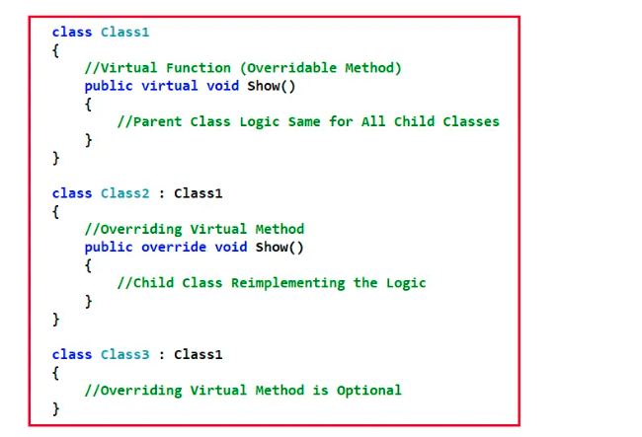

As you can see in the above image, the Show method is declared as a Virtual method in the class Class1. Further Class1 is the Parent class for Class2 and Class2. Class2 overrides the Show method while class does not override the Show method as overriding the virtual method inside a child class is optional.

Suppose, on your birthday, your parents give you a mobile phone. Then your parents tell you, if you like it, it’s OK, you just use it. And if you don’t like the mobile phone, then you can exchange it. So, if you want to exchange it, take the bill, go and exchange the mobile phone. So, you have two options. What are these? The first option, whatever your parent gives you, you just use it. The second option, if you don’t like it, go and exchange and take whatever you like.

This is exactly the same as Method overriding. You have one method in the Parent class, and that method is given to the child class for consumption. Now, if the child class wants then the child class can consume the method else the child class can reimplement the method or override the method. By declaring the Parent method as virtual, it gives permission to the child classes to override the method and the child classes can override the method by using the override modifier.

##### **Example to Understand Method Overriding in C#**

Let us see an example for understanding Method Overriding in C#. Please have a look at the below code. Here class Class1 is the parent class and in this class, we defined one method i.e. Show() by using the virtual keyword which marks this method to be overridable inside the child classes. The class Class2 is derived from the class Class1 and hence it becomes a child class of class Class1 and as soon as it becomes a child class, it got permission to override the overridable method Show(). As you can see in the child class, we override the Show method by using the override modifier.

using System;

namespace PolymorphismDemo

{

class Class1

{

//Virtual Function (Overridable Method)

public virtual void Show()

{

//Parent Class Logic Same for All Child Classes

Console.WriteLine("Parent Class Show Method");

}

}

class Class2 : Class1

{

//Overriding Method

public override void Show()

{

//Child Class Reimplementing the Logic

Console.WriteLine("Child Class Show Method");

}

}

class Program

{

static void Main(string[] args)

{

Class1 obj1 = new Class2();

obj1.Show();

Class2 obj2 = new Class2();

obj2.Show();

Console.ReadKey();

}

}

}

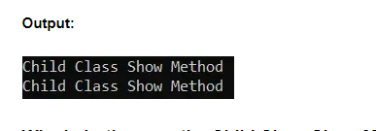

##### **Why in both cases the Child Class Show Method is Invoked?**

While working with Polymorphism in C# we need to understand two things i.e. what happens at the time of compilation and what happens at the time of execution for a method call. Is the method going to be executed from the same class at run-time which is bounded to the class at the compile time or is the method going to be executed from a different class at run-time rather than the class bounded at compile time? Let us understand this.

In our example, we have written the following code inside the Main method.

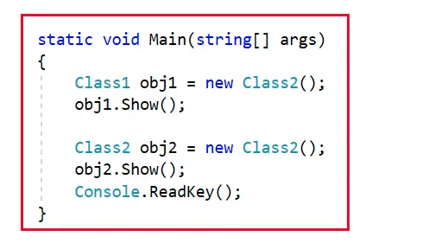

Now, let us understand what Compiler and CLR do when each statement is executed. Please observe the first statement. Here, you can see that the reference variable obj1 type is Class1 and this obj1 reference variable points to the object whose type is Class2.

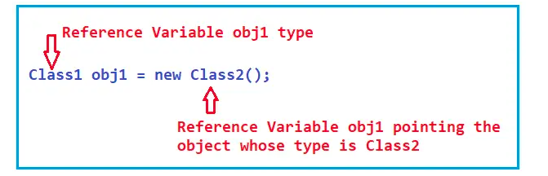

Here, Class1 is the superclass and Class2 is the subclass. The point that you need to keep in mind is that the Super Class Reference Variable Can hold the Subclass object reference and but the reverse is not possible i.e. Sub Class Reference Variable can never hold the Super Class Object Reference. So, the Class1 reference variable can hold the Class2 object reference.

Now, observe the following statement. Here, the obj1 reference variable type is Class1 and obj1 points to the object whose type is Class2. Then using obj1 we are invoking the Show() method. Now, let us try to understand what happens at compilation time and at runtime for the following method call.

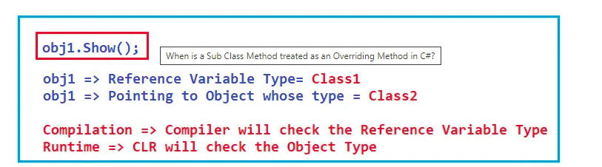

At the time of compilation, the function call will bind with its function definition. That means the compiler will create a link between the function call and function definition. To bind the function, the compiler will check the type of the reference variable and will check if that method or function is available in that type or not. If available then compilation will be done successfully and if not available then compilation will fail and you will get a compilation error. In our example, the Show method is available in Class1 (type of the reference variable obj1) and hence compilation is successful.

At the time of program execution, the CLR will check the object type and it is going to execute the method from the reference object type. If the method is not available in the corresponding object type, then it will try to execute the method from the Parent class of the object type. In our case, the Show method is available in the class Class2 and hence this method is going to be executed from the class Class2. This is because of method overriding and this is also called Dynamic Polymorphism or Runtime Polymorphism.

##### **What is Dynamic Polymorphism or Runtime Polymorphism?**

The function call is bounded to the class at the time of compilation, if the function is going to be executed by CLR from a different class at run-time rather than the class bounded at compilation-time, then it is called Run-Time Polymorphism in C#. This happens in the case of Method Overriding because, in the case Overriding, we have multiple methods with the same signature i.e. Parent Class and the Child class have the same method implementation. So, in this case, we will be able to know at runtime from which class the method is going to be executed.

It is also called Dynamic Polymorphism or Late Binding as at Run-time we will be able to know from which class the method is going to be executed.

##### **What is Static Polymorphism or Compile Time Polymorphism?**

The function call is bounded to the class at the time of compilation, if the function is going to be executed from the same bounded class at run-time, then it is called Compile-Time Polymorphism in C#. This happens in the case of Method Overloading because, in the case of overloading each method will have a different signature and based on the method call, we can easily recognize the method which matches the method signature.

It is also called Static Polymorphism or Early Binding as at the Compilation time we will be able to know from which class the method going to be executed.

Now, please observe the following code. Here, the reference variable obj2 type is Class2 and it is also pointing to the object reference whose type is Class2. Then using the obj2 reference variable we are invoking the Show method.

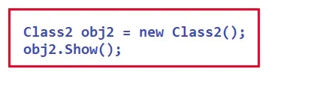

At the time of compilation, the compiler will check whether the Show method is available inside the Class2 reference variable and it will find that method is available and hence compilation is successful. Then at runtime, the CLR will check the method definition inside the object type i.e. Class2 and it finds that method is available inside the Class2 and it will execute that method from the Class2. So, in both, the method call the method is going to be executed from the child class as both the reference variable are pointing to the child class object.

**Note:** The point that you need to keep in mind is that the overriding method is always going to be executed from the current class object. The superclass method is called the overridden method and the sub-class method is called the overriding method.

##### **Overriding the Virtual Method is Optional in C#:**

The point that you need to keep in mind is overriding the virtual method in the child classes is optional. If you are not overriding the virtual method means you going with the default implementation which is provided by the superclass. Let us understand this with an example. In the below example, inside the Parent class Class1, we marked the Show method as virtual but inside the child class Class2, we have not overridden the method. In this case, always the method is going to be executed from the Parent class only.

using System;

namespace PolymorphismDemo

{

class Class1

{

//Virtual Function (Overridable Method)

public virtual void Show()

{

//Parent Class Logic Same for All Child Classes

Console.WriteLine("Parent Class Show Method");

}

}

class Class3 : Class1

{

//Not Overriding the Virtual Method

}

class Program

{

static void Main(string[] args)

{

Class3 obj3 = new Class3();

obj3.Show();

Class1 obj4 = new Class3();

obj4.Show();

Console.ReadKey();

}

}

}

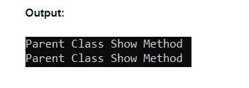

Now, let us understand the Main method code. Please observe the following code first. In this case, the type of the reference variable and the object the variable points to are the same i.e. Class3.

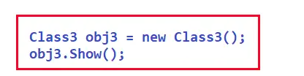

So, at the time of compilation, the compiler will check the Show method inside Class3 and it will not find the Show method inside this class. So, it will again go and check the Superclass of Class3 which is Class1 and it finds the method inside the Class1 and it will link that method definition from Class1 with the method call.

At the time of execution, the CLR will try to execute the method from the object type which is Class3 in this case and it will not find the method definition inside the class Class3. So, it again goes and tries to execute the method from its superclass i.e. Class1 and it finds that the method definition is there and it will execute that method definition

Now, observe the next function call statements as shown in the below image. In this case, the type of the reference variable is Class1 and the reference variable obj4 points to the object whose type is Class3.

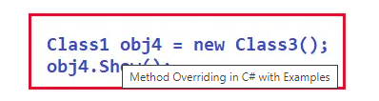

At the time of compilation, the compiler will check the Show method inside the Class1 and it will find the Show method inside this class and it will link that method definition from Class1 with the method call.

At the time of execution, the CLR will try to execute the method from the object type which is Class3 in this case and it will not find the method definition inside the class Class3. So, it will go and try to execute the method from its superclass i.e. Class1 and it finds that the method definition is there and it will execute that method definition. So, in this example, for both the method call, the method is going to be executed from the Parent class.

##### **How can we execute the superclass method if it is overridden in the sub-class in C#?**

Once we re-implement the parent class methods under the child classes, then the object of the child class calls its own method but not its parent class method. But if you want to still consume or call the parent class’s methods from the child class, then it can be done in two different ways.

By creating the parent class object under the child class, we can call the parent class methods from the child class, or by using the base keyword, we can call parent class methods from the child class, but this and the base keyword cannot be used under the static block.

##### **Using the base keyword to call the Parent Class Methods in C#:**

Let us see an example for a better understanding. As you can see in the below code, from the child class Show method we are calling the parent class Show method by using base.Show() method call.

using System;

namespace PolymorphismDemo

{

class Class1

{

//Virtual Function (Overridable Method)

public virtual void Show()

{

//Parent Class Logic Same for All Child Classes

Console.WriteLine("Parent Class Show Method");

}

}

class Class2 : Class1

{

//Overriding Method

public override void Show()

{

base.Show(); //Calling Parent Class Show method

Console.WriteLine("Child Class Show Method");

}

}

class Program

{

static void Main(string[] args)

{

Class1 obj1 = new Class2();

obj1.Show();

Class2 obj2 = new Class2();

obj2.Show();

Console.ReadKey();

}

}

}

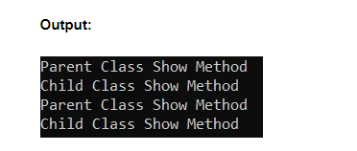

##### **Calling Parent Class Methods by creating the Parent Class Object under the Child Class:**

Let us see an example for a better understanding of how to create the parent class object and call the parent class methods from the child class method. As you can see in the below example, from the child class Show method, we are creating an instance of the Parent class and calling the Parent Class Show method.

using System;

namespace PolymorphismDemo

{

class Class1

{

public virtual void Show()

{

Console.WriteLine("Parent Class Show Method");

}

}

class Class2 : Class1

{

public override void Show()

{

//Creating an instance of Parent Class

Class1 class1 = new Class1();

//Calling Parent Class Show method

class1.Show();

Console.WriteLine("Child Class Show Method");

}

}

class Program

{

static void Main(string[] args)

{

Class1 obj1 = new Class2();

obj1.Show();

Class2 obj2 = new Class2();

obj2.Show();

Console.ReadKey();

}

}

}

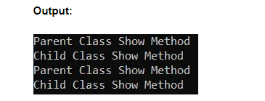

##### **Method Overriding Real-Time Example in C#**

We need to develop an application to calculate bonuses based on the designation of the Employees. The management team has decided to give 50000 as a fixed bonus or based only salary they may get 20% or 25% as bonus whichever is higher. Here, we are taking the example of three different designations, but you can take as many as per your requirement.

1. If the designation is Developer, then the employee gets either 50000 or 20% of the Salary as a bonus (whichever is higher).
2. If the designation is Manager, then the employee gets either 50000 or 25% of the Salary as a bonus (whichever is higher).
3. If the designation is Admin, then the employee will get a fixed 50000 as a bonus.

The following example code does the same as per our requirement.

using System;

namespace MethodOverriding

{

public class Employee

{

public int Id { get; set; }

public string Name { get; set; }

public string Designation { get; set; }

public double Salary { get; set; }

public virtual double CalculateBonus(double Salary)

{

return 50000;

}

}

public class Developer : Employee

{

//50000 or 20% Bonus to Developers which is greater

public override double CalculateBonus(double Salary)

{

double baseSalry = base.CalculateBonus(Salary);

double calculatedSalary = Salary * .20;

if (baseSalry >= calculatedSalary)

{

return baseSalry;

}

else

{

return calculatedSalary;

}

}

}

public class Manager : Employee

{

//50000 or 25% Bonus to Developers which is greater

public override double CalculateBonus(double Salary)

{

double baseSalry = base.CalculateBonus(Salary);

double calculatedSalary = Salary * .25;

if (baseSalry >= calculatedSalary)

{

return baseSalry;

}

else

{

return calculatedSalary;

}

}

}

public class Admin : Employee

{

//return fixed bonus 50000

//no need to overide the method

}

class Program

{

static void Main(string[] args)

{

Employee emp1 = new Developer

{

Id = 1001,

Name = "Ramesh",

Salary = 500000,

Designation = "Developer"

};

double bonus = emp1.CalculateBonus(emp1.Salary);

Console.WriteLine($"Name: {emp1.Name}, Designation: {emp1.Designation}, Salary: {emp1.Salary}, Bonus:{bonus}");

Console.WriteLine();

Employee emp2 = new Manager

{

Id = 1002,

Name = "Sachin",

Salary = 800000,

Designation = "Manager"

};

bonus = emp2.CalculateBonus(emp2.Salary);

Console.WriteLine($"Name: {emp2.Name}, Designation: {emp2.Designation}, Salary: {emp2.Salary}, Bonus:{bonus}");

Console.WriteLine();

Employee emp3 = new Admin

{

Id = 1003,

Name = "Rajib",

Salary = 300000,

Designation = "Admin"

};

bonus = emp3.CalculateBonus(emp3.Salary);

Console.WriteLine($"Name: {emp3.Name}, Designation: {emp3.Designation}, Salary: {emp3.Salary}, Bonus:{bonus}");

Console.WriteLine();

Employee emp4 = new Developer

{

Id = 1004,

Name = "Priyanka",

Salary = 200000,

Designation = "Developer"

};

bonus = emp1.CalculateBonus(emp4.Salary);

Console.WriteLine($"Name: {emp4.Name}, Designation: {emp4.Designation}, Salary: {emp4.Salary}, Bonus:{bonus}");

Console.Read();

}

}

}

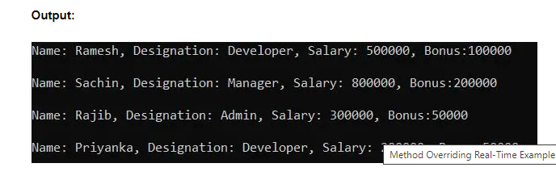

##### **What is the difference between Method Overloading and Method Overriding in C#?**

###### ****Method Overloading in C#****

1. It is an approach to defining multiple methods with the same name but with a different signature means by changing the number, type, and order of parameters.
2. Overloading a method can be performed within a class as well as between the Parent-Child classes also.
3. To overload a parent class method under the child classes, the child class does not require to take any permission from the parent.
4. This is all about defining multiple behaviors to a method.
5. Used to implement static polymorphism.
6. No separate keywords are used to implement function overloading.

###### ****Method Overriding in C#****

1. It is an approach to defining multiple methods with the same name and with the same signature means the same number, type, and order of parameters.
2. Overriding of methods is not possible within the same class it must be performed under the child classes only.
3. To override a parent class method under the child classes, first, the child class requires to take permission from its parent.
4. This is all about changing the behavior of a method.
5. Used to implement dynamic polymorphism.
6. Use the virtual keyword for the base class function and override keyword in the derived class function to implement function overriding.

## **Method Hiding in C# with Examples**

In this article, I am going to discuss **Method Hiding in C#** with Examples. Please read our previous article, where we discussed [**Method Overriding in C#**](https://dotnettutorials.net/lesson/function-overriding-csharp/) with Examples. At the end of this article, you will understand what exactly Method Hiding is and when and how to use Method Hiding in C# with Multiple Examples.

##### **What is Method Hiding in C#?**

Method Hiding/Shadowing is also an approach of re-implementing the parent class methods under the child class exactly with the same signature (same name and same parameters).

##### **How we can Re-Implement a Parent Method in the Child Class in C#?**

We can re-implement the parent class methods under the child classes in two different approaches. They are as follows

1. **Method Overriding**
2. **Method Hiding**

Then what are the differences between them, let us understand.

In Method Overriding, the child classes re-implement their parent class methods which are declared as virtual. That means here, the child classes re-implement the parent class methods with the permission of the parent class because here in the parent class the method is declared as virtual giving permission to the child classes for overriding the methods using the override modifier.

In Method Hiding/Shadowing, the child classes can re-implement any method of its parent class methods even if they are not declared as virtual. That means here the child class re-implements the parent class methods without taking any permission from its parent.

##### **How to Implement Method Hiding/Shadowing in C#?**

Please have a look at the following image to understand the syntax of Method Hiding/Shadowing in C#. It does not matter whether the parent class method is virtual or not. We can hide both virtual and non-virtual methods under the child class. Again, we can hide the method in the child class in two ways i.e. by using the new keyword and also, without using the new keyword. If we are not using the new keyword then we will get a warning and the reason for the warning we will discuss later part of this article.

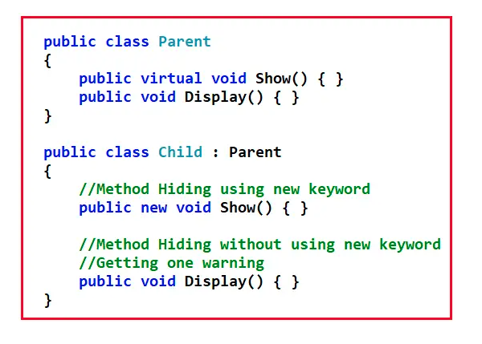

When we use the new keyword to hide a Parent Class Methods under the child class, then it is called Method Hiding/Shadowing in C#. Using the new keyword for re-implementing the Parent Class Methods under the child class is optional.

##### **Example to Understand Method Hiding/Shadowing in C#:**

Please have look at the following example. Here, inside the Parent class, we have declared two methods i.e. Show and Display. The Show method is declared as virtual and Display is not declared as virtual. And then the Child class is inheriting from the Parent class. That means the Child class is now also having the parent class methods. And when we create the instance of the Child class and invoke the methods, then the methods are going to be executed from the Parent class. This is the concept of [**Inheritance**](https://dotnettutorials.net/lesson/inheritance-c-sharp/)and we have already discussed this concept.

using System;

namespace MethodHiding

{

public class Parent

{

public virtual void Show()

{

Console.WriteLine("Parent Class Show Method");

}

public void Display()

{

Console.WriteLine("Parent Class Display Method");

}

}

public class Child : Parent

{

}

class Program

{

static void Main(string[] args)

{

Child obj = new Child();

obj.Show();

obj.Display();

Console.ReadKey();

}

}

}

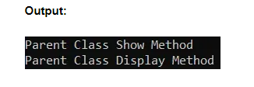

Now, as a child class user, we don’t like the above output. We want our own versions of the above two methods inside the Child class. If you look at the Show method, then it is declared as virtual inside the Parent class, so we can override this virtual method inside the Child class by using the override modifier. But we cannot override the Display method inside the Child class as it is not declared as virtual inside the Parent class. But we want to re-implement the method. In that case, we need to re-implement the Parent Class Display Method using the new keyword inside the Child class which is nothing but Method Hiding/Shadowing in C#. The complete example code is given below.

using System;

namespace MethodHiding

{

public class Parent

{

public virtual void Show()

{

Console.WriteLine("Parent Class Show Method");

}

public void Display()

{

Console.WriteLine("Parent Class Display Method");

}

}

public class Child : Parent

{

//Method Overriding

public override void Show()

{

Console.WriteLine("Child Class Show Method");

}

//Method Hiding/Shadowing

public new void Display()

{

Console.WriteLine("Child Class Display Method");

}

}

class Program

{

static void Main(string[] args)

{

Child obj = new Child();

obj.Show();

obj.Display();

Console.ReadKey();

}

}

}

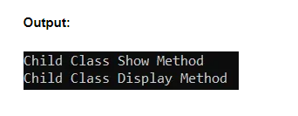

So, here, you can observe both Method Overriding and Method Hiding doing the same thing. That is re-implementing the Parent class methods under the Child class. Then what are the differences between them? With method overriding, you can re-implement only virtual methods. On the other hand, with Method Hiding, you can re-implement any methods.

For a better understanding, please have a look at the following example. Here, inside the Parent class, we have declared defined two virtual methods and two non-virtual methods. Inside the Child class, we are re-implementing both virtual and non-virtual methods using both Method Overriding and Method Hiding. Here, you will get a compile-time error while you are trying to re-implement the non-virtual method using the override modifier but you will not get an error when you are re-implementing the virtual and non-virtual method using the new keyword.

using System;

namespace MethodHiding

{

public class Parent

{

public virtual void Method1()

{

Console.WriteLine("Parent Class Method1 Method");

}

public void Method2()

{

Console.WriteLine("Parent Class Method2 Method");

}

public virtual void Method3()

{

Console.WriteLine("Parent Class Method3 Method");

}

public void Method4()

{

Console.WriteLine("Parent Class Method4 Method");

}

}

public class Child : Parent

{

//Overriding Virtual Method

//Method Overriding

public override void Method1()

{

Console.WriteLine("Child Class Method1 Method");

}

//Overriding Non-Virtual Method

//Not Possible. Compile Time Error

public override void Method2()

{

Console.WriteLine("Child Class Method2 Method");

}

//Method Hiding/Shadowing Virtual Method

public new void Method3()

{

Console.WriteLine("Child Class Method3 Method");

}

//Method Hiding/Shadowing Non-Virtual Method

public new void Method4()

{

Console.WriteLine("Child Class Method4 Method");

}

}

class Program

{

static void Main(string[] args)

{

Child obj = new Child();

obj.Method1();

obj.Method2();

obj.Method3();

obj.Method4();

Console.ReadKey();

}

}

}

When you try to run the above code, you will get the following error and this makes sense because we cannot override the non-virtual method inside the Child class.

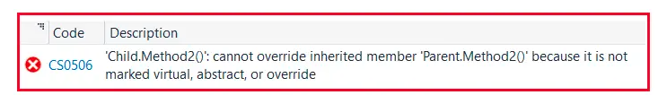

##### **Why we are using the new keyword in Method Hiding?**

The new keyword explicitly tells us that you are hiding the base class or parent class members inside the child class. Even if you are not using the new keyword, then also you can re-implement the method under the child, but in that case, you will get a warning from the compiler as shown in the below image.

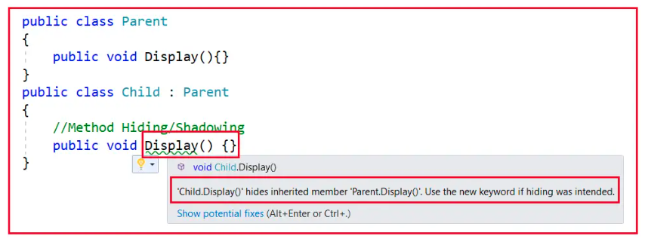

Method Overriding is an approach of re-implementing the parent class methods under the child class exactly with the same signature (same name and same parameters).

Here, you can see that the compiler gives us one warning that the Child class Display method hides the inherited Parent class Display method. In the second message, it is saying that if you want to hide the member, then please use the new keyword.

Let us try to understand the warning in more detail. Today, we intentionally defined the method Display inside the Child class which is already present inside the Parent class. Tomorrow, there might be a chance while you are defining the Child class, you might forget that there is a method called Display defined in the Parent class. At that time, the compiler will warn you. What is the warning? The compiler will warn you that already this method is defined in the Parent class and this method will hide the Parent class method from now onwards. So, if you are mistaken better change the name of the method, or if hiding was your intention, then please use the new keyword.

So, when we use the new keyword, it is just a piece of information to the compiler that the programmer intentionally defined a method with the same name and same signature as the parent class method. So, if you removed the new keyword there is no difference in the program execution only you will get a warning. That is the only use of the new keyword in this context.

##### **How to Invoke the Parent class Methods from the Child Class re-implemented methods?**

In C#, we can re-implement the Parent class methods under the child class in two ways. They are as follows:

1. **Method Overriding**
2. **Method Hiding**

In the first case, with permission, and in the second case, without permission. In Method Overriding and Method Hiding, after performing the re-implementation, a call to the method by using the child class instance always invokes the local methods i.e. child class methods. For a better understanding, please have a look at the following example. Here, we create an instance of the Child class and then invoke both the methods, and in this case, both the methods are going to be executed from the Child class only.

using System;

namespace MethodHiding

{

public class Parent

{

public virtual void Show()

{

Console.WriteLine("Parent Class Show Method");

}

public void Display()

{

Console.WriteLine("Parent Class Display Method");

}

}

public class Child : Parent

{

//Method Overriding

public override void Show()

{

Console.WriteLine("Child Class Show Method");

}

//Method Hiding/Shadowing

public new void Display()

{

Console.WriteLine("Child Class Display Method");

}

}

class Program

{

static void Main(string[] args)

{

Child obj = new Child();

obj.Show();

obj.Display();

Console.ReadKey();

}

}

}

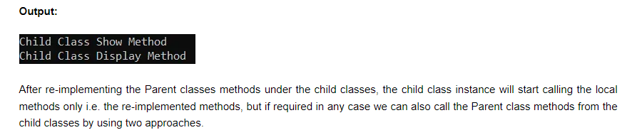

1. **Using the Parent Class Instance**
2. **Using the base keyword**

So, by creating the parent class object under the child class, we can call the parent class methods from the child class, or by using the base keyword, we can also call parent class methods from the child class, but the keyword like this and base cannot be used under the static block.

For a better understanding, please have a look at the following example. Here, you can see, inside the Overriding and Hiding method, we invoke the parent class methods using both approaches. You can invoke any of the parent methods. It is not like you can only invoke the Parent class Show method from the Overriding Show method, you can also invoke the Display method.

using System;

namespace MethodHiding

{

public class Parent

{

public virtual void Show()

{

Console.WriteLine("Parent Class Show Method");

}

public void Display()

{

Console.WriteLine("Parent Class Display Method");

}

}

public class Child : Parent

{

//Method Overriding

public override void Show()

{

//Using Parent class instance to Invoke the Parent Methods

Parent parent = new Parent();

parent.Show();

//Using base keyword to invoke the Parent method

base.Display();

Console.WriteLine("Child Class Show Method");

}

//Method Hiding/Shadowing

public new void Display()

{

//Using Parent class instance to Invoke the Parent Methods

Parent parent = new Parent();

parent.Display();

//Using base keyword to invoke the Parent method

base.Show();

Console.WriteLine("Child Class Display Method");

}

}

class Program

{

static void Main(string[] args)

{

Child obj = new Child();

obj.Show();

obj.Display();

Console.ReadKey();

}

}

}

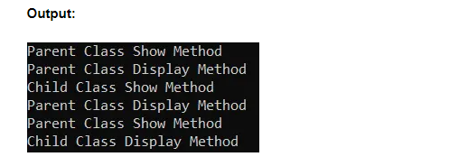

##### **Differences Between Method Overriding and Method Hiding in C#:**

As of now, we have not found any major differences between Method Overriding and Method Hiding in C#. There are some differences in terms of implementation, but from the execution point of view, when we invoked the methods using the child class instance, then both the methods are going to be executed from the child class. Then what is the major difference between them, let us try to understand.

Can we create a Parent class reference variable using the Child class instance in C#? Yes, it is possible and we have already discussed this in our Inheritance article. So, a Parent class reference variable can hold the child class object reference.

For a better understanding, please have a look at the following example. Here, we are creating an instance of the Child class and storing that instance reference in the Parent class reference variable, and then invoking the two methods.

using System;

namespace MethodHiding

{

public class Parent

{

public virtual void Show()

{

Console.WriteLine("Parent Class Show Method");

}

public void Display()

{

Console.WriteLine("Parent Class Display Method");

}

}

public class Child : Parent

{

//Method Overriding

public override void Show()

{

Console.WriteLine("Child Class Show Method");

}

//Method Hiding/Shadowing

public new void Display()

{

Console.WriteLine("Child Class Display Method");

}

}

class Program

{

static void Main(string[] args)

{

Parent obj = new Child();

obj.Show();

obj.Display();

Console.ReadKey();

}

}

}

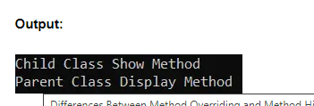

You can see in the above output that the Show method (Overriding Method) is executed from the Child class while the Display method (Hiding Method) is executed from the Parent class. Why?

The point that you need to remember is that a parent class reference variable even if created by using the child class instance, cannot access any members which are purely defined inside the child class but can call the overriding methods of the child class because overridden members are not considered as pure child class members, but the members which are re-implemented inside the child class by using the approach of hiding are considered as pure child class members and cannot be accessed by Parent reference variable. For a better understanding, please have a look at the following diagram.

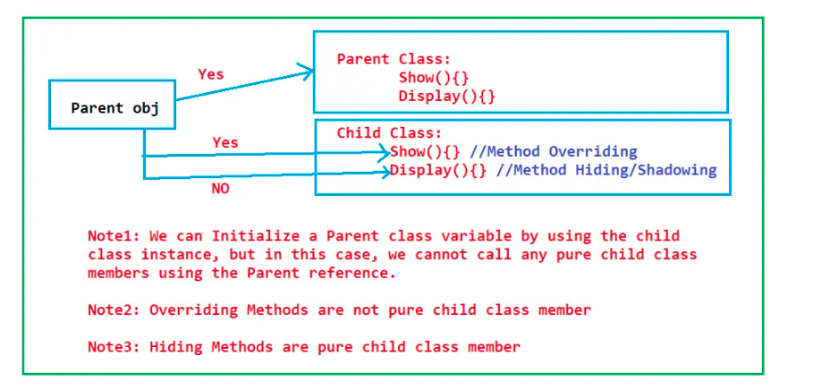

Using Parent obj, we can access the parent class members and if it is created using the child class instance, then we can access the overriding members of the Child class.

Here, the Show method is an overriding method and overriding methods are not pure child class methods. The Show method is defined in the Parent class and again re-defined inside the Child class, and hence we can invoke the Show method using the Parent reference variable and when we invoke the Show method using the Parent reference variable, as it holds the object of the child class, so, the method is going to be executed from the Child class only.

So, the point that you need to remember is in the case of method overriding, the Parent class gives permission to the child classes to override the method. And when the child class re-implements the method, the parent class identifies them or the Parent class recognizes them. As the Parent class recognizes. So, it is able to call the child class overriding methods.

But this is not the case with Method Hiding/Shadowing. In Method Hiding, without taking the Parent’s permission, the Child class started re-implementing the methods. As the child does not take any permission from the Parent, so, the Parent reference variable does not recognize them and hence the Parent reference variable cannot access them. So, in this case, the Parent class method is going to invoke. So, hiding a Parent Member inside the child class is considered a pure child class member.

This is the major difference between Method Overriding and Method Hiding in C#. So, if a Parent class reference variable is created using the Child class object reference, then using that Parent reference we can call the Child class overriding methods but we cannot call the child class hiding methods.

##### **What are Extension Methods in C#?**

It is a new feature that has been added in C# 3.0 which allows us to add new methods into a class without editing the source code of the class i.e. if a class consists of a set of members in it and in the future if you want to add new methods into the class, you can add those methods without making any changes to the source code of the class.

Extension methods can be used as an approach to extending the functionality of a class in the future if the source code of the class is not available or we don’t have any permission in making changes to the class.

Before extension methods, inheritance is an approach that is used for extending the functionality of a class i.e. if we want to add any new members to an existing class without making a modification to the class, we will define a child class to that existing class and then we add new members in the child class.

In the case of an extension method, we will extend the functionality of an existing class. In this case, we will create a new class and by using that new class we will extend the functionality of an existing class.

Both these approaches can be used for extending the functionalities of an existing class whereas, in the case of inheritance, we call the methods defined in the old and new classes by using the object of the new class whereas, in the case of extension methods, we call the old and new methods by using the object of the old class.

**Note:** Sometimes inheritance is not possible. That means if the class is declared using the sealed modifier, then we cannot create a derived class from the sealed. But we can extend the functionality of sealed class using the Extension Method.

##### **Example to Understand Extension Methods in C#:**

Let us understand Extension Methods in C# with an example. First, create a console application and then add a class file with the name OldClass.cs and then copy and paste the following code into it. As you can see in the below code, here we created the OldClass with one data member i.e. x, and two methods i.e. Test1 and Test2.

using System;

namespace ExtensionMethods

{

public class OldClass

{

public int x = 100;

public void Test1()

{

Console.WriteLine("Method one: " + this.x);

}

public void Test2()

{

Console.WriteLine("Method two: " + this.x);

}

}

}

Now our requirement is to add three new methods to the class OldClass. For some reason, let us assume the source code is not available to us or we don’t have access to the source to edit. That means we cannot change the source code of OldClass. Then how we can extend the OldClass functionality i.e. how we can add three methods to the OldClass and how we can call those new methods using the OldClass object. This is where extension methods come into the picture.

So, we can extend the functionality of OldClass with the help of extension methods. Let’s create a new class with the name NewClass.cs and then copy and paste the following code into it

using System;

namespace ExtensionMethods

{

public static class NewClass

{

public static void Test3(this OldClass O)

{

Console.WriteLine("Method Three");

}

public static void Test4(this OldClass O, int x)

{

Console.WriteLine("Method Four: " + x);

}

public static void Test5(this OldClass O)

{

Console.WriteLine("Method Five:" + O.x);

}

}

}

Let us first test the application, and see whether we can access the above methods using the OldClass object or not, and then we will understand the extension methods i.e. the code written in the above class. Now to test whether the methods are accessed using the old class objects or not. Modify the Main method of the Program class as follows. Here, you can see that we are creating an instance of the OldClass and then invoking the methods which are defined inside the OldClass as well as the methods which are defined inside the NewClass, and the compiler also not giving errors.

using System;

namespace ExtensionMethods

{

class Program

{

static void Main(string[] args)

{

OldClass obj = new OldClass();

obj.Test1();

obj.Test2();

//Calling Extension Methods

obj.Test3();

obj.Test4(10);

obj.Test5();

Console.ReadLine();

}

}

}

Now, run the application and see if everything is working as expected and it will display the following output.

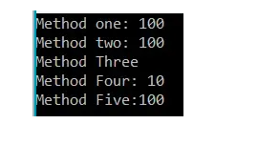

##### **Points to Remember while working with C# Extension methods:**

While working with the Extension Method in C#, we need to remember the following points.

1. Extension methods must be defined only under the static class. If you check our NewClass, then you will see that the NewClass is a static class.
2. We already discussed that Static Class in C# contains only Static Members. As an extension method is defined under a static class, it means the extension method should be created as a static method whereas once the method is bound with another class, the method changes into non-static. Now, if you check the methods in NewClass, then you will see that all three methods are declared as static only.
3. The first parameter of an extension method is known as the binding parameter which should be the name of the class to which the method has to be bound and the binding parameter should be prefixed with this As here we are creating these extension methods to extend the functionality of OldClass, so, you can check the first parameter of all these methods are going to be OldClass which is also prefixed with this keyword.
4. An extension method can have only one binding parameter and that should be defined in the first place on the parameter list.
5. If required, an extension method can be defined with normal parameters also starting from the second place of the parameter list. If you check the Test3 method, we have passed the second parameter as int and while calling this method we also need to pass one integer value.

##### **Extension Method Real-Time Example in C#:**

Let us see one real-time scenario where we can use the extension method in C#. As we know string is a built-in class provided by .NET Framework. That means the source code of this class is not available to us and hence we can change the source code of the string class. Also, the string is a sealed class in C# and hence we cannot create a derived class from the string class.

Now our requirement is to add a method to the String class i.e. GetWordCount() and that method will return the number of words present in a string and we should call this method as shown in the below image. That means by using the string object we should call that method.



How we can achieve this? We can achieve the above requirement by using the Extension Methods in C#. First, create a class file with the name **StringExtension.cs** and then copy and paste the following code into it. As you can see, here we created the class as static and hence the GetWordCount as static and provide the first parameter as the string class name so that we can call this method on the String class object. Here, we are splitting the string by space and then we are storing each word in a string array, and then we call the LINQ Count which will return the number of elements present in the string array, and that count we are returning from the method. But if the string is empty or null then, in that case, we are returning the count as 0.

using System.Linq;

namespace ExtensionMethods

{

public static class StringExtension

{

public static int GetWordCount(this string inputstring)

{

if (!string.IsNullOrEmpty(inputstring))

{

//Split the string by a space

string[] strArray = inputstring.Split(' ');

return strArray.Count();

}

else

{

return 0;

}

}

}

}

Once you have created the extension method for the string class, then you can use that extension method on the String object. Now, let us modify the Main method of the Program class to use the string extension method to get the word count as shown in the below code.

using System;

namespace ExtensionMethods

{

class Program

{

static void Main(string[] args)

{

string myWord = "Welcome to Dotnet Tutorials Extension Methods Article";

int wordCount = myWord.GetWordCount();

Console.WriteLine("string : " + myWord);

Console.WriteLine("Count : " + wordCount);

Console.Read();

}

}

}

That’s it. Now run the application and you should get the output as expected as shown in the below image.

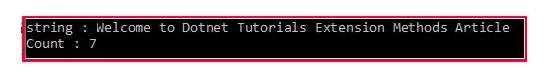

**Note:** Extension methods in C# enable us to add methods to an existing type without creating a new derived type, without modifying the original type. Extension methods are static methods, but they’re called as if they were instance methods on the extended type.

##### **LINQ uses Extension Methods Effectively:**

The most common extension methods are the LINQ standard query operators that add query functionality to the existing System.Collections.IEnumerable and System.Collections.Generic.IEnumerable<T> types. Once we start discussing the LINQ concept, then you will get better clarity about the Extension Methods. For a better understanding, please have a look at the following example. Here, we are using LINQ Where Method to filter the collection.

using System;

using System.Collections.Generic;

using System.Linq;

namespace SealedDemo

{

class Program

{

static void Main(string[] args)

{

List<int> intList = new List<int>()

{

10, 20, 30, 40, 50

};

//If you go to the definition of Where method, then you will see that

//it is implemented as an extension method

var List1 = intList.Where(x => x > 20).ToList();

Console.ReadKey();

}

}

}

Here, if you go to the definition of the Where method, then you will see that it is implemented as an extension method as shown in the below image.

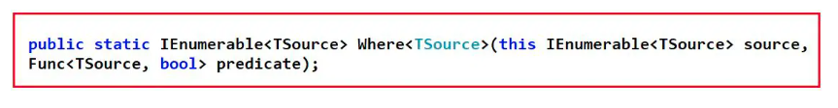

## **Static Class in C# with Examples**

In this article, I am going to discuss **Static Class in C#** with Examples. Please read our previous article where we discussed [**Extension Methods in C#**](https://dotnettutorials.net/lesson/extension-methods-csharp/) with Examples. I am sure at the end of this article; you will understand the need and use for Static Class in C# with Examples.

##### **Static Class in C#**

The class which is created by using the static modifier is called a static class in C#. A static class can contain only static members. It is not possible to create an instance of a static class. This is because it contains only static members. And we know we can access the static members of a class by using the class name.

##### **Example to understand the Static Class in C#:**

Let us understand the need and use of Static Class in C# with Example. First, create a console application with the name StaticClassDemo.

##### **CountryMaster.cs:**

Once you created the Console application, then add a class file with the name**CountryMaster.cs**and then copy and paste the below code into it. Here we have created the class with three properties and one method. The CountryCode property is going to hold the three-letter symbols of the country while the CountryName property going to hold the full country name. The ComputerName property has the logic to retrieve the current machine name. The Insert Method inserts the country record into the database and while inserting it also uses the ComputerName property to tell that from which computer this record was inserted.

namespace StaticClassDemo

{

public class CountryMaster

{

public string CountryCode { get; set; }

public string CountryName { get; set; }

private string ComputerName

{

get

{

return System.Environment.MachineName;

}

}

public void Insert()

{

//Insert the data

}

}

}

##### **Customer.cs**

Next, create another class file with the name **Customer.cs** and then copy and paste the following code into it.

namespace StaticClassDemo

{

public class Customer

{

public string CustomerCode { get; set; }

public string CustomerName { get; set; }

private string MachineName = "";

private bool IsEmpty(string value)

{

if (value.Length > 0)

{

return true;

}

return false;

}

public void Insert()

{

if (IsEmpty(CustomerCode) && IsEmpty(CustomerName))

{

//Insert the data

}

}

}

}

##### **Explanation of Above Code:**

The **CustomerCode** property is going to hold the three-letter code of the customer while the CustomerName property holds the customer’s name. The IsEmpty method accepts one value and then checks if the value is empty or not. If not empty then return true else return false. The Insert method simply checks if both CustomerCode and CustomerName are not empty then insert the customer record into the database.

Here, the problem is with the **MachineName**variable. The **MachineName**should have the current computer name while inserting the customer data into the database so that we can track from which machine this customer data was inserted

If you remember, the **CountryMaster**class has the logic to retrieve the computer name. Rather than writing the duplicate logic here, we should go and use the logic which is already written in the **CountryMaster**class, so that we can avoid writing repeating code or redundant code.

If you check the ComputerName property in the class **CountryMaster.cs**file, then you will see that, it is private, so in order to use that property in the Customer class, first, we need to change it to the public as shown in the below image.

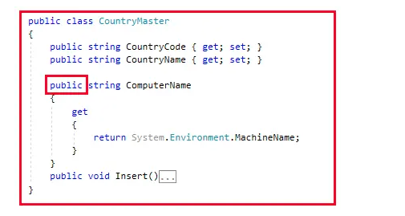

Again, while inserting the CountryMaster record into the database, we also need to check both CountryCode and CountryName should not be empty. To check if empty or not, we also like to use the **IsEmpty**method which is defined in the Customer class rather than writing the complete logic here. Further, if you notice, the IsEmpty method of the Customer class is private, so in order to use that method in CountryMaster class, we need to change it to the public as shown in the below image.

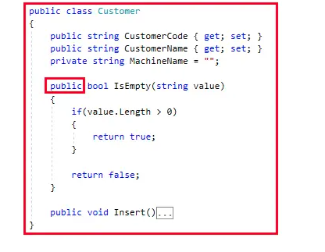

The CountryMaster class has logic to retrieve the computer name and we want to use that logic in the Customer class so we made the ComputerName property public. Similarly, the Customer class has the logic check whether a value is empty or not and we also want that logic in the CountryMaster class, so we made the IsEmpty method as public. As long as we did this, we violate the [**encapsulation principle**](https://dotnettutorials.net/lesson/encapsulation-csharp/).

##### **How we are Violating the OOPs Encapsulation Principle?**

Let us understand how we are violating the encapsulation principle. Modify the Program class as shown below. Once you created the Customer class object, then you can see the public member of that class as shown in the below image.

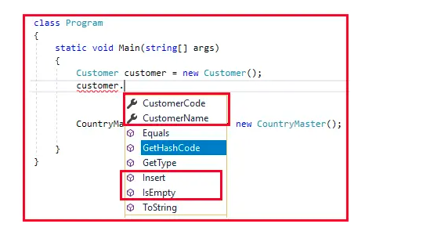

As you can see, we have exposed the CustomerCode, CustomerName, Insert, and IsEmpty methods. There is a clear violation of abstraction. Abstraction means showing only what is necessary. So, the external person who is consuming your class, should see and consume the **CustomerCode**, **CustomerName,** and **Insert** method. But should not see the **IsEmpty** method. The **IsEmpty** method is for internal use i.e. use by other methods not by the consumer of the class. As we make the IsEmpty method as public, we are violating the Encapsulation principle.

In the same way, we also violating the abstraction principle with the **CountryMaster**object as we are exposing the **ComputerName**property to the external world that is going to consume the class as shown in the below image. The **ComputerName** property is for internal use only.

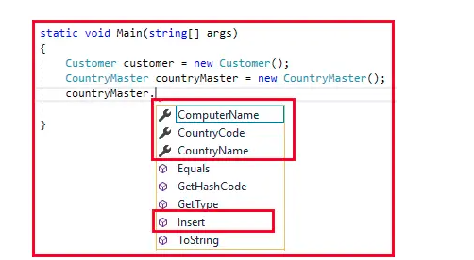

**Note:**With the above, we are achieving code reusability (reusing the ComputerName and IsEmpty method) but violating the encapsulation principle.

##### **How to solve this problem?**

How to solve the above problem means how should we achieve code reusability without violating the OOPs principles (i.e. Encapsulation Principle). In order to achieve both, let us add a new class and then move those two functions into that class. Create a class file with the name **CommonTask.cs**and then copy and paste the following code into it.

namespace StaticClassDemo

{

public class CommonTask

{

public bool IsEmpty(string value)

{

if (value.Length > 0)

{

return true;

}

return false;

}

public string GetComputerName()

{

return System.Environment.MachineName;

}

}

}

Please remove the IsEmpty() method from the Customer class and the ComputerName property from the CountryMaster class. Now both the logic which violates the OOPs principle has been moved to the **CommonTask**class.

##### **Modifying Customer class:**

Now modify the Customer class as shown below. As you can see, in the constructor we set the value of the MachineName private variable and in the Insert method, we create an instance of **CommonTask** class and Invoke the **IsEmpty** method.

namespace StaticClassDemo

{

public class Customer

{

public string CustomerCode { get; set; }

public string CustomerName { get; set; }

private string MachineName = "";

public Customer()

{

CommonTask commonTask = new CommonTask();

MachineName = commonTask.GetComputerName();

}

public void Insert()

{

CommonTask commonTask = new CommonTask();

if (!commonTask.IsEmpty(CustomerCode) && !commonTask.IsEmpty(CustomerName))

{

//Insert the data

}

}

}

}

##### **Modifying the CountryMaster class:**

Please modify the **CountryMaster** class as shown below. Here, we created the instance of **CommonTask** and then Invoke the GetComputerName and IsEmpty methods.

namespace StaticClassDemo

{

public class CountryMaster

{

public string CountryCode { get; set; }

public string CountryName { get; set; }

private string ComputerName

{

get

{

CommonTask commonTask = new CommonTask();

return commonTask.GetComputerName();

}

}

public void Insert()

{

CommonTask commonTask = new CommonTask();

if (!commonTask.IsEmpty(CountryCode) && !commonTask.IsEmpty(CountryName))

{

//Insert the data

}

}

}

}

As we centralized the **IsEmpty** and **GetComputerName**methods in the **CommonTask** class, we can use these methods in both the **Customer** and **CountryMaster** classes. The above solution seems to be decent as it does not violate the **OOPs Principle** and also achieves code reusability and I hope many of you also agree to it. But there is also some problem.

##### **What is the problem in the above solution?**

In order to understand the problem, let us first analyze the **CommonTask** class in a great manner.

1. This **CommonTask** class is a collection of unrelated methods and properties that are not related to each other. Because it has unrelated methods, properties, or logic, it does not represent any real-world objects.
2. As it does not represent any real-world objects, so any kind of OOPs principles (inheritance, abstraction, polymorphism, encapsulation) should not be allowed to be applied to this CommonTask class.
3. So, in simple words, we can say that this is a fixed class i.e. a class with a fixed behavior. That is, its behavior can not be changed by inheritance, and its behavior can not be polymorphed by using either static or dynamic polymorphism. So, we can say that this class is a fixed class or static class.

##### **How do we avoid Inheritance, how do we avoid abstract keywords, or how do we avoid the OOPs principle in a class?**

The answer is by using the **static** keyword. So, you need to mark the **CommonTask** class as **static** by using the static keyword. When you mark a class as **static**, everything inside the class should be static. That means, we also need to mark the **IsEmpty** and **GetComputerName** methods as static. So, modify the **CommonTask** class as shown below.

namespace StaticClassDemo

{

public static class CommonTask

{

public static bool IsEmpty(string value)

{

if (value.Length > 0)

{

return true;

}

return false;

}

public static string GetComputerName()

{

return System.Environment.MachineName;

}

}

}

Once you make the class static, then you cannot use the **new**keyword with the static class to create an instance, rather you need to invoke the **IsEmpty** and **GetComputerName** methods by using the class name. Internally only one instance of the static class gets created by CLR which serves all the clients.

##### **Modify the Customer class:**

Now modify the Customer class as shown below. As you can see, now we are invoking the **GetComputerName** and **IsEmpty** method using the class name i.e. **CommonTask**.

namespace StaticClassDemo

{

public class Customer

{

public string CustomerCode { get; set; }

public string CustomerName { get; set; }

private string MachineName = "";

public Customer()

{

MachineName = CommonTask.GetComputerName();

}

public void Insert()

{

if (!CommonTask.IsEmpty(CustomerCode) && !CommonTask.IsEmpty(CustomerName))

{

//Insert the data

}

}

}

}

##### **Modify the CountryMaster Class:**

Modify the **CountryMaster** class as shown below. As you can see in the below code, we are invoking the **GetComputerName** and **IsEmpty** method using the class name i.e. **CommonTask**.

namespace StaticClassDemo

{

public class CountryMaster

{

public string CountryCode { get; set; }

public string CountryName { get; set; }

private string ComputerName

{

get

{

return CommonTask.GetComputerName();

}

}

public void Insert()

{

if (!CommonTask.IsEmpty(CountryCode) && !CommonTask.IsEmpty(CountryName))

{

//Insert the data

}

}

}

}

##### **How is the static Class Instantiated in C#?**

We cannot apply any OOPs principles to the static class like inheritance, polymorphism, encapsulation, and abstraction. But in the end, it is a class. And at least to use a class it has to be instantiated. If the static class is not instantiated then we cannot invoke the methods and properties that are present in the static class. Now let us see how the instantiation takes place internally of a static class i.e. in our example, it is the **CommonTask** class.

The CLR (Common Language Runtime) will create only one instance of the **CommonTask** class irrespective of how many times they called from the **Customer** and **CountryMaster** class. For a better understanding, please have a look at the below image.

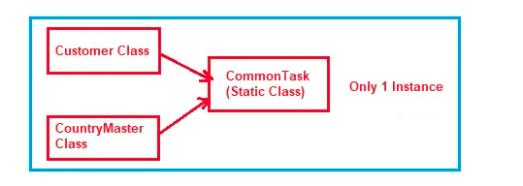

Due to the single instance behavior, the static class is also going to be used to share the common data.

##### **Can we create an Instance of a Static Class in C#?**

We cannot create an instance of a static class in C#. For a better understanding, please have a look at the below code. In our example, CommonTask is a static class and hence we cannot create an instance of the CommonTask, and if we try then we will get a compile-time error as shown in the below image.

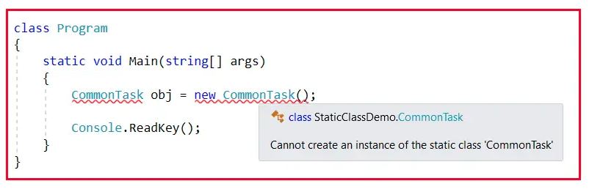

##### **Can we Inherit a Static Class in C#?**

Internally, static classes are sealed, which means we cannot inherit a static class from another class. For a better understanding, please have a look at the below image. Here, we are trying to inherit the static class and hence we are getting a compile-time error.

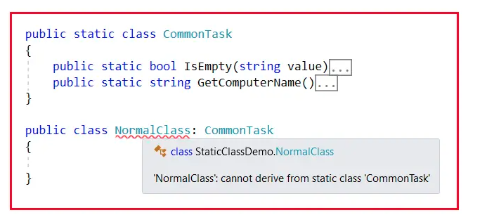

1. In C#, the static class is created by using the static keyword, the rest of the others are non-static classes.
2. We cannot create an instance of a static class even if reference variables are not possible. On the other hand, we can create both instance and reference variables using a non-static class.
3. We can access the members of a static class directly by using the class name. To access the non-static members, we need an instance or object of that class.
4. In static class, we can only define static members. On the other hand, inside a non-static class, we can define both static and non-static members.
5. A static class contains only a static constructor whereas a non-static class contains can both static and instance constructors.
6. Static classes are sealed and hence cannot inherit from another class. On the other hand, the non-static class can be inherited by another class.

# **Variable Reference and Instance of a Class in C#**

## **Differences Between Variable, Reference, and Instance of a Class in C#**

In this article, I am going to discuss the differences between **Variables, References, and Instances of a Class in C#** with Examples. Please read our previous article where we discussed [**Static Class in C#**](https://dotnettutorials.net/lesson/static-class-in-csharp/) with Examples. As a programmer, it is very important for us to understand what are Variables, References, and Instances of a Class in C#.

##### **Differences Between Variable, Reference, and Instance of a Class in C#**

1. **Variable of a Class:** A copy of the class that is not initialized.
2. **Instance of a Class:** A copy of the class that is initialized by using the new keyword which has its own memory and is never shared with another instance.
3. **Reference of a Class:**A copy of a class that is initialized by using an existing instance and references of a class will not have any memory allocation, they will be sharing the memory of the same instance that is assigned for initializing the variable.

Let us understand the above definitions in detail with examples.

##### **What is a Class?**

Simply speaking a class is a user-defined type in C#. We are saying string is a data type. But this string data type is created as a class in C#. It’s a pre-defined class and all pre-defined classes or user-defined classes in C# are also called data types.

The second point that you need to understand is that we can never consume a class directly. How to consume a class means we need to create a copy of that class. Why create a copy of the class? Let us understand this. We know int is a data type in C#. Can we use the int data type as follows?  
**int = 10;**

No. It’s not possible. We can never consume int like the above. Why because int is only a blueprint for your particular data, it does not have memory allocation for your data. If you want memory allocation for your data, then you should like as follows:  
int I = 10;

**What is “I” here?** Here, “I” is a copy of the int data type. In the same way, the following statement is also invalid.  
**string = “Hello”;**  
Here, the string is a class and a class is a user-defined data type. You cannot consume it directly. If you want to consume string, then you need to use it as follows.  
**string s = “Hello”;**

**What is s here?** Here, s is a copy of the string data type.  
See, to build a house we require a plan. Can we build a house without a plan? No. Not possible. So, every house requires a plan. The same thing is also here. Here, int and string are nothing but the plan of your house and i and s are your constructed houses. To build a house, you will consult with an architect. The architect will give you the plan? Can you leave in the plan? No, you cannot live in the plan. So, if you really want to live, then you need a house that is constructed based on the plan.

Exactly the same thing also happens here. Here, int is the plan and i is the constructed house based on the plan. So, now, the value 10 is nothing but you, living in a constructed house which is in our example i, and the house is constructed based on the plan i.e. int. So, the point that you need to remember is that the data type is always going to be the plan and a copy of that data type is the implementation of that plan.

**Note:** Every class whether it is predefined or user-defined, is going to be a data type. To consume the class what we need to do is we need to create a copy of that class. Until and unless we are not creating a copy of that class, the memory will not be allocated. If you want the memory to be allocated, then you need to create a copy of the type.

##### **Example to Understand How to Consume a Type in C#:**

Please have a look at the following example. Here, I have created an integer variable called x with the value 10, and then within the Main method and I am just printing the x value in the console window.

using System;

namespace VariablesDemo

{

internal class Example

{

int x = 10;

static void Main(string[] args)

{

Console.WriteLine(x);

Console.ReadKey();

}

}

}

Now, if you try to run the above code, you will get the following error. Here, we are getting the error when we try to print the value of x. This is because x is an instance member or you can say non-static member and you cannot access any non-static member directly from a static block, and here the Main method is a static block.

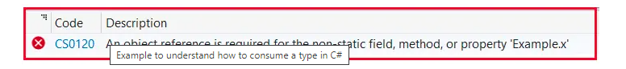

Now, the Main method is a static block and x is an instance member, so you cannot access x directly. If you want to access x, then first you need to create an instance of the Example class or a copy of the Example class and using the Example class instance only you can access the value of x as shown in the below example.

using System;

namespace VariablesDemo

{

internal class Example

{

int x = 10;

static void Main(string[] args)

{

Example e = new Example();

Console.WriteLine(e.x);

Console.ReadKey();

}

}

}

So, here e is an instance of the Example class, or you can say e is a copy of the Example class. And now, the memory is allocated for that instance e. An instance of a class is created by using the new keyword only.

So, the point that you need to remember is we can only print the value of x by using the instance of the class or copy of the class and the instance is created by using the new keyword only in C#.

##### **Variables of a Class in C#:**

Now, let us understand what is a variable of a class in C#. Please observe the following code.

**Example e;**

Here, we are not initializing e. So, what is a variable of a class? Variable of a class means a copy of a class that is not initialized. It is also considered an uninitialized copy of a class. For a better understanding, please have a look at the following code.

using System;

namespace VariablesDemo

{

internal class Example

{

int x = 10;

static void Main(string[] args)

{

//Variable

//Uninitialized copy of class Example

Example e;

Console.WriteLine(e.x);

Console.ReadKey();

}

}

}

Now, if you try to run the above code, you will get the following compile time error i.e. **Use of unassigned local variable ‘e’**. Here, e is not an instance, you can see in the error message, it is saying local variable e. So, here e is a local variable. And you are trying to access a member called x using a variable which is not possible in C# language and hence you are getting the following error.

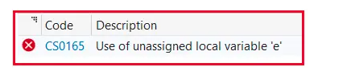

So, the point that you need to remember is you can access the non-static members of a class by using instance only, not by using the variables. An instance of a class is created by using the new keyword only. And if the new keyword is not used, means it is not an instance, it is just a variable. Now, observe the following code.

**Example e;**Here e is a variable of class Example

**e = new Example();**Now, here, e is an instance of class Example. As soon as you use the new keyword, e becomes an instance and now, you can access the x variable using the e instance as shown in the below example.

using System;

namespace VariablesDemo

{

internal class Example

{

int x = 10;

static void Main(string[] args)

{

Example e; //e is Variable of class Example

e = new Example(); //e is instance of class Example

Console.WriteLine(e.x);

Console.ReadKey();

}

}

}

So, we can create an instance in C# using the following two ways and both are going to be the same. In the first case, we have done the declaration and initialization at the same line. And in the second we have separated the declaration and initialization into two lines. First, we declare the variable and then we initialize the object. When we initialize the variable, then the variable becomes an instance of the class and using the instance we can access only the non-static members of the class.

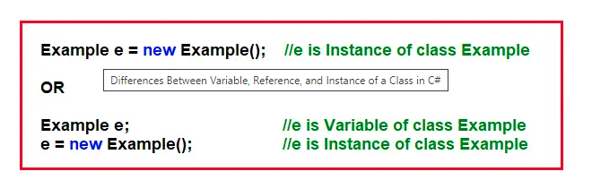

##### **Difference Between Variable and Instance of a Class in C#:**

Variables of a Class are nothing but the uninitialized copy of a class. They don’t occupy any memory. They are holding null. And using variables, we cannot consume the member of a class. When we initialize a variable with the new keyword, then it becomes an instance. An instance is nothing but a copy of a class. It occupies memory and using instances of a class, we can access the non-static members of that class. For a better understanding of the difference between Variable and Instance in C#, please have a look at the following diagram.

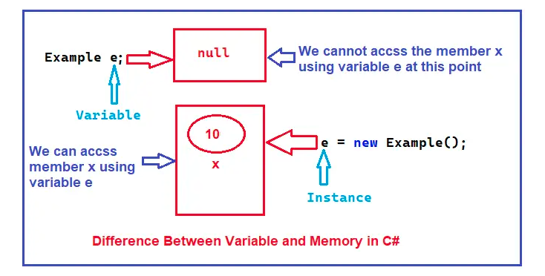

**Note:** So, the point that you need to remember is until and unless you initialize the variable, the memory allocation will not be done. Once you initialize the variable using the new keyword, then the memory allocation will be done, and then only you can access the non-static members of the class. And instances are going to be created by using the new keyword only.

When we initialize a variable using the new keyword, then the variable becomes an instance. And you can declare and initialize the variable at the same line (using a single statement) or you can split the declaration and initialization into two statements as shown in the below image.

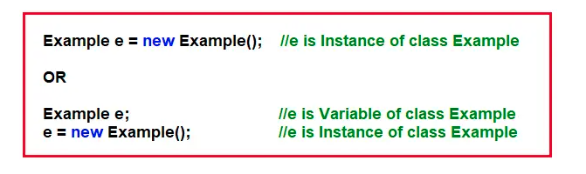

##### **Reference of a Class in C#:**

Now, let us understand what is a reference for a class in C#. Please observe the following code. Here, I am creating two instances of the class Example i.e. e1 and e2. So, here, two times the memory will be allocated. One for e1 as we are using a new keyword and the other for e2 as again we are using the new keyword to initialize the instances. So, in the below examples, the memory will be allocated two times. And then we are printing the value of x using both instances.

using System;

namespace VariablesDemo

{

internal class Example

{

int x = 10;

static void Main(string[] args)

{

Example e1 = new Example(); //e1 is Instance of class Example

Example e2 = new Example(); //e2 is Instance of class Example

Console.WriteLine($"e1.x: {e1.x} and e2.x: {e2.x}");

Console.ReadKey();

}

}

}

Now, when you run the above code, you will get the following output.

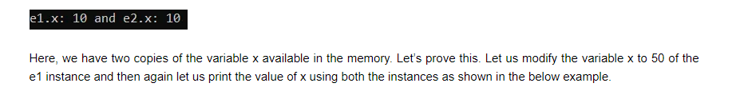

using System;

namespace VariablesDemo

{

internal class Example

{

int x = 10;

static void Main(string[] args)

{

Example e1 = new Example(); //e1 is Instance of class Example

Example e2 = new Example(); //e2 is Instance of class Example

Console.WriteLine($"e1.x: {e1.x} and e2.x: {e2.x}");

e1.x = 50; //Modifying the x variable of e1 instance

Console.WriteLine($"e1.x: {e1.x} and e2.x {e2.x}");

Console.ReadKey();

}

}

}

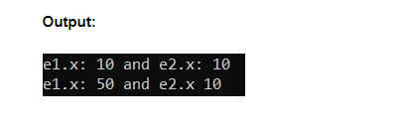

As you can see in the above output, the x variable of the e1 instance is changed to 50 only. It will not change the x variable of the e2 instance. Now, let us modify the x variable of the e2 instance and then print the x value of both instances again as shown in the below example.

using System;

namespace VariablesDemo

{

internal class Example

{

int x = 10;

static void Main(string[] args)

{

Example e1 = new Example(); //e1 is Instance of class Example

Example e2 = new Example(); //e2 is Instance of class Example

Console.WriteLine($"e1.x: {e1.x} and e2.x: {e2.x}");

e1.x = 50; //Modifying the x variable of e1 instance

Console.WriteLine($"e1.x: {e1.x} and e2.x {e2.x}");

e2.x = 150; //Modifying the x variable of e2 instance

Console.WriteLine($"e1.x: {e1.x} and e2.x {e2.x}");

Console.ReadKey();

}

}

}

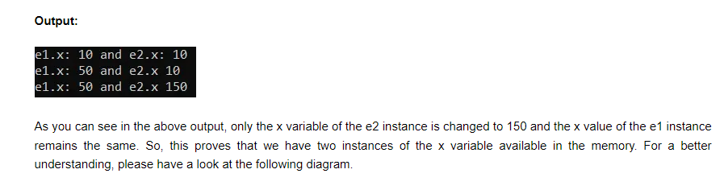

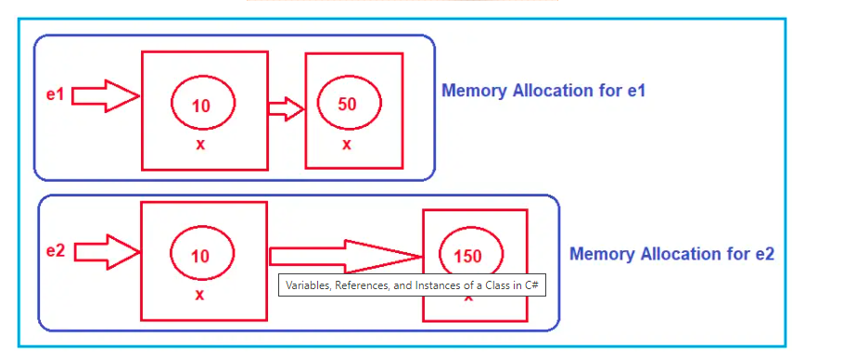

**Note:** The point that you need to understand is that you can create any number of instances for your class, and for each instance, a separate memory allocation will be done. The memory allocation done for one instance is never going to be shared with other instances.

This is the beauty of Object-Oriented Programming or you can say it is the security of Object-Oriented Programming. Every instance is unique itself. The changes made in one instance will never reflect in other instances.

This is all about instances of a class. Now, let us talk about the References of a class in C#. Please have a look at the following code. Here, e1 is an instance of a class but e2 is a reference of a class. See, e2 is not initialized with the new keyword and hence it is not an instance. But e2 is initialized with an existing instance.

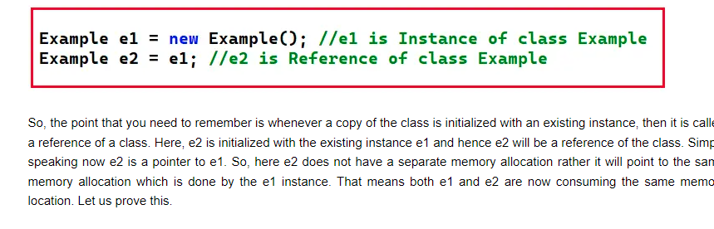

In the below example, e1 is an instance and e2 is a reference pointing to the e1 instance. Then we are modifying the x value to 50 using the e1 instance and if both are pointing to the same memory location, then the changes should also affect e2 also.

using System;

namespace VariablesDemo

{

internal class Example

{

int x = 10;

static void Main(string[] args)

{

Example e1 = new Example(); //e1 is Instance of class Example

Example e2 = e1; //e2 is Reference of class Example

Console.WriteLine($"e1.x: {e1.x} and e2.x: {e2.x}");

e1.x = 50; //Modifying the x variable of e1 instance

Console.WriteLine($"e1.x: {e1.x} and e2.x {e2.x}");

Console.ReadKey();

}

}

}

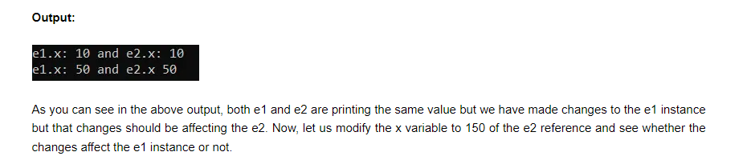

using System;

namespace VariablesDemo

{

internal class Example

{

int x = 10;

static void Main(string[] args)

{

Example e1 = new Example(); //e1 is Instance of class Example

Example e2 = e1; //e2 is Reference of class Example

Console.WriteLine($"e1.x: {e1.x} and e2.x: {e2.x}");

e1.x = 50; //Modifying the x variable of e1 instance

Console.WriteLine($"e1.x: {e1.x} and e2.x {e2.x}");

e2.x = 150; //Modifying the x variable of e2 reference

Console.WriteLine($"e1.x: {e1.x} and e2.x {e2.x}");

Console.ReadKey();

}

}

}

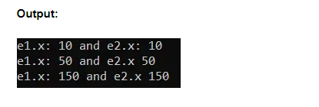

As you can see the changes made in the e2 reference also affect the e1 instance. That means whether we made changes in e1 or e2, it will affect both. This is because both e1 and e2 are pointing to the same memory location. For a better understanding, please have a look at the following diagram.

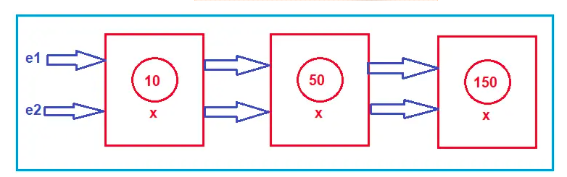

Simply speaking reference of a class can be called a pointer to the instance and every modification we perform on the members using the instance will reflect when we access those members using references and vice versa is also true.

**Note:** Using variables, you cannot access the non-static members of a class, but using both instances or references, you can access the non-static members of a class. This is because the reference is initialized with an existing instance only and variables are never initialized.

**Note:** References do not have their own memory allocation, rather they will point to an existing memory. But references are used like instances.